

SUBMITTED BY
NAME | K.Narendrasai
ROLL NO. | AV.SC.U4CSE25055
YEEAR/SEM/SECTION | 1st Year/Sem-02/CSE-A
CREDITS | 03

SUBMITTED TO | DR.RAJ KUMAR BATCHU
DESIGNATION | ASST.PROFFESSOR
DEPARTMENT | School of Computing

INDEX

S.NO | TITLE | PAGE NO | REMARKS
1 | WEEK 1:  1(A) Aim:  To understand the installation process of a VS code and get familiar with its environment for web development.  1(B) Aim:  To learn the basic structure of an HTML document and create a simple webpage using headings and paragraphs.  1(C) Aim:  To understand and implement basic HTML tags such as image, hyperlink, text formatting, and inline styling to design a simple webpage. | 4-15
2 | WEEK 2:  2a) To design a simple web page using HTML that demonstrates the use of  background color, background image, heading styling, and preformatted text.  2B)To create a static webpage using only HTML that displays basic information about Amrita Vishwa Vidyapeetham, including a heading, descriptive text, background styling through HTML attributes, and a table showing the list of campuses in different states.  2C) To design a restaurants menu webpage using HTML and displaying menu items in a table format with proper layout and visual styling. | 15-24
3 | WEEK 3:  3(A) Aim:  To design and develop an academic timetable using HTML tables by applying row span, column span, and styling for proper structure and presentation.  3(B) Aim:  To create a comprehensive webpage that includes an academic timetable along with syllabus representation using images and structured HTML elements. | 24-38
4 | WEEK-4:  4(A) Aim:  To understand the concept of forms and design a structured student registration form using HTML tables, including various input types such as text fields, radio buttons, checkboxes, file upload, and dropdown lists.  4(B) Aim:  To understand the concept of forms and design user login and registration webpages using HTML, and to display them within a single interface using iframe for better layout and user interaction. | 38-43
5 | Week 5:  5(A) Aim:  To create a responsive card layout using HTML and CSS with three cards, each containing an image, title, and button.  5(B) Aim:  To design a mini website using iframe with navigation links (Home, About, Contact), where clicking on each link displays the respective content within the same page using internal or external CSS.  5(C) Aim:  To design an Amrita login page using HTML and CSS that displays different campuses, where clicking on each campus shows its details on the same page | 43-60
6 | 6A.Aim)Design a responcive E-Commers web application using grid layout . this application should contain different categories of products such as electronics , clothing , homeappliances , books .based on that categorie are selected corresponding products should be displayed on the side bar.  6B.Aim)Design a responsive E-Commerce application using the grid layout. This application should different categories of products such as electronics, clothing, home-appliances, books. Those should display on products. | 60-72
7 | 7.Aim) create a GitHub account and create a repository in it and push all the week 6 code files in it. | 72-77
8 | Week 8  8(A):create a web page that displays a square that continuously rotates 360 using css animation  8(B):create a ball that moves up and down continuously using css animation  8(C):create a circle that moves horizontally and rotates At the same time | 77-84
9 | WEEK9:Create an webpage using html, CSS, java script based on the given conditions:  a)Create a button for each program, based on the button clicked the corresponding program has to be executed and should display the output.  b)The logics for each button includes finding an even numbers, odd number, prime or not, factorial of a number, amstrong or not.  c)Use appropriate designs to display the  output. | 93-99
10 | A)WriteJavaScript conditional statement to find the sign of product of three numbers using functions. Display an alert box with specified sign  B): write a java script conditional statements to sort 3 numbers using functions display an alert box to show the result.  C): write a java script conditional statement to find largest of find largest of five numbers using function and onclick event. display an alert box to show the result.  D): write a java script for loop that will iterate from 0 to 15. For each iteration, it will check if the current number odd or even, and display a message on screen.  E) write a java script program to read 6 subjects marks from the student then computes theaverage marks of students then, this average is used to determine the corresponding grade. | 100-109
11 | A)WriteJavaScript conditional statement to find the sign of product of three numbers using functions. Display an alert box with specified sign  B): write a java script conditional statements to sort 3 numbers using functions display an alert box to show the result.  C): write a java script conditional statement to find largest of find largest of five numbers using function and onclick event. display an alert box to show the result.  D): write a java script for loop that will iterate from 0 to 15. For each iteration, it will check if the current number odd or even, and display a message on screen.  E) write a java script program to read 6 subjects marks from the student then computes theaverage marks of students then, this average is used to determine the corresponding grade. | 110-121
12 | Steps to install and set up electron | 122-133

Week-1
1. A)AIM: To understand the installation process of a VS code and get familiar with its environment for web development.

PROCEDURE
STEP1:
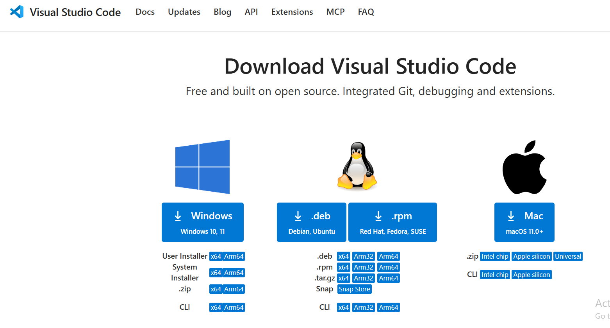

STEP2:
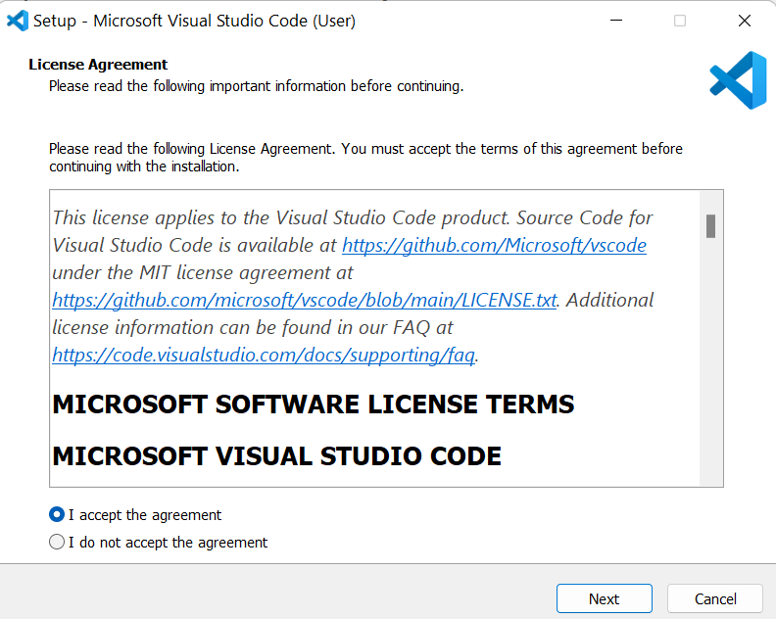

STEP3: 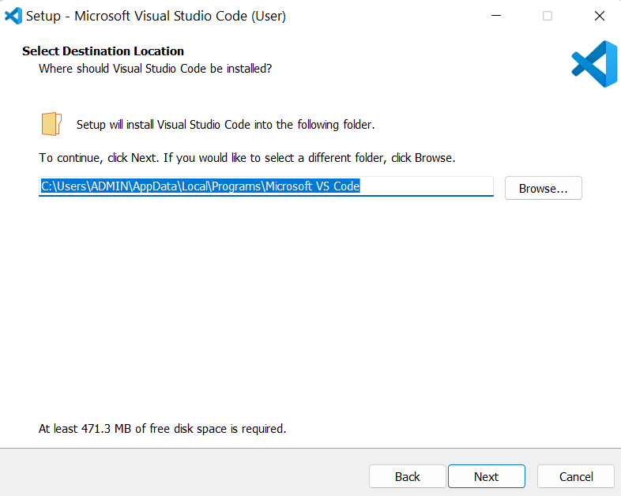

STEP 4: 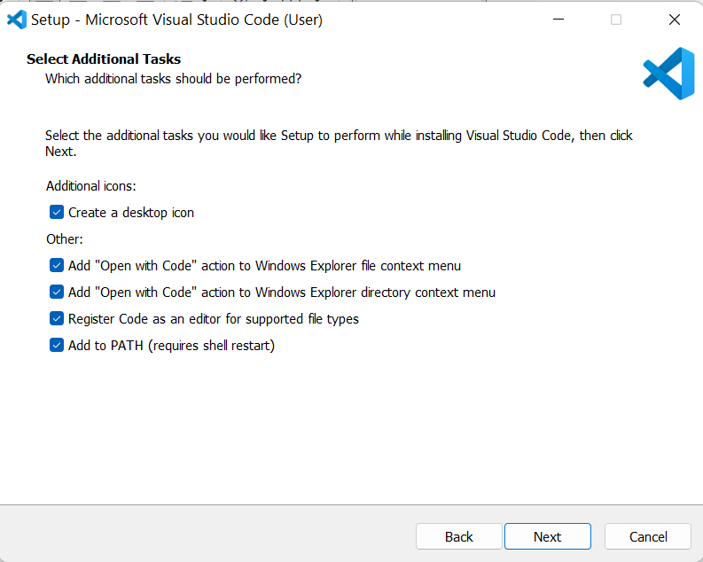

STEP5: 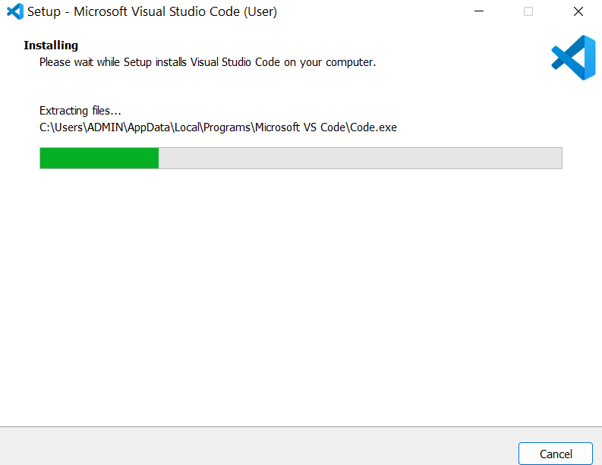

STEP6: 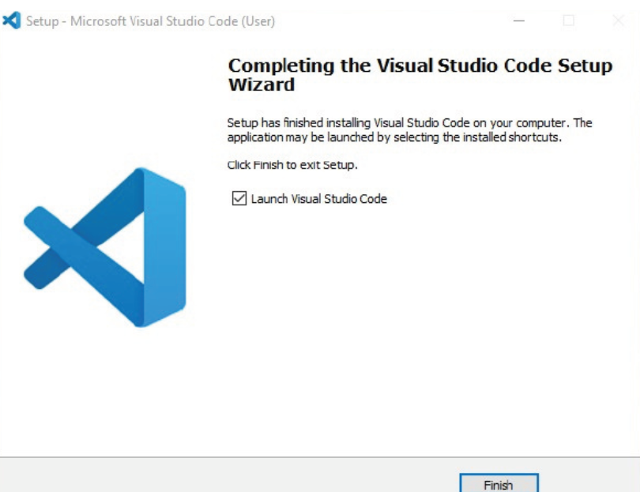
1.B)AIM: To learn the basic structure of an HTML document and create a simple webpage using headings and paragraph.
Program:
<!doctype html>
<html>
<head>
<title>Student ID details</title>
</head>
<body>
<h1>My personal details</h1>
<p>Name:Narendrasai</p>
<p>age:18</p>
<p>CSE department</p>
<p>Gender:Male</p>
</body>
</html>
Output:
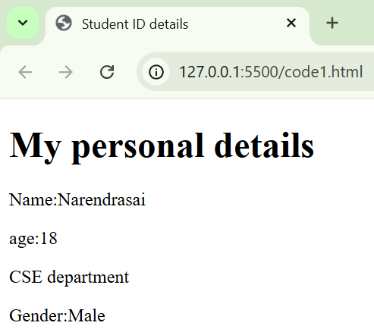
Explanation of the tags:
• HTML stands for Hyper Text Markup Language.
• HTML is used to create and structure web pages.
• It tells the web browser what to display and how to display it.
• <DOCTYPE HTML> : The <DOCTYPE html> element tells the browser , this is an HTML5 document
• <html>: The <html> element is the root element of an HTML page.
• <head>: The <head> element contains meta information about the HTML page.
• <title>: The <title> element specifies a title for the HTML page.
• <body>: The <body> element contains all visible content like text ,images ,links ,tables ,etc.
• <h3>: The <h3> element defines a large heading.
• <p>: The <p> element defines a paragraph.

1 .C ) AIM : To understand and implement basic HTML tags such as image, hyperlink, text formatting, and inline styling to design a simple webpage.
PROGRAM:
<!DOCTYPE HTML>
<HTML>
<HEAD>
<TITLE>LINKS</TITLE>
</HEAD>
<BODY>
<H1>LINKS OF COLLEGES</H1>
<H3>AMRITA:</H3>
<IMG SRC="HTTPS://WEBFILES.AMRITA.EDU/2025/12/AMRITA-LOGO-NEW.SVG" ALT="AMRITA UNIVERSITY"
WIDTH="100" HEIGHT="50"><BR>
<A HREF="HTTPS://WWW.AMRITA.EDU">AMRITA UNIVERSITY</A>
<P>AMRITA VISHWA VIDYAPEETHAM IS A MULTI-DISCIPLINARY, RESEARCH-INTENSIVE, PRIVATE UNIVERSITY, EDUCATING A VIBRANT STUDENT POPULATION OF OVER 30,000 BY 2000+ STRONG FACULTY. ACCREDITED WITH THE HIGHEST POSSIBLE A++ GRADE BY NAAC, AMRITA OFFERS MORE THAN 300 UG, PG, AND PH.D. PROGRAMS ACROSS
VARIOUS DISCIPLINES, INCLUDING ENGINEERING, MANAGEMENT, MEDICAL SCIENCES, AYURVEDA, LIFE SCIENCES, PHYSICAL SCIENCES, AGRICULTURAL SCIENCES, LAW, ARTS & HUMANITIES, AND SOCIAL & BEHAVIORAL
SCIENC NCES.</P>
<H3>S 3>SRM AP</H3>
<IMG SRC="HTTPS://WWW.SRMAP.EDU.IN/WP-CONTENT/UPLOADS/2025/01/SRM-UNIVERSITY-LOGO-1.PNG"
ALT="SRM UNIVERSITY AP" WIDTH="100" HEIGHT="50"><BR>
<A HREF=HTTPS://WWW.SRMAP.EDU.IN> SRM UNIVERSITY AP</A>
<P>SRM UNIVERSITY-AP, ANDHRA PRADESH IS A PRIVATE UNIVERSITY IN INDIA, IT WAS ESTABLISHED IN 2017 BY THE SRM TRUST, THE UNIVERSITY IS LOCATED IN THE CITY OF AMARAVATI, THE CAPITAL OF ANDHRA PRADESH. IT OFFERS UNDERGRADUATE, POSTGRADUATE, AND DOCTORAL PROGRAMS IN VARIOUS FIELDS SUCH AS ENGINEERING, MANAGEMENT, SCIENCE, AND HUMANITIES.</P>
<H3>VIT AP</H3>
<IMG SRC="HTTPS://WWW.VITAP.AC.IN/WP-CONTENT/UPLOADS/2023/01/VIT-AP-UNIVERSITY-LOGO.PNG"
ALT="VIT AP UNIVERSITY" WIDTH="100" HEIGHT="50"><BR>
<A HREF=HTTPS://VITAP.AC.IN VIT AP UNIVERSITY</A>
<P>VIT-AP UNIVERSITY IS A PRIVATE UNIVERSITY LOCATED IN AMARAVATI, ANDHRA PRADESH, INDIA, IT IS PART OF THE VELLORE INSTITUTE OF TECHNOLOGY (VIT) GROUP OF INSTITUTIONS. ESTABLISHED IN 2017, VIT-AP OFFERS UNDERGRADUATE, POSTGRADUATE, AND DOCTORAL PROGRAMS IN VARIOUS FIELDS SUCH AS ENGINEERING, SCIENCE, MANAGEMENT, AND HUMANITIES. THE UNIVERSITY AIMS TO PROVIDE QUALITY EDUCATION AND FOSTER RESEARCH AND IN INNOVATION AMONG ITS STUDENTS AND FACULTY.</P>
</BODY></HTML>
OUTPUT: 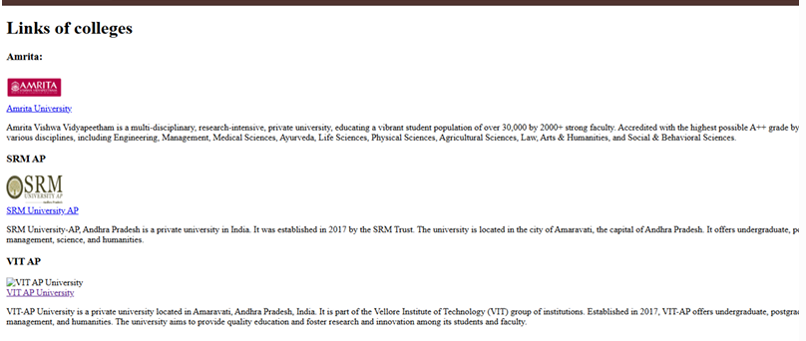
Explanation of the tags:
• HTML stands for Hyper Text Markup Language.
• HTML is used to create and structure web pages.
• It tells the web browser what to display and how to display it.
<DOCTYPE HTML>: The <DOCTYPE html>element tells the browser, this is an HTML5 document
<html>: The <html> element is the root element of an HTML page.
<head>: The <head> element contains meta information about the HTML page.
<title>: The <title> element specifies a title for the HTML page.
<body>: The <body>element contains all visible content like text ,images, links, tables, etc.
<h1>: The <h1> element defines a large heading.
<p>: The <p> element defines a paragraph.
. <br>: The HTML <br> element defines a line break, it is an empty tag with no end tag
<img>: The <img> tag is a fundamental HTML element used to embed an image into a web page
<a>: The HTML <a> tag, which stands for "anchor", is used to define a hyperlink

WEEK-02
2A)Aim) To design a simple web page using HTML that demonstrates the use of background color, background image, heading styling, and preformatted text.
Program:
<html>
<body
style="
background-image: url(&quot;style practise imaze.jpg&quot;);
background-size: cover;
font-family: Arial;
"
;>
<h1 style="text-align: center; color: #333">Automobile Industry Data</h1>

<table
style="
width: 60%;
margin: 30px auto;
border-collapse: collapse;
background-color: rgba(255, 255, 255, 0.8);
border: 3px solid #333;
">
<caption
style="
font-weight: bold;
font-size: 18px;
color: #004d40;
padding: 10px;
">
<b> Car Companies </b>
</caption>

<tr style="background-color: #004d99; color: white">
<th style="border: 2px solid #333; padding: 12px">Company</th>
<th style="border: 2px solid #333; padding: 12px">Product</th>
<th style="border: 2px solid #333; padding: 12px">Country</th>
</tr>

<tr>
<td style="border: 2px solid #333; padding: 10px; text-align: center">
Audi
</td>
<td style="border: 2px solid #333; padding: 10px; text-align: center">
Tyre
</td>
<td style="border: 2px solid #333; padding: 10px; text-align: center">
Brazil
</td>
</tr>

<tr style="background-color: #f2f2f2">
<td style="border: 2px solid #333; padding: 10px; text-align: center">
BMW
</td>
<td style="border: 2px solid #333; padding: 10px; text-align: center">
Engine
</td>
<td style="border: 2px solid #333; padding: 10px; text-align: center">
Australia
</td>
</tr>

<b> <p style="text-align: right">-K.Narenndrasai</p> </b>
</table>
</body>
</html>

Output: 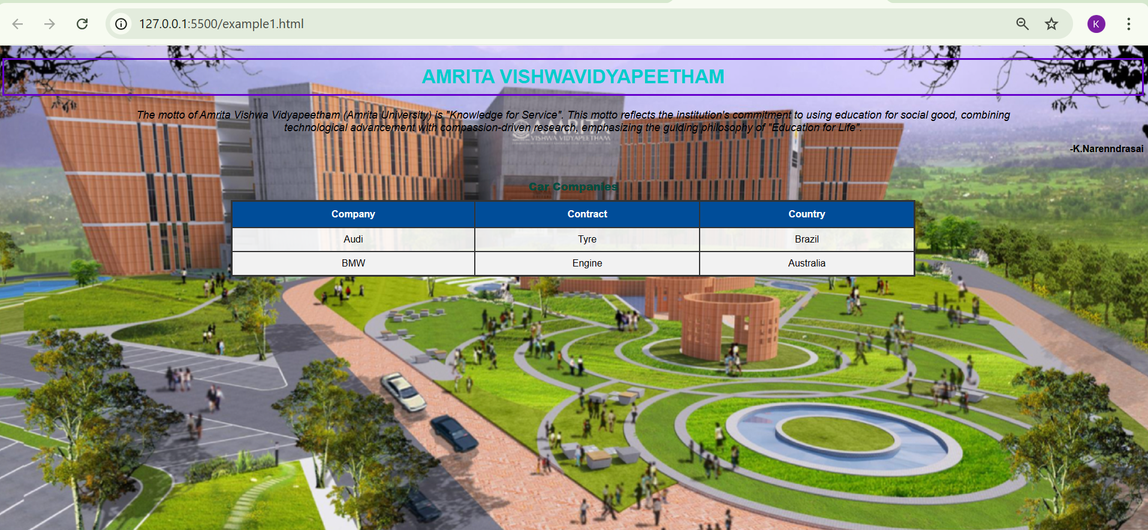
Explanation of the tags:
<html>: The root element that wraps all the content on the page.
- <body>: Contains the visible content of the document. In your code, it uses inline CSS to set a background image and a font.
- <h1>: A top-level heading. It’s used here for the main title, "Automobile Industry Data."
- <p>: Defines a paragraph.
- <table>: The container for all table-related data. Your code adds a white background with 80% opacity (rgba) so it’s readable over the background image.
- <caption>: Provides a title or description for the table (e.g., "Car Companies"), usually appearing at the top.
- <tr>: Stands for Table Row. It groups together a single horizontal line of cells.
- <th>: Stands for Table Header. These cells are usually bold and centered by default, used for the top labels like "Company" and "Product."
- <td>: Stands for Table Data. These are the standard cells that hold the actual information (like "Audi" or "Brazil").

2B)Aim: To create a static webpage using only HTML that displays basic information about Amrita Vishwa Vidyapeetham, including a heading, descriptive text, background styling through HTML attributes, and a table showing the list of campuses in different states.
PROGRAM:
<!DOCTYPE HTML>
<HTML>
<HEAD>
<TITLE>Amrita Vishwa Vidyapeetham</TITLE>
</HEAD>

<BODY BGCOLOR="#FFF8E7" TEXT="#333333">

<!-- MAIN CONTAINER -->
<TABLE ALIGN="CENTER" WIDTH="80%" BGCOLOR="#FFFFFF" CELLPADDING="20" CELLSPACING="0" BORDER="0">
<TR>
<TD>

<!-- HEADING -->
<H1 ALIGN="CENTER">
<FONT COLOR="#2E8B57">Amrita Vishwa Vidyapeetham</FONT>
</H1>

<HR WIDTH="50%" COLOR="#2E8B57">

<!-- DESCRIPTION -->
<P ALIGN="CENTER">
Amrita Vishwa Vidyapeetham is a premier multi-campus, multi-disciplinary
research university in India. Accredited with NAAC 'A++' grade, the
university is known for academic excellence, cutting-edge research,
and value-based education. Amrita offers a wide range of programs in
engineering, medicine, management, arts, and sciences across its
campuses.
</P>

<BR>

<!-- TABLE TITLE -->
<H2 ALIGN="CENTER">
<FONT COLOR="#1E3A8A">Our campuses across India</FONT>
</H2>

<!-- CAMPUSES TABLE -->
<TABLE BORDER="1" ALIGN="CENTER" WIDTH="70%" CELLPADDING="10" CELLSPACING="0">

<TR BGCOLOR="#1E3A8A">
<TH><FONT COLOR="WHITE">S.No</FONT></TH>
<TH><FONT COLOR="WHITE">Campus</FONT></TH>
<TH><FONT COLOR="WHITE">State</FONT></TH>
</TR>

<TR ALIGN="CENTER">
<TD>1</TD>
<TD>Coimbatore</TD>
<TD>Tamil Nadu</TD>
</TR>

<TR ALIGN="CENTER" BGCOLOR="#EEF2FF">
<TD>2</TD>
<TD>Amritapuri</TD>
<TD>Kerala</TD>
</TR>

<TR ALIGN="CENTER">
<TD>3</TD>
<TD>Bengaluru</TD>
<TD>Karnataka</TD>
</TR>

<TR ALIGN="CENTER" BGCOLOR="#EEF2FF">
<TD>4</TD>
<TD>Kochi</TD>
<TD>Kerala</TD>
</TR>

<TR ALIGN="CENTER">
<TD>5</TD>
<TD>Chennai</TD>
<TD>Tamil Nadu</TD>
</TR>

<TR ALIGN="CENTER" BGCOLOR="#EEF2FF">
<TD>6</TD>
<TD>Mysuru</TD>
<TD>Karnataka</TD>
</TR>

</TABLE>

<BR><BR>

<!-- FOOTER -->
<HR WIDTH="60%">
<P ALIGN="CENTER">
<FONT COLOR="#777777">
Official website: www.amrita.edu
</FONT>
</P>

</TD>
</TR>
</TABLE>

</BODY>
</HTML>

OUTPUT: 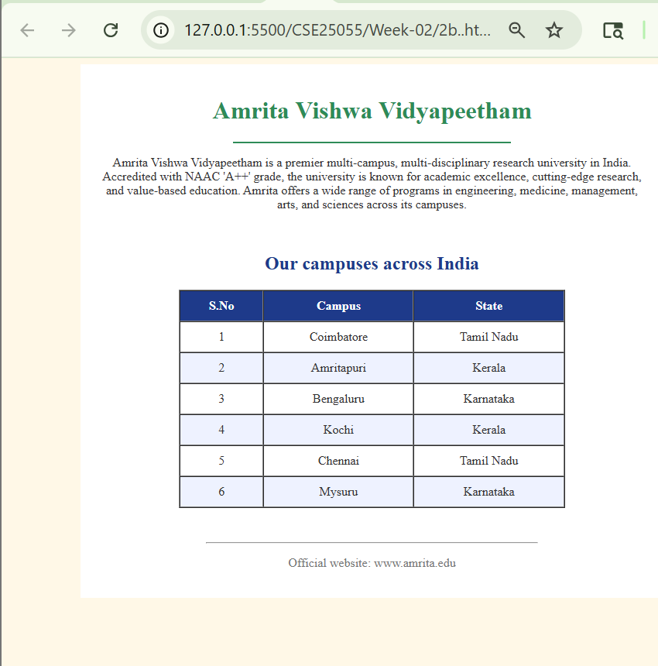
Explanation of the tags:
- <html>: The "container" for the whole page. Everything starts and ends here.
- <head>: Holds hidden info about the page, like the title you see on the browser tab.
- <title>: Sets the name that appears at the very top of your browser window.
- <body>: This is where all the visible stuff goes (text, images, tables).
- <h1>: A big, bold heading. It’s usually used for the main title of the page.
- <p>: Short for "paragraph." Use this to wrap your regular blocks of text.
- <hr>: Draws a horizontal line across the page to separate different sections.
- <br>: A simple line break. It moves the text following it down to the next line.
- <table>: Used to create a grid of data (like your list of campuses).
- <tr>: Stands for "Table Row." It creates a single horizontal line in your table.
2C)Aim: To design a restaurants menu webpage using HTML and displaying menu items in a table format with proper layout and visual styling
Program:
<!doctype html>
<html>
<head>
<title>Hotel Menu</title>
<style>
body {
font-family: sans-serif;
}
h1 {
color: #333;
text-align: center;
}
table {
width: 60%;
margin: 20px auto;
border-collapse: collapse;
box-shadow: 0 4px 8px rgba(0, 0, 0, 0.1);
}
th,
td {
border: 1px solid:#ddd;
padding: 12px;
text-align: left;
}
th {
background-color: #f4f4f4;
color: #555;
}
tr:nth-child(even) {
background-color: #f9f9f9;
}
</style>
</head>
<body style="background-color: blue; background-image: url(menu.avif)">
<h1>The Grand Hotel Menu</h1>

<table>
<thead>
<tr>
<th
style="
border: 2px solid blue;
padding: 10px;
background-color: lightgrey;
">
Item Name
</th>
<th
style="
border: 2px solid:blue;
padding: 10px;
background-color: lightgrey;
">
Price
</th>
</tr>
</thead>
<tbody>
<!-- Lunch Items -->
<tr>
<td>Panner Biryani</td>
<td>230</td>
</tr>
<tr>
<td>Egg Biryani</td>
<td>250</td>
</tr>
<tr>
<td>Shawerma(Panner)</td>
<td>190</td>
</tr>

<tr>
<td>Shawerma(Chicken)</td>
<td>180</td>
</tr>
<tr>
<td>Butter Chicken</td>
<td>220</td>
</tr>
<!-- Dinner Items -->
<tr>
<td>2-Parotas and chicken curry (Andhra/Telangana)</td>
<td>100</td>
</tr>
<tr>
<td>Chicken Dum Biryani</td>
<td>300</td>
</tr>
<!-- Desserts -->
<tr>
<td>Chocalate Lava Cake</td>
<td>200</td>
</tr>
</tbody>
</table>
</body>
</html>

OUTPUT: 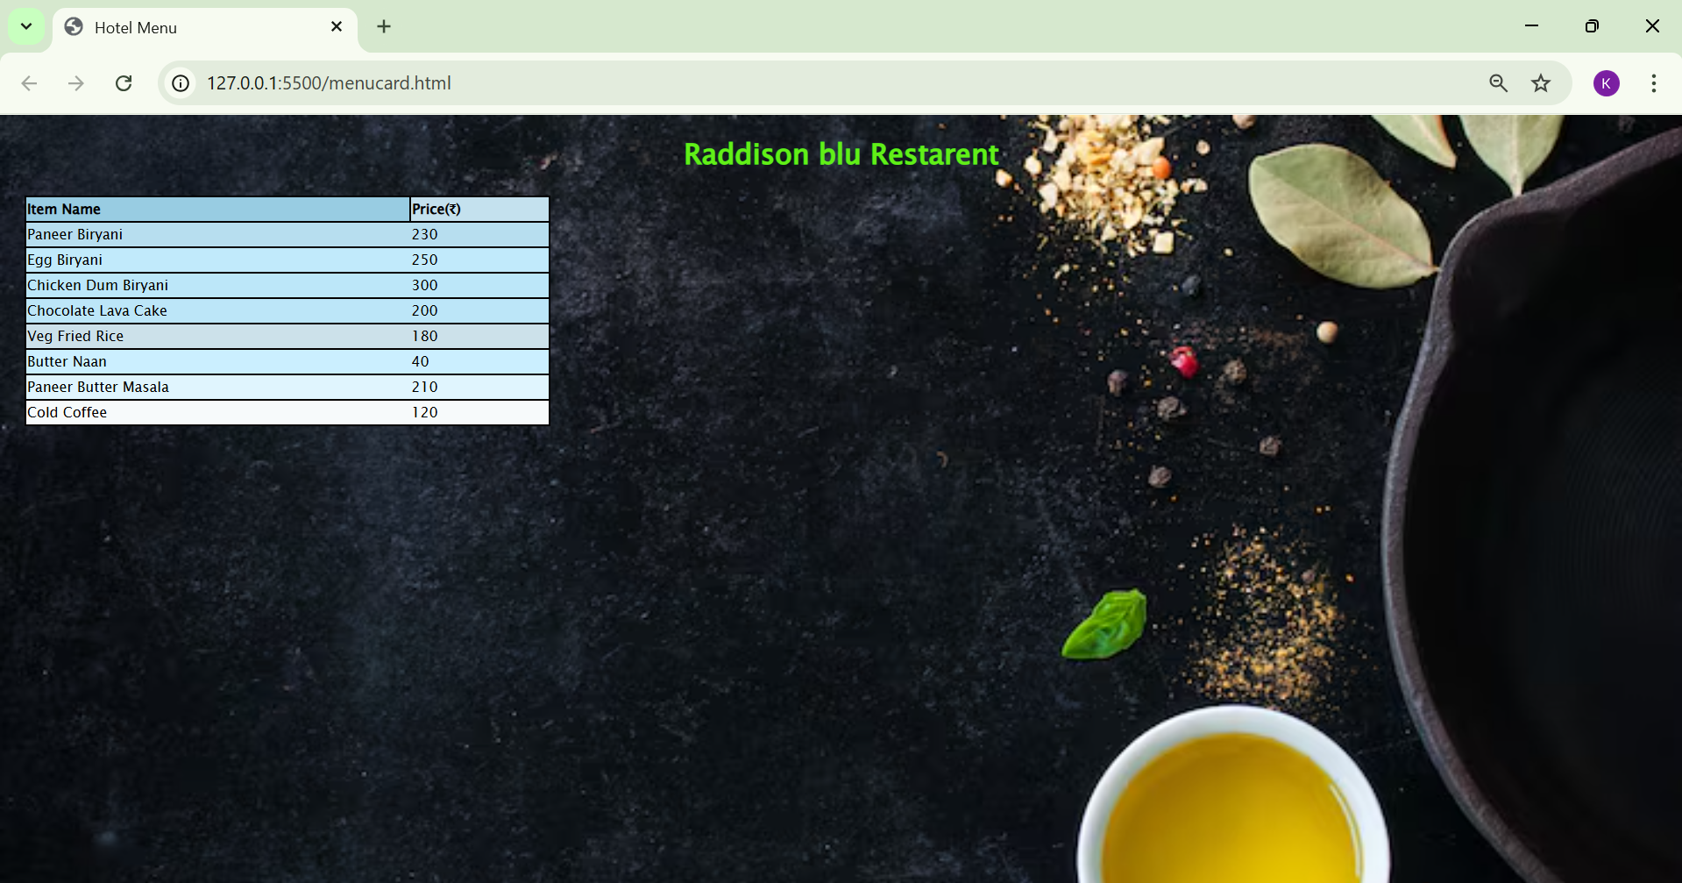
Explanation of the tags:
- <u> – Underlines the enclosed text to give it visual emphasis.
- <b> – Displays text in bold without indicating extra importance.
- <strong> – Marks text as strongly important and usually
displays it in bold.
- <sub> – Shows text as subscript below the normal text line.
- <i> – Displays text in italic style to indicate a term or emphasis.
- <sup> – Shows text as superscript above the normal text line.
- <del> – Represents deleted or removed text with a strike-
through.
- <mark> – Highlights text to indicate special importance or
relevance.
- <table> – Creates a table to arrange data in rows and columns.
- <tr> – Defines a table row inside the table.
- <td >– Defines a normal table data cell used to store text, images, or other content.
- <th> – Defines a table header cell. It is bold and centered by default and is used for headings.
- style attribute – Used to apply CSS styles directly to an element to control color, alignment, background, font size, spacing, borders, and layout.

WEEK-03
3A)Aim: To design and develop an academic timetable using HTML tables by applying row span, column span, and styling for proper structure and presentation.
Program:
<!doctype html>
<html lang="en">
<head>
<meta charset="UTF-8" />
<meta name="viewport" content="width=device-width, initial-scale=1.0" />
<title>Exercise-2a</title>
</head>
<body>
<table border="6px" style="text-align: center; padding: 0%;width: 100%;
border-collapse: collapse;
">
<tr>
<th style="column-span: all;">
Master Time Table CSE II Semester A Section
</th>
</tr>
<tr>
<td style="column-span: 4">Dept.CSE</td>
<td rowspan="3" style="column-span: 8">Class Room Venue: 510</td>
</tr>
<tr>
<td style="column-span: 4">Class: B. Tech. CSE-A</td>
</tr>
<tr>
<td style="column-span: 4">Semester-II</td>
</tr>
<tr>
<td style="column-span: 4">
<pre>
Class Advisors:
1. Name: Dr. K. Sindhu
Email : k_sindhu@av.amrita.edu
Mobile Number : +91-9959387057
</pre
>
</td>
<td style="column-span: 8">
<pre>
2. Name: Dr. Sumanta Kumar Nanda
Email : n_sumantakumar@av.amrita.edu
Mobile Number :+91- 7978115993
</pre
>
</td>
</tr>
<tr>
<td rowspan="2">Time/ Day</td>
<td>Slot 1</td>
<td>Slot 2</td>
<td rowspan="2">10.35am-10.45am</td>
<td>Slot 3</td>
<td>Slot 4</td>
<td>Slot 5</td>
<td rowspan="2">01.15pm-02.05pm</td>
<td>Slot 6</td>
<td rowspan="2">.300pm-3.10pm</td>
<td>Slot 7</td>
<td>Slot 8</td>
</tr>
<tr>
<td>8.55-09.45am</td>
<td>09.45-10.35am</td>
<td>10.45-11.35am</td>
<td>11.35am-12.25pm</td>
<td>12.25am-01.15pm</td>
<td>02.10-03.00pm</td>
<td>03.10-04.00pm</td>
<td>04.00-04.50pm</td>
</tr>
<tr>
<td>Monday</td>
<td>23CSE111 Object Oriented Programming</td>
<td>23CSE113 User Interface Design</td>
<td rowspan="5" ; style="background-color: yellow">
<p style="transform: rotate(90deg)">BREAK</p>
</td>
<td>23MAT116 Discrete Mathematics LAB</td>
<td>LIBRARY</td>
<td>LIBRARY</td>
<td rowspan="5" ; style="background-color: yellow">
<pre
style="
transform: rotate(90deg);
font-family: &quot;Times New Roman&quot;, Times, serif;
">
Lunch Break</pre
>
</td>
<td>LIBRARY/SPORTS</td>
<td rowspan="5" ; style="background-color: yellow">
<p style="transform: rotate(90deg)">BREAK</p>
</td>
<td colspan="2">LIBRARY/SPORTS</td>
</tr>
<tr>
<td>TUESDAY</td>
<td colspan="2">23CSE111 Object Oriented Programming</td>
<td>23MAT115 Discrete Mathematics</td>
<td colspan="2">23MAT117 LINEAR ALGEBRA</td>
<td>LIBRARY</td>
<td colspan="2">23ADM11 GLIMPSES OF GLORIOUS INDIA</td>
</tr>
<tr>
<td>WEDNESDAY</td>
<td>23MAT117 LINEAR ALGEBRA</td>
<td>23MAT117 LINEAR ALGEBRA</td>
<td>LIBRARY</td>
<td>23PHY115 Modern Physics</td>
<td>23CSE111 Object Oriented Programming</td>
<td>23MEE115 Manufactring Practice lab</td>
<td colspan="2">23MEE115 Manufactring Practice lab</td>
</tr>
<tr>
<td>THURSDAY</td>
<td>23CSE113 User Interface Design</td>
<td>23MAT117 LINEAR ALGEBRA</td>
<td colspan="2">23CSE113 User Interface Design</td>
<td>23MAT115 Discrete Mathematics</td>
<td style="color: red">COUNSELLING</td>
<td colspan="2">LIBRARY/SPORTS</td>
</tr>
<tr>
<td>FRIDAY</td>
<td>23MAT117 LINEAR ALGEBRA</td>
<td>23PHY115 Modern Physics (T)</td>
<td>23CSE111 Object Oriented Programming</td>
<td>23MAT115 Discrete Mathematics</td>
<td style="color: red">COUNSELLING</td>
<td>23ADM11 GLIMPSES OF GLORIOUS INDIA</td>
<td colspan="2">LIBRARY/SPORTS</td>
</tr>
</table>
</body>
</html>
Output: 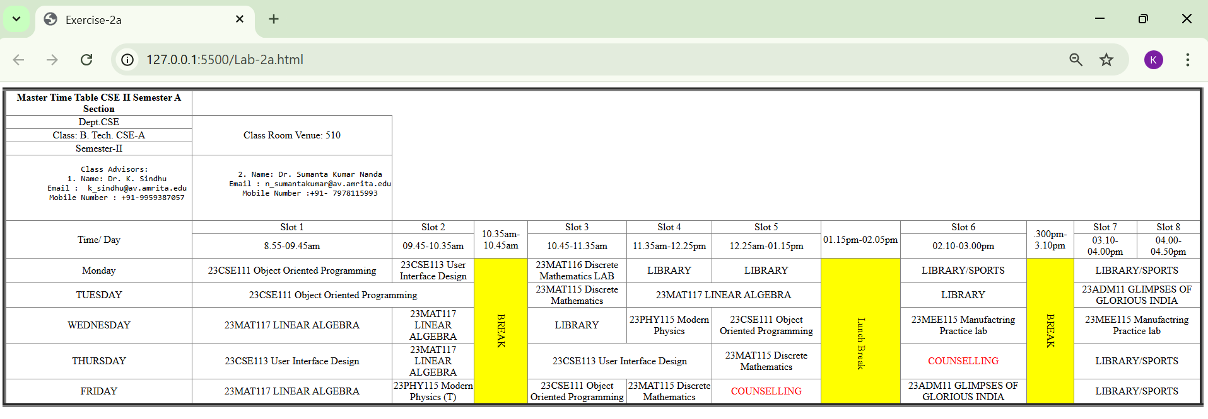
Explanation of the tags:
- <!doctype html>: Tells the browser this is a modern HTML5 document.
- <html>: The root element; the lang="en" attribute specifies the language is English.
- <meta>: Provides "data about data," like setting the character encoding (UTF-8) or making the page look good on mobile screens.
- <table>: The main structure for the timetable; here it uses a border of 6px to make the grid lines thick.
- <tr>: A "Table Row" that groups cells horizontally (like the "Monday" row).
- <th>: A "Table Header" cell. It automatically makes the text bold and centered (used here for the timetable title).
- <td>: A "Table Data" cell. These make up the individual slots for subjects like "Linear Algebra."
- <pre>: Short for "Preformatted text." It displays text exactly as typed—preserving spaces and line breaks (used for the Class Advisor details).
- <p>: A simple paragraph tag, used here to hold the "BREAK" text.
- <span> (implied/related context): While not a tag itself, the code uses attributes like rowspan and colspan inside the <td> tags to make cells stretch across multiple rows or columns.
3B)Aim: To create a comprehensive webpage that includes an academic timetable along with syllabus representation using images and structured HTML elements.
Program:
<html>
<table border="1px"widith="420" style="text-align: center;"cellpading="0"cellpading="0">

<th colspan="12" style= "text-align:center;">Master Time Table AIE II Semester C Section</th>

<tr>
<td colspan="6">ai dept</td>
<td colspan="8" rowspan="3">venue-612</td>

</tr>
<tr>
<td colspan="6">aie-c</td>
</tr>
<tr>
<td colspan="6">sem=2</td>
</tr>
<tr>
<td colspan="6">Class Advisors: <br>
1.Name:Mrs. Kolluru Venkata Anusha <br>
Email : kv_anusha@av.amrita.edu <br>
Mobile Number : +91-9951615749</td>
<td colspan="6">
<br>
2. Name: Dr.Culala Rajasekharaudayar Kesavulu <br>
Email :cr_kesavulu@av.amrita.edu <br>
Mobile Number : +91-9885248868 <br>
</td>
</tr>

<tr>
<td rowspan="2">TIME/DAY</td>
<td>slot1</td>
<td>slot2</td>
<td rowspan="2">10:35 to 10:45</td>
<td>slot3</td>
<td>slot4</td>
<td>slot5</td>
<td rowspan="2">1.15pm-02.05pm</td>
<td>slot6</td>
<td rowspan="2">3.00pm-3.10pm</td>
<td>slot7</td>
<td>slot8</td>
</tr>
<tr>
<td>08.55-09.45am</td>
<td>09.45-10.35am</td>
<td>10.45-11.35am</td>
<td>11.35am-12.25pm</td>
<td>12.25am-01.15pm</td>
<td>02.10-03.00pm</td>
<td>03.10-04.00pm</td>
<td>04.00-04.50pm</td>
</tr>
<tr>
<td>Monday </td>
<td>22AIE114 Introduction to
Electrical and Electronics
Engineering </td>
<td>22AIE111 Object Oriented
Programming in Java</td>
<td style="background-color: rgba(255, 247, 12, 0.833);" rowspan="5"><p style="transform: rotate(90deg)">short breaks</p> </td>
<td colspan="3">2AIE112 Data
Structures &
algorithm 1_Lab </td>
<td style="background-color: rgb(232, 248, 10);" rowspan="5"><p style="transform: rotate(90deg)">lunch</p></td>
<td>22AIE113Elements of
Computing Systems - 2 </td>
<td style="background-color: rgb(255, 243, 10);" rowspan="5">
<p style="transform: rotate(90deg)">BREAK</p></td>
<td>COUNSELLING </td>
<td> SPORTS</td>

</tr>
<tr>

<td> Tuesday</td>
<td>22AIE115 User Interface
Design </td>
<td>22ADM111 Glimpses of
Glorious India </td>
<td>22AIE111 Object
Oriented
Programming in Java </td>
<td>22AIE114
Introduction to
Electrical and
Electronics
Engineering </td>
<td>22MAT122
Mathematics for
Computing 2(T) </td>
<td>22AIE111Object
Oriented
Programming in
Java-LAB BYOD</td>
</td>
<td colspan="2">22AIE111 Object Oriented Programming in
Java-LAB_3 </td>

</tr>
<tr>
<td>Wednesday</td>
<td>22ADM111 Glimpses of
Glorious India </td>
<td> 22AIE111Object Oriented
Programming in Java(T)</td>
<td colspan="3">22AIE113Elements of Computing Systems - 2 - Lab</td>
<td>
22AIE115 UserInterface Design_lab</td>
<td colspan="2">
22AIE115 UserInterface Design_lab</td>
</tr>
<tr>
<td>Thursday </td>
<td>22MAT122 Mathematics forComputing 2</td>
<td> 22AIE115_User InterfaceDesign</td>
<td colspan="2"> 22AIE114 Introduction to Electrical and
Electronics Engineering Lab B1</td>
<td> 22AIE112_DataStructures &Algorithms 1</td>
<td>22MAT122Mathematics forComputing 2_lab</td>
<td colspan="2">22MAT122Mathematics forComputing 2_lab</td>
</tr>
<tr>

<td> Friday</td>
<td>22AIE113 Elements ofComputing Systems - 2</td>
<td>22MAT122 Mathematicsfor Computing 2</td>
<td colspan="2">22AIE112_DataStructures &Algorithms 1</td>
<td>COUNSELLING</td>
<td>22AIE114Introduction toElectrical andElectronicsEngineering LabB2</td>
<td>22AIE114Introduction toElectrical andElectronicsEngineering Lab B2
<td>Library </td>
</tr>
<hr></hr>
<h2>CSE-A Details</h2>
<h4>Syllabus and Curriculum</h4>
<img
src="screenshot-2.jpeg"
alt="CSE Curriculum"
width="600"
height="400"
/>
<h4>Discrete Mathematics Syllabus</h4>
<img src="screenshot-1.jpeg" alt="dm syllabus" />
<h4>Object Oriented Programming Syllabus</h4>
<img src="screenshot-3.jpeg" alt="Linear Algebra Syllabus" />
<h4>Modern Physics</h4>
<img src="screenshot-4.jpeg" alt="OOPS Syllabus" />
<h4>User Interface Design</h4>
<img src="screenshot-5.jpeg" alt="Modern Physics Syllabus" />
<h4>Manufacturing Practice Syllabus</h4>
<img src="screenshot-6.jpeg" alt="uid syllabus" />
<h4>Glimpses of glorious India Syllabus</h4>
<img src="screenshot-7.jpeg" alt="manufacturinng syllabus" />
<h4>Linear Algebra Syallabus</h4>
<img src="screenshot-8.jpeg" alt="Glimpses syllabus" />
</html>

Output: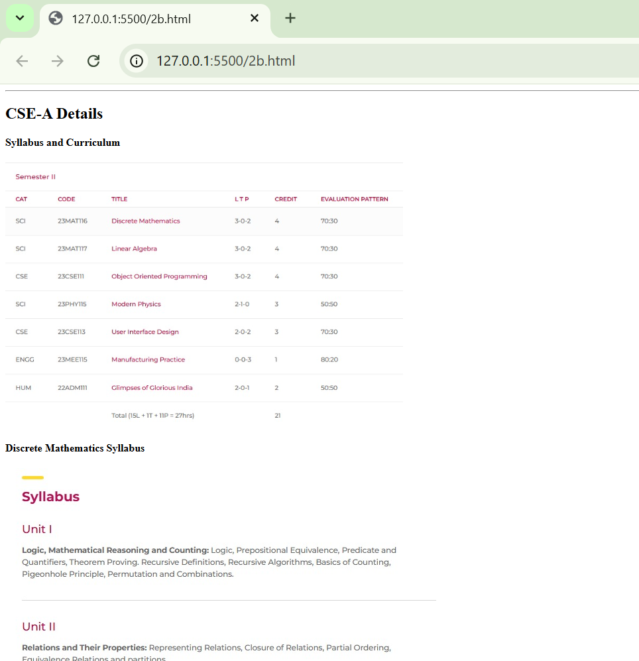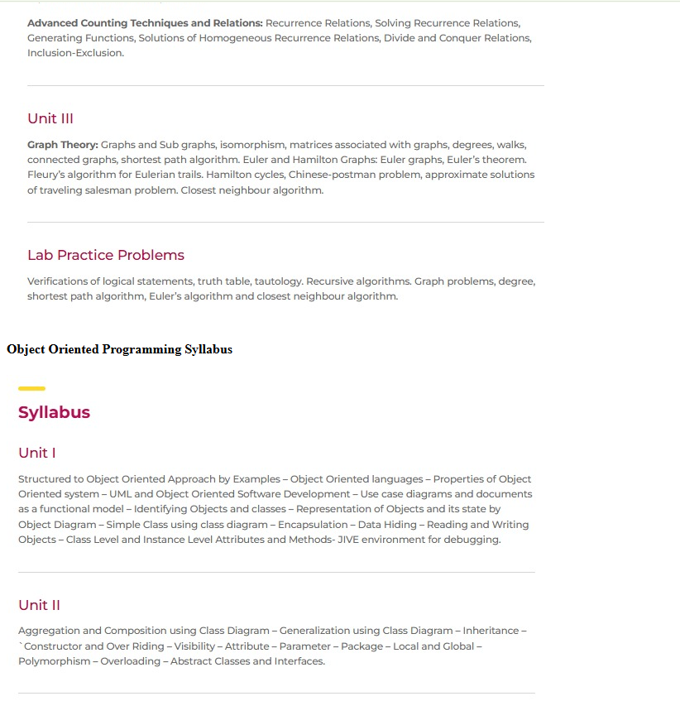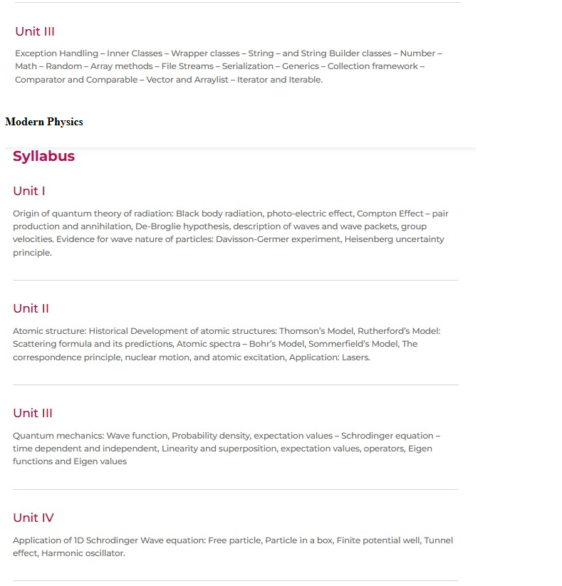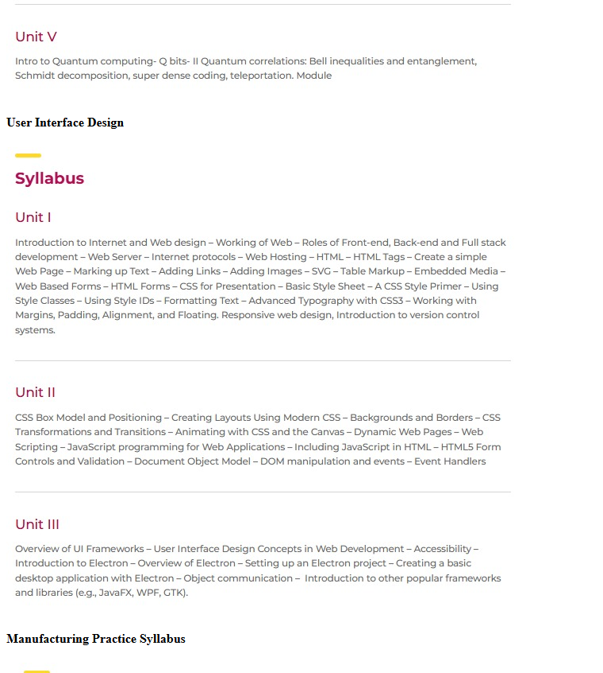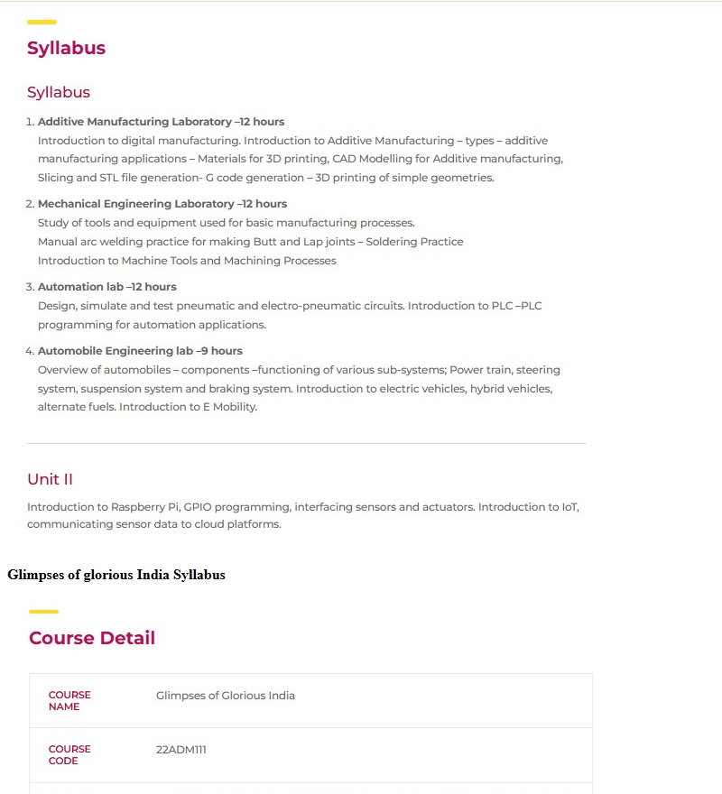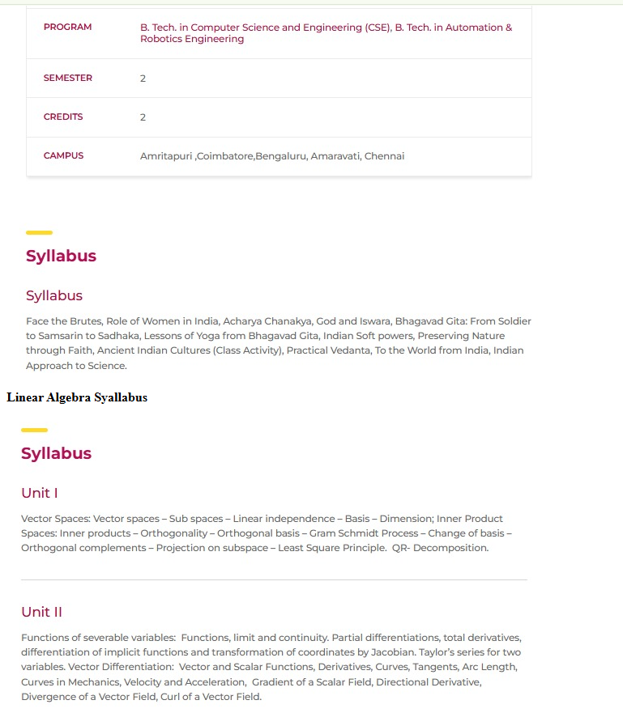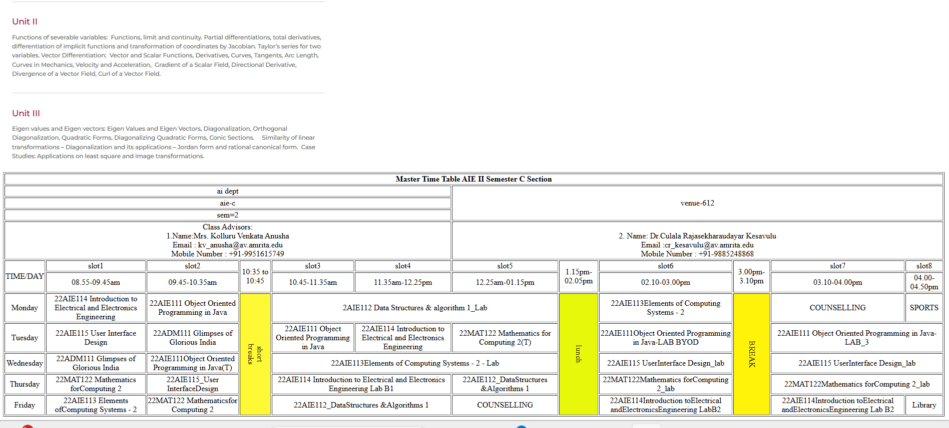
Explanation:
This program is an HTML webpage that shows the 2nd semester syllabus and CSE-B timetable in one page. It starts with the basic HTML structure and sets the page title. CSS is used to add borders and collapse lines for all tables so they look neat. The page background color is set to orange, and a centered heading “SYLLABUS” is displayed at the top.
Next, the program lists each subject name using <h2> headings and shows the syllabus images using <img> tags. The images are loaded from a folder named SY_IMG and displayed with a fixed width, so each subject’s syllabus appears visually on the page.
After the syllabus section, the program creates a large timetable using an HTML table. It uses rows and columns to show class details, advisors, time slots, subjects, labs, breaks, and faculty information. Features like colspan and rowspan are used to merge cells for breaks and lab hours, and some cells are colored to highlight breaks and counselling. Overall, the program combines images and tables to present both syllabus content and the weekly timetable in a structured format

WEEK-04

4A)Aim: To understand the concept of forms and design a structured student registration form using HTML tables, including various input types such as text fields, radio buttons, checkboxes, file upload, and dropdown lists.
Program:
<!DOCTYPE html>
<html>
<head>
<title>Q3a</title>
</head>
<body>
<form>
<table border="3px" align="center" style="background-color: cornsilk;">

<tr>
<td><label for="fullname">Full Name:</label></td>
<td><input type="text" id="fullname" placeholder="Enter your Full name"></td>
</tr>

<tr>
<td><label for="email">Email:</label></td>
<td><input type="email" id="email" placeholder="Enter your e-mail"></td>
</tr>

<tr>
<td><label for="phone">Phone Number:</label></td>
<td><input type="text" id="phone" placeholder="Enter your phone number"></td>
</tr>

<tr>
<td>Gender:</td>
<td>
<input type="radio" name="gender" id="male">
<label for="male">Male</label>

<input type="radio" name="gender" id="female">
<label for="female">Female</label>
</td>
</tr>

<tr>
<td><label for="course">Course applying for:</label></td>
<td>
<select id="course">
<option>B.Tech</option>
<option>M.Tech</option>
<option>MBA</option>
<option>M.Sc</option>
</select>
</td>
</tr>

<tr>
<td>Hobbies:</td>
<td>
<input type="checkbox" id="sports">
<label for="sports">Sports</label>

<input type="checkbox" id="music">
<label for="music">Music</label>

<input type="checkbox" id="reading">
<label for="reading">Reading</label>
</td>
</tr>

<tr>
<td><label for="dob">Date of Birth:</label></td>
<td><input type="date" id="dob"></td>
</tr>

<tr>
<td><label for="certificates">Upload your Certificates:</label></td>
<td><input type="file" id="certificates"></td>
</tr>

<tr>
<td><label for="address">Address:</label></td>
<td>
<textarea id="address" rows="3" cols="25" placeholder="Enter your Address"></textarea>
</td>
</tr>

<tr>
<td colspan="2" align="center">
<button type="submit">Submit</button>
<button type="reset">Reset</button>
</td>
</tr>

</table>
</form>

</body>
</html>

Output: 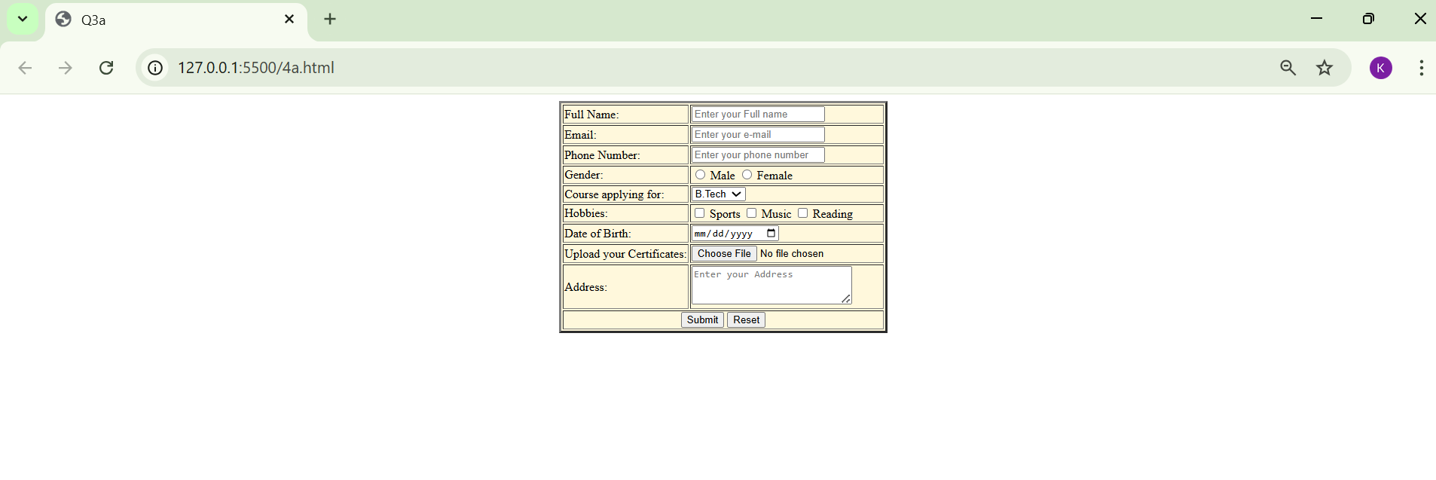
Tags/Attributes used:
- <form> – Used to create an HTML form for user input.
- <label> – Defines a label for an input field. It improves accessibility and user understanding.
- <input> – Used to create input fields. It can take different types like:
- <select> – Creates a drop-down list.
- <option> – Defines options inside the drop-down list.
- id attribute – Uniquely identifies an element.
- name attribute – Used to send form data to the server.
- size attribute – Specifies how many options are visible in a select box.
- <textarea> – Used for multi-line text input like address.
- <button> – Creates clickable buttons like Submit and Reset.
- <iframe> – Used to display another webpage inside the current webpage.
4B)Aim: To understand the concept of forms and design user login and registration webpages using HTML, and to display them within a single interface using iframe for better layout and user interaction.

Program : <!DOCTYPE html>
<html>
<head>
<title>Login</title>
</head>

<body style="background-color: lightblue;">

<h1 style="text-align:center">User Login</h1>

<form>
<table border="3" align="center" cellpadding="10">

<tr>
<td>
<label for="username">Username:</label>
</td>
<td>
<input type="text" id="username">
</td>
</tr>

<tr>
<td>
<label for="password">Password:</label>
</td>
<td>
<input type="password" id="password">
</td>
</tr>

<tr>
<td colspan="2" align="center">
<button type="submit">Login</button>
</td>
</tr>

</table>
</form>

</body>
</html>

Output: 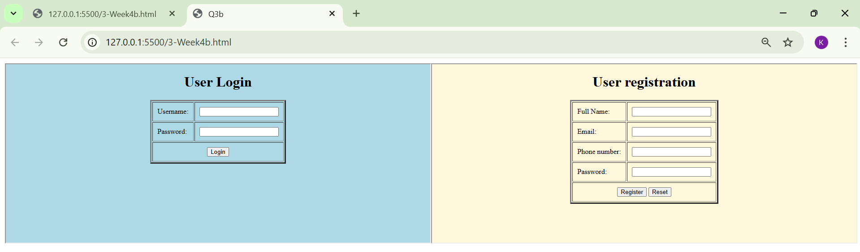
Tags/Attributes used:
- <form> – Used to create an HTML form for user input.
- <label> – Defines a label for an input field. It improves accessibility and user understanding.
- <input> – Used to create input fields. It can take different types like:
- <select> – Creates a drop-down list.
- <option> – Defines options inside the drop-down list.
- id attribute – Uniquely identifies an element.
- name attribute – Used to send form data to the server.
- size attribute – Specifies how many options are visible in a select box.
- <textarea> – Used for multi-line text input like address.
- <button> – Creates clickable buttons like Submit and Reset.
- <iframe> – Used to display another webpage inside the current webpage

WEEK-5

5A)AIM: To create a responsive card layout using HTML and CSS with three cards, each containing an image, title, and button.
PROGRAM:
<!DOCTYPE html>
<html>
<head>
<title>Courses Cards</title>

<style>
body{
font-family: Arial;
background:#08d1f0;
text-align:center;
margin:0;
}

h1{
background:#e8e8e3;
color:rgb(145, 75, 75);
padding:20px;
margin:0;
}

.container{
display:flex;
flex-wrap:wrap;
justify-content:center;
gap:25px;
padding:40px;
}

.card{
background:white;
color:black;
width:390px;
padding:20px;
border-radius:12px;
box-shadow:0 5px 15px rgb(252, 233, 233);
}

.hero-img{
width:350px;
height: 280px;
object-fit:cover;
border-radius:8px;
}

.card-title{
font-size:20px;
font-weight:bold;
margin-top:10px;
}

.card-text{
margin:10px 0;
}

.card-btn{
display:inline-block;
padding:8px 16px;
background:#1cb4b9;
color:white;
text-decoration:none;
border-radius:6px;
}

.card-btn:hover{
background:black;
}
</style>
</head>

<body>

<h1>Our Courses</h1>

<div class="container">

<!-- Card 1 -->
<div class="card">
<img src="batsmen.jpg" alt="Batsmem" class="hero-img">
<div class="card-title">Batsmem</div>
<div class="card-text">Right/left Batting</div>
<a href="#" class="card-btn">Select</a>
</div>

<!-- Card 2 -->
<div class="card">
<img src="bowling.jpg" alt="Bowling" class="hero-img">
<div class="card-title">Bowling</div>
<div class="card-text">Right/left Bowling</div>
<a href="#" class="card-btn">Select</a>
</div>

<!-- Card 3 -->
<div class="card">
<img src="images.jpg" alt="All-Rounder" class="hero-img">
<div class="card-title">All-Rounder</div>
<div class="card-text">Type of bowling and batting</div>
<a href="#" class="card-btn">Select</a>
</div>

</div>

</body>
</html>

Output: 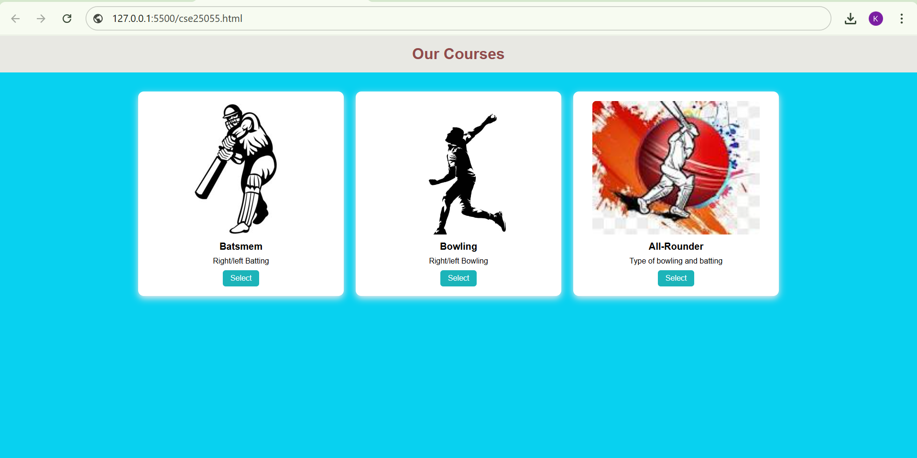
Explanation of the tags/attributes:
- <!DOCTYPE html>: The document type declaration. It tells the web browser that this is an HTML5 document so it renders correctly.
- <html>: The root element. It acts as the main container for all other HTML elements on the page.
- <head>: The metadata container. it holds information about the page that isn't displayed directly to the user, like styles and the title.
- <style>: The internal CSS tag. It is used to define the visual rules (colors, fonts, layouts) for the HTML elements in one place.
- <title>: The document title. This defines the text that appears on the browser tab (e.g., "Courses Cards").
- <body>: The content container. It contains all the visible parts of the web page, such as headings, images, and buttons.
- <h1>: The level 1 heading. It is used for the most important title on the page, appearing large and bold by default.
- <div>: The division or section tag. It is a generic container used to group elements together (like the "card" or "container") for styling purposes.
- <img>: The image tag. It is used to embed pictures into the page. The src attribute tells the browser where to find the image file.
- <a>: The anchor (link) tag. It creates a hyperlink to another page or section. In this code, it is styled to look like a "Select" button.
5B)AIM: To design a mini website using iframe with navigation links (Home, About, Contact), where clicking on each link displays the respective content within the same page using internal or external CSS.
<!DOCTYPE html>
<html>
<head>
<title>Mini Website</title>
<style>
body {
margin: 0;
font-family: Arial, sans-serif;
background-color: whitesmoke;
}

header {
background-color: midnightblue;
color: white;
padding: 20px;
text-align: center;
font-size: 26px;
letter-spacing: 2px;
}

nav {
background-color: steelblue;
padding: 12px;
text-align: center;
}

nav a {
color: white;
text-decoration: none;
margin: 20px;
font-size: 18px;
font-weight: bold;
}

nav a:hover {
color: coral;
}

.frame-container {
text-align: center;
margin-top: 20px;
}

iframe {
width: 85%;
height: 400px;
border-radius: 12px;
border: 4px solid seagreen;
background-color: white;
}
</style>
</head>
<body>

<header>Mini Website</header>

<nav>
<a href="home.html" target="content">Home</a>
<a href="about.html" target="content">About</a>
<a href="contact.html" target="content">Contact</a>
</nav>

<div class="frame-container">
<iframe name="content" src="home.html"></iframe>
</div>

</body>
</html>

<!DOCTYPE html>
<html>
<body style="font-family: Arial; text-align:center; padding:40px; background-color: lavender;">

<h2 style="color: steelblue;">Welcome to Home Page</h2>
<p>This is the home section of our mini website.</p>
<p>Content loads inside the same page using iframe.</p>

</body>
</html>

<!DOCTYPE html>
<html>
<body style="font-family: Arial; text-align:center; padding:40px; background-color: mistyrose;">

<h2 style="color: coral;">About Us</h2>
<p>This mini website is created using HTML iframe.</p>
<p>Navigation links display content without reloading the main page.</p>

</body>
</html>
<!DOCTYPE html>
<html>
<body style="font-family: Arial; text-align:center; padding:40px; background-color: honeydew;">

<h2 style="color: seagreen;">Contact Us</h2>
<p>Email: example@gmail.com</p>
<p><Phone:7396766611></p>

</body>
</html>
Output: 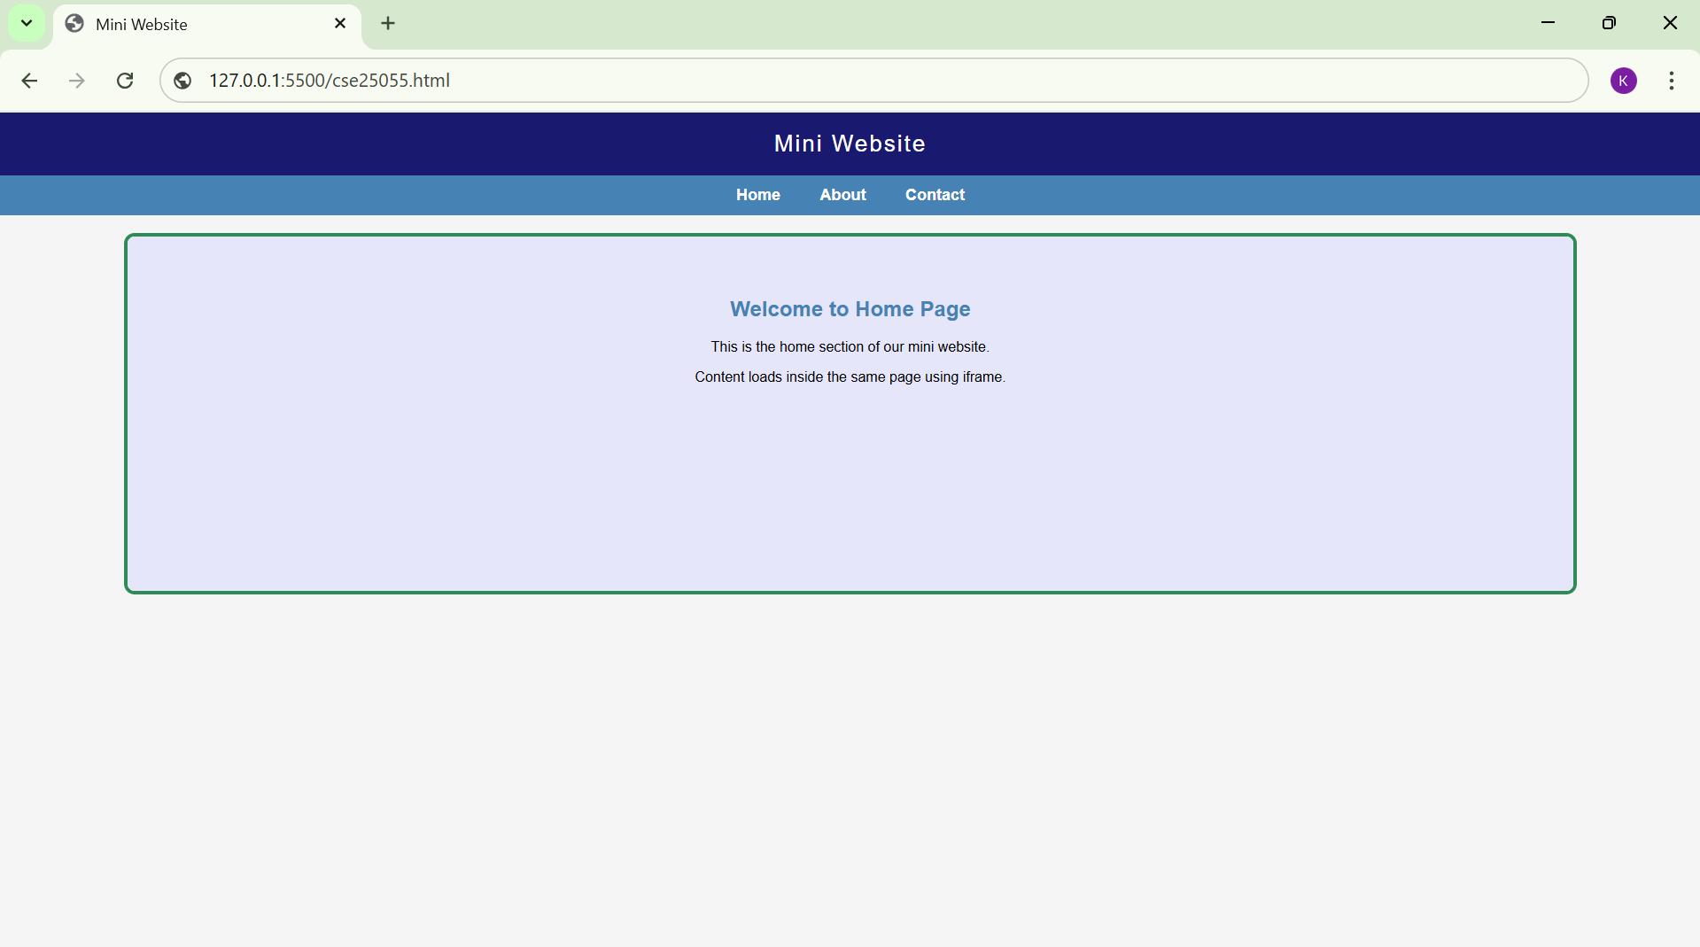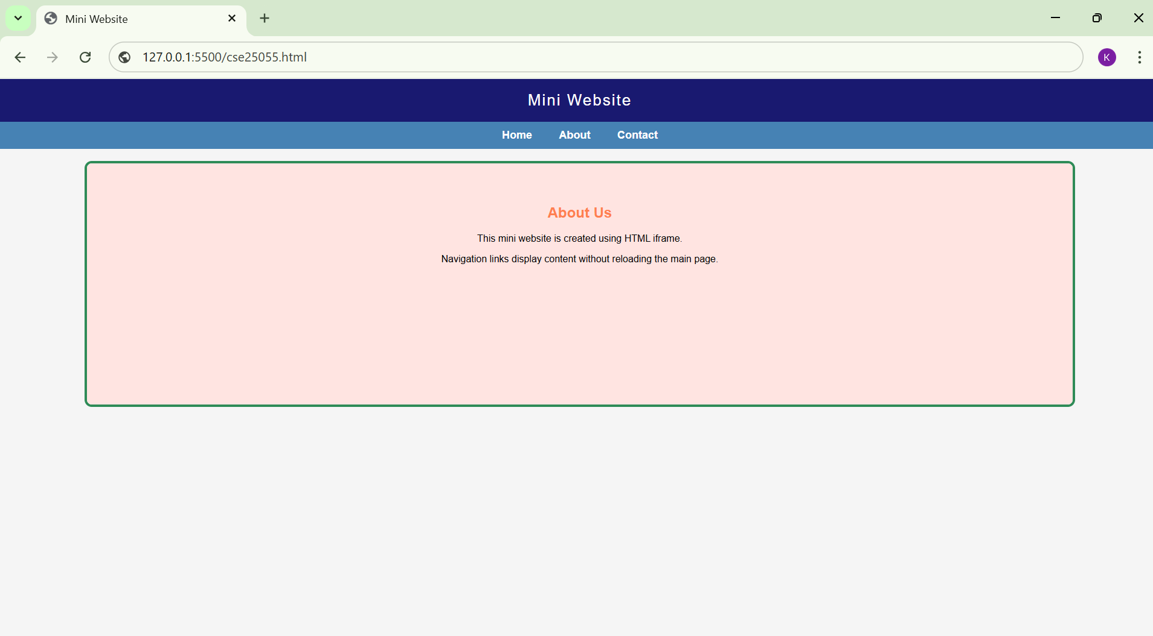
Explanation of the tags/attributes:
- <!DOCTYPE html>: The document type declaration. It tells the web browser that this is an HTML5 document so it renders correctly.
- <html>: The root element. It acts as the main container for all other HTML elements on the page.
- <head>: The metadata container. it holds information about the page that isn't displayed directly to the user, like styles and the title.
- <style>: The internal CSS tag. It is used to define the visual rules (colors, fonts, layouts) for the HTML elements in one place.
- <title>: The document title. This defines the text that appears on the browser tab (e.g., "Courses Cards").
- <body>: The content container. It contains all the visible parts of the web page, such as headings, images, and buttons.
- <h1>: The level 1 heading. It is used for the most important title on the page, appearing large and bold by default.
- <div>: The division or section tag. It is a generic container used to group elements together (like the "card" or "container") for styling purposes.
- <img>: The image tag. It is used to embed pictures into the page. The src attribute tells the browser where to find the image file.
- <a>: The anchor (link) tag. It creates a hyperlink to another page or section. In this code, it is styled to look like a "Select" button.
5C)AIM: Design an amrita login page showing different campuses on the homepage. On clicking each campus, display campus details on the same page using HTML and CSS to design stylish webpage.
Program:
<!DOCTYPE html>
<html>
<head>
<title>Amrita Vishwa Vidyapeetham</title>

<style>

body{
margin:0;
font-family:Arial, sans-serif;
background:linear-gradient(to right,#003366,#006699);
}

.container{
width:90%;
margin:30px auto;
padding:25px;
background:#f5f5f5;
border-radius:12px;
box-shadow:0px 0px 12px black;
}

h1{
text-align:center;
color:#003366;
}

.campus-links{
text-align:center;
margin-bottom:25px;
}

.campus-links a{
text-decoration:none;
margin:0 12px;
font-weight:bold;
color:#0059b3;
}

.campus-links a:hover{
color:#ff6600;
}

.main{
display:flex;
gap:25px;
}

.login{
width:35%;
padding:20px;
background:#e8f0f7;
border-radius:10px;
}

.login input,.login select{
width:90%;
padding:10px;
margin:10px 0;
border-radius:5px;
border:1px solid #444;
}

.login button{
width:90%;
padding:10px;
border:none;
border-radius:5px;
background:#003366;
color:white;
cursor:pointer;
}

.about{
width:65%;
padding:20px;
background:#e0e0e0;
border-radius:10px;
}

.campus-content{
display:none;
}

.campus-content:target{
display:block;
}

.campus-content img{
width:70%;
height:250px;
object-fit:cover;
border-radius:10px;
margin-bottom:15px;
}

</style>
</head>

<body>

<div class="container">

<h1>AMRITA VISHWA VIDYAPEETHAM</h1>

<div class="campus-links">
<a href="#bangalore">Bangalore</a>
<a href="#coimbatore">Coimbatore</a>
<a href="#amaravati">Amaravati</a>
<a href="#mysore">Mysore</a>
<a href="#chennai">Chennai</a>
<a href="#kochi">Kochi</a>
<a href="#faridabad">Faridabad</a>
<a href="#amritapuri">Amritapuri</a>
<a href="#haridwar">Haridwar</a>
<a href="#nagaracoil">Nagaracoil</a>
</div>

<div class="main">

<div class="login">

<h3>Student Login</h3>

<!-- changed order -->

<input type="email" placeholder="Enter Email" required>

<input type="text" placeholder="Username">

<input type="tel" placeholder="Enter Phone Number" required>

<select required>
<option value="">Select Course</option>
<option>B.Tech</option>
<option>M.Tech</option>
<option>BCA</option>
<option>MCA</option>
<option>BBA</option>
<option>MBA</option>
</select>

<input type="password" placeholder="Password">

<button>Submit</button>

</div>

<div class="about">

<h3>Campus Information</h3>

<div id="bangalore" class="campus-content">
<img src="bgl.jpeg" alt="Bangalore Campus">
<h4>Bangalore Campus</h4>
<p>This campus is located near the major technology hub of India and provides modern engineering and computing programs.</p>
</div>

<div id="coimbatore" class="campus-content">
<img src="cmb.jpeg" alt="Coimbatore Campus">
<h4>Coimbatore Campus</h4>
<p>The administrative headquarters with large infrastructure, laboratories, libraries and business schools.</p>
</div>

<div id="amaravati" class="campus-content">
<img src="am.jpg" alt="Amaravati Campus">
<h4>Amaravati Campus</h4>
<p>A growing campus with modern classrooms and facilities for engineering and technology education.</p>
</div>

<div id="mysore" class="campus-content">
<img src="msy.jpg" alt="Mysore Campus">
<h4>Mysore Campus</h4>
<p>This campus mainly focuses on computer science, data science and advanced technology courses.</p>
</div>

<div id="chennai" class="campus-content">
<img src="chn.jpg" alt="Chennai Campus">
<h4>Chennai Campus</h4>
<p>The Chennai campus provides quality engineering education with strong industrial collaboration.</p>
</div>

<div id="kochi" class="campus-content">
<img src="koc.jpg" alt="Kochi Campus">
<h4>Kochi Campus</h4>
<p>Known for its lively campus environment and programs in engineering and management.</p>
</div>

<div id="faridabad" class="campus-content">
<img src="fb.jpg" alt="Faridabad Campus">
<h4>Faridabad Campus</h4>
<p>This campus in Haryana offers engineering and management education with modern facilities.</p>
</div>

<div id="amritapuri" class="campus-content">
<img src="ar.jpg" alt="Amritapuri Campus">
<h4>Amritapuri Campus</h4>
<p>Located in Kerala near the coast and famous for research in engineering and biotechnology.</p>
</div>

<div id="haridwar" class="campus-content">
<img src="hr.jpg" alt="Haridwar Campus">
<h4>Haridwar Campus</h4>
<p>The campus focuses on technical education along with value based learning.</p>
</div>

<div id="nagaracoil" class="campus-content">
<img src="nc.jpg" alt="Nagaracoil Campus">
<h4>Nagaracoil Campus</h4>
<p>A peaceful academic campus offering various undergraduate and postgraduate programs.</p>
</div>

</div>

</div>

</div>

</body>
</html>

Output: 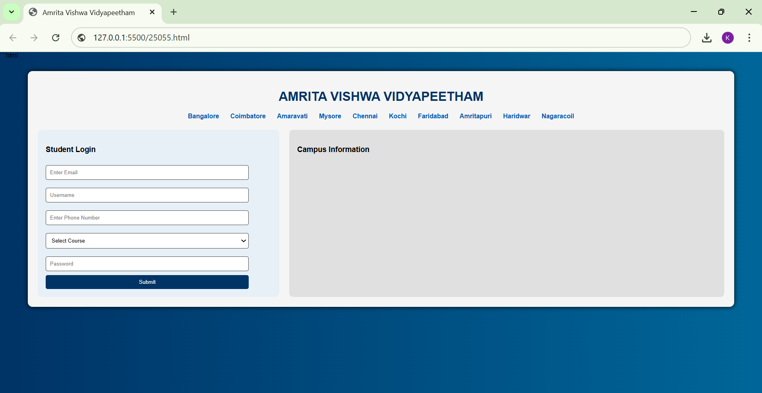 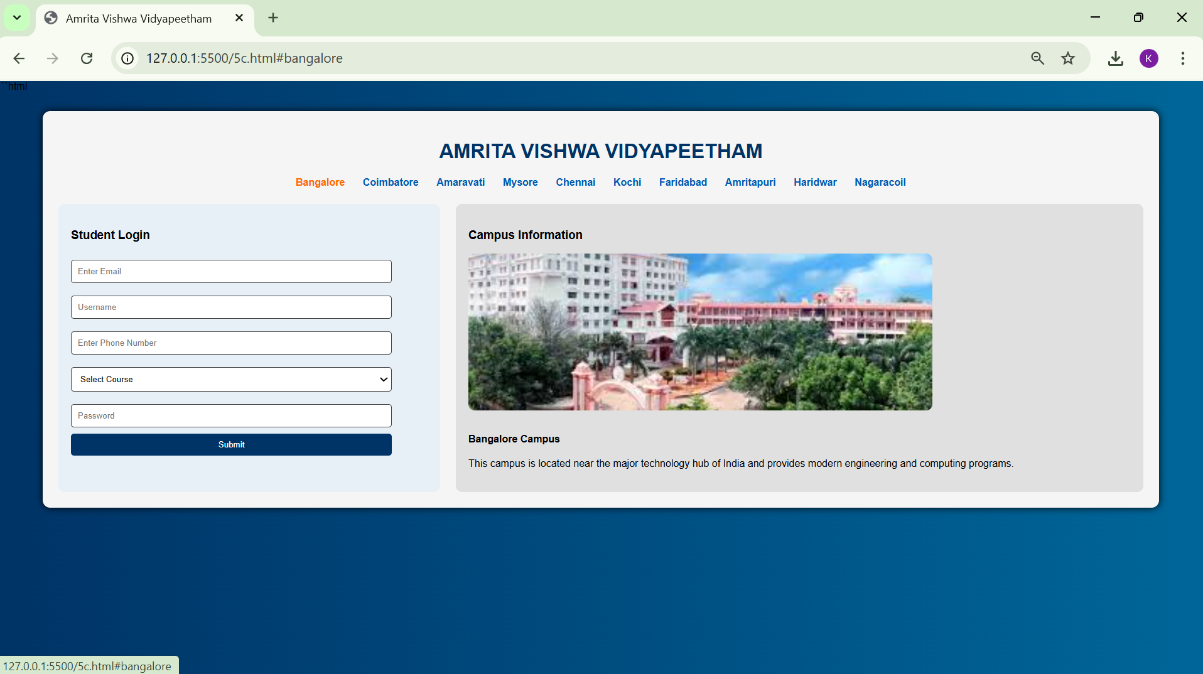 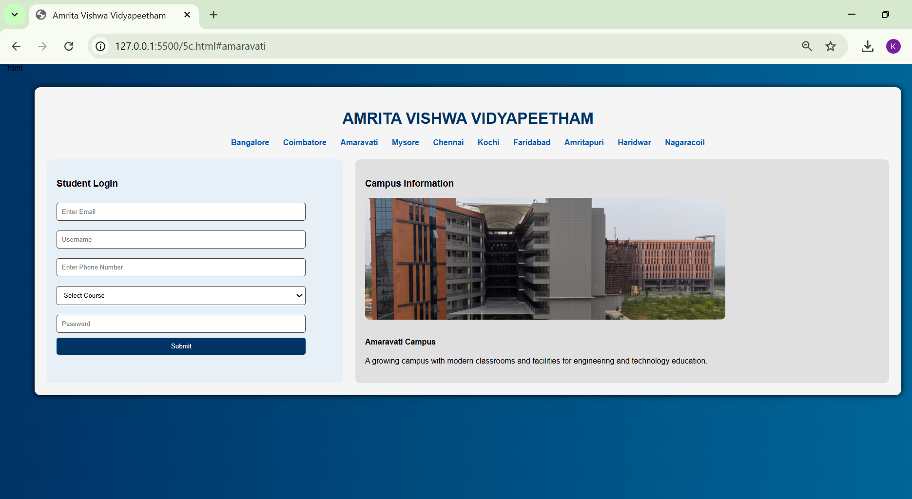 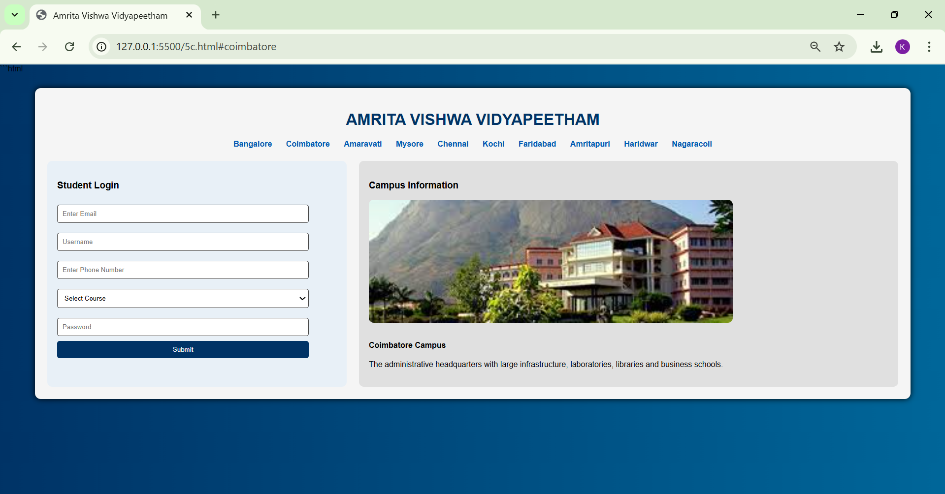 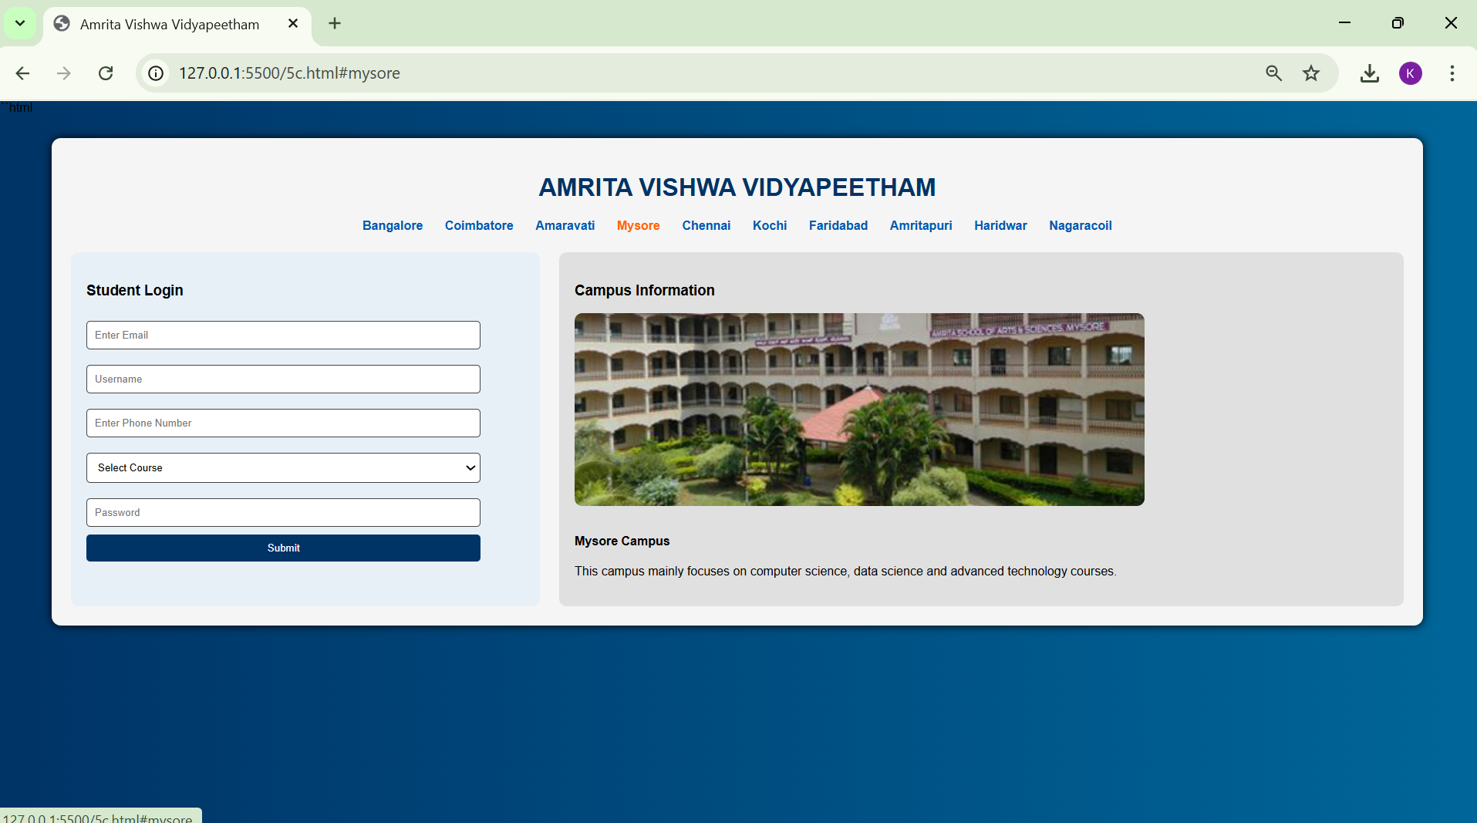 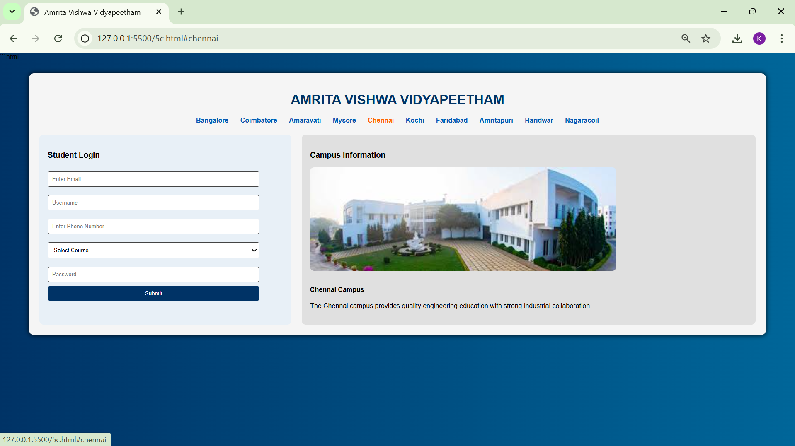 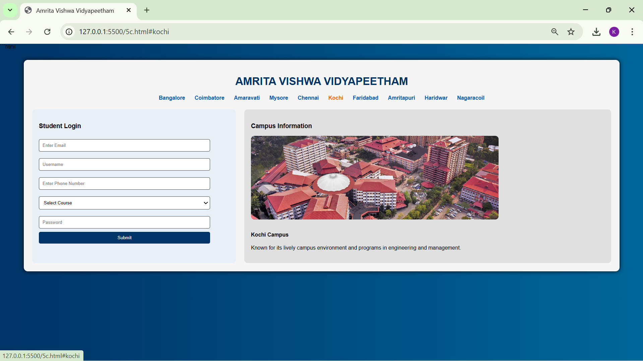 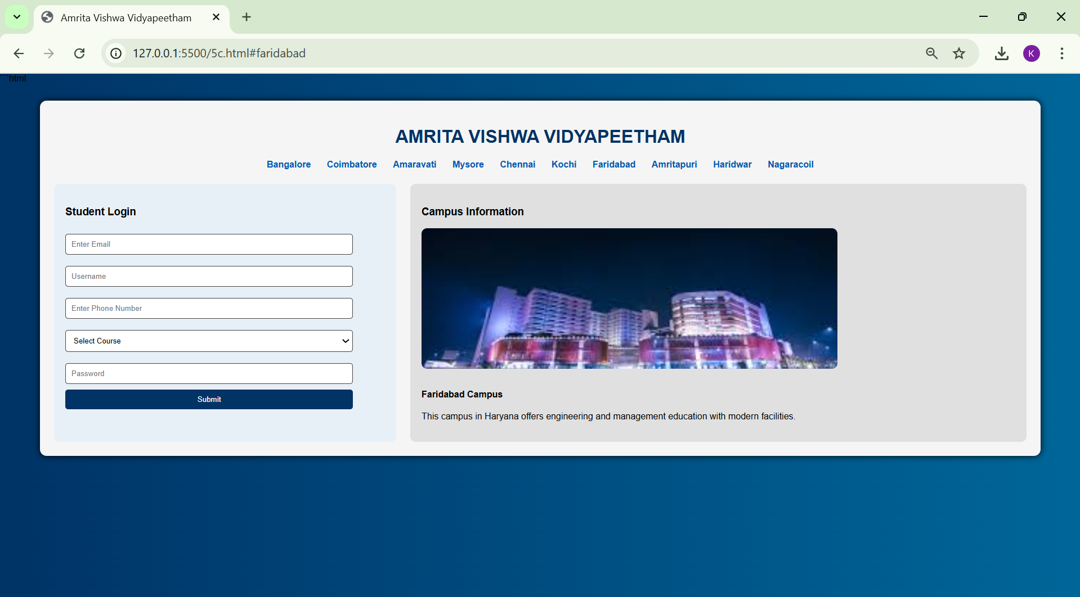 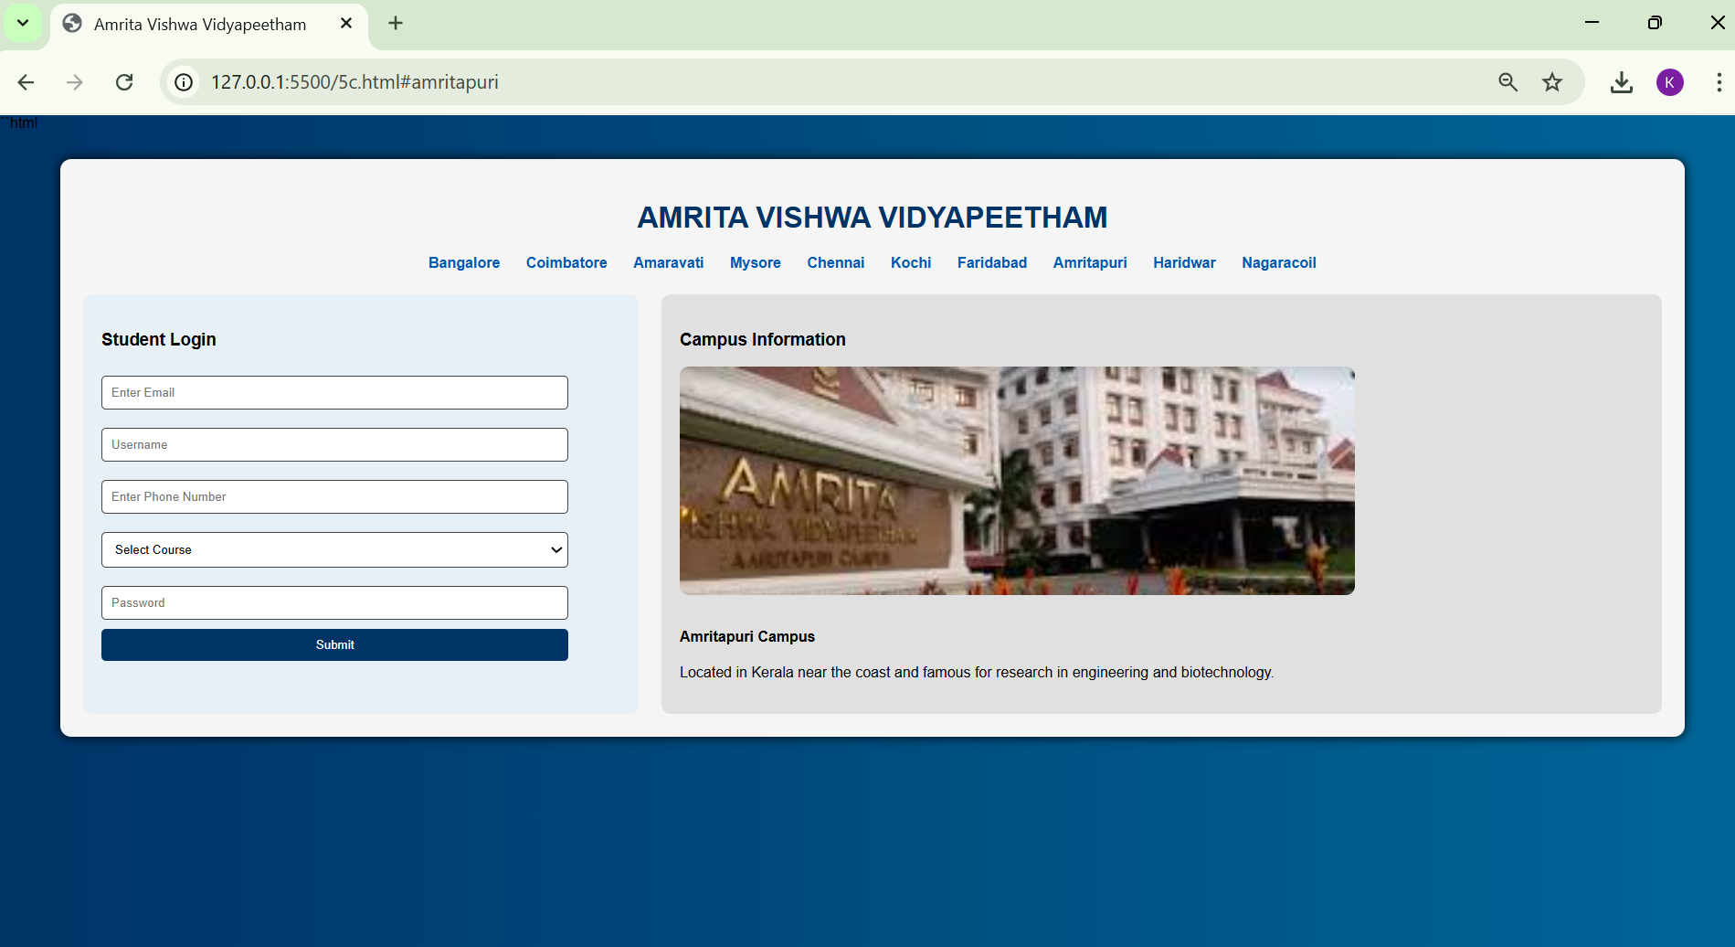 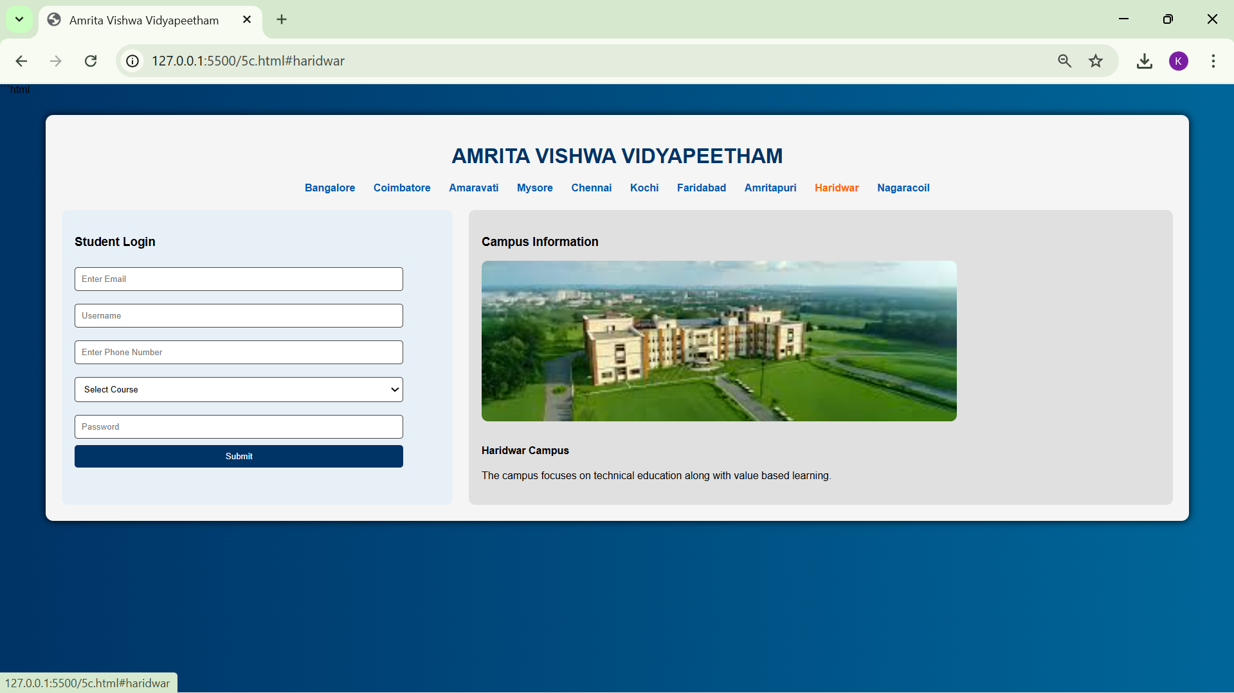 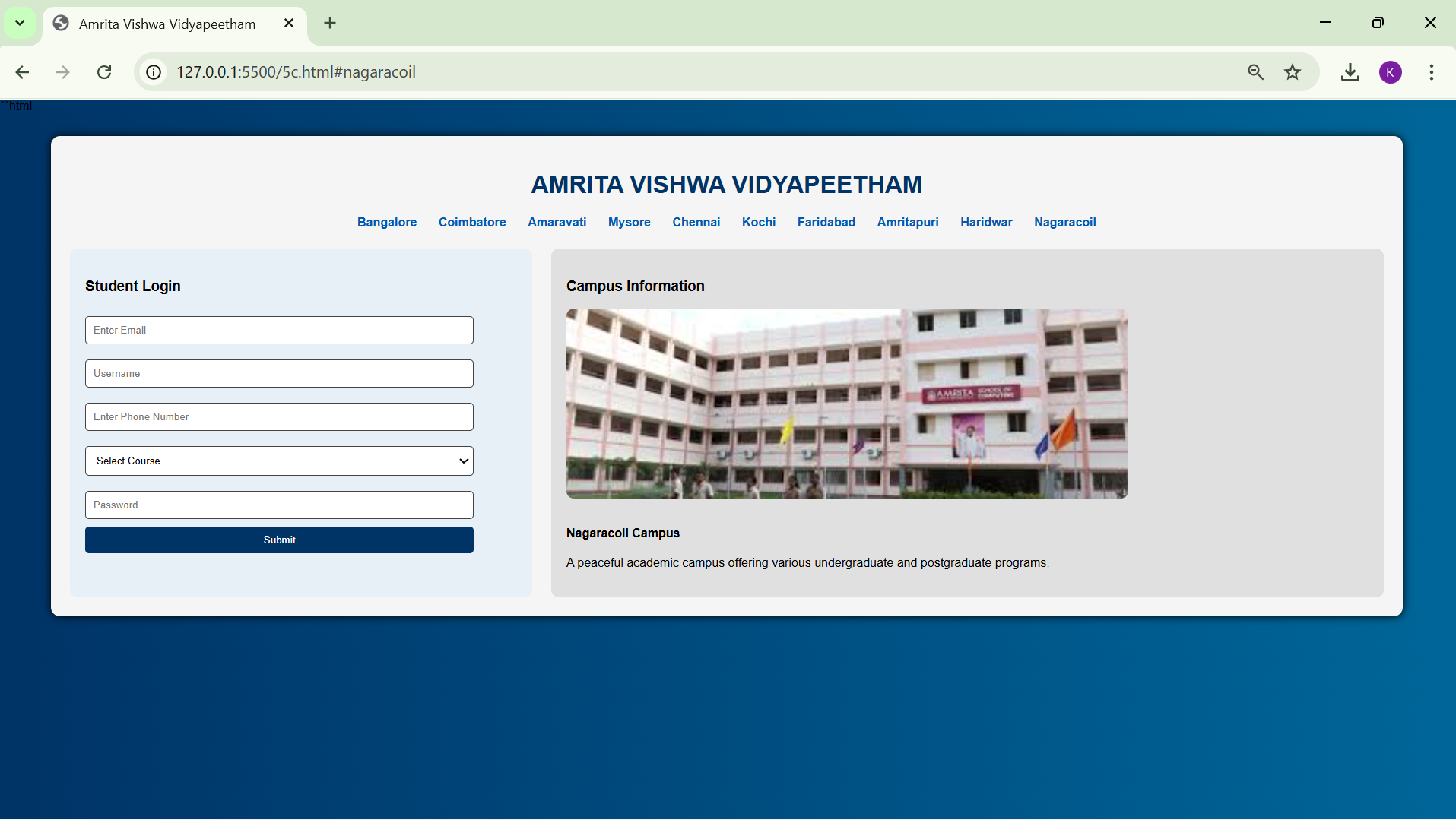
Explanation of the tags/attributes:
- <!DOCTYPE html>: The Document Type Declaration. It ensures the browser uses the latest HTML5 standards for layout and styling.
- <style>: The Internal CSS Container. It holds all the design rules, such as the blue linear-gradient background and flexbox layouts.
- <div>: The Division tag. It acts as a structural container; here, it groups the "login" and "about" sections into a multi-column layout.
- <h1 - h4>: Heading tags. These define the information hierarchy, from the main university title (<h1>) down to specific campus names (<h4>).
- <a>: The Anchor tag. It is used here for internal navigation; clicking a link jumps to a specific campus description using its id.
- <input>: The Data Input tag. It creates interactive fields for the student login, such as type="email" for email validation and type="password" for masked text.
- <select>: The Dropdown Menu tag. It creates a selectable list of courses (B.Tech, MBA, etc.) for the user to choose from.
- <option>: The List Item tag. It defines the individual choices available within the <select> dropdown menu.
- <button>: The Action tag. It provides a clickable element to submit the login form data to the server.
- <img>: The Image Embed tag. It displays campus photos. The alt attribute provides a text description if the image fails to load.

WEEK-06
6.Aim)Design a responcive E-Commers web application using grid layout . this application should contain different categories of products such as electronics , clothing , homeappliances , books .based on that categorie are selected corresponding products should be displayed on the side bar
<title>Minimal Store</title>

<style>

body{
margin:0;
font-family: "Segoe UI", Arial;
background:#f5f7fa;
}

/* HEADER */

.header{ Program: <!doctype html>
<html>
<head>

display:flex;
justify-content:space-between;
align-items:center;
background:#1f2937;
color:white;
padding:15px 30px;
font-size:22px;
}

.search-box input{
padding:8px 12px;
border:none;
border-radius:20px;
outline:none;
}

/* MAIN LAYOUT */

.container{
display:flex;
min-height:85vh;
}

/* SIDEBAR */

.sidebar{
width:220px;
background:white;
padding-top:20px;
box-shadow:2px 0 8px rgba(0,0,0,0.08);
}

.sidebar a{
display:block;
padding:14px 20px;
text-decoration:none;
color:#374151;
font-weight:500;
transition:0.3s;
}

.sidebar a:hover{
background:#6366f1;
color:white;
padding-left:28px;
}

/* CONTENT AREA */

.content{
flex:1;
padding:20px;
}

iframe{
width:100%;
height:600px;
border:none;
border-radius:8px;
box-shadow:0 4px 10px rgba(0,0,0,0.08);
}

/* FOOTER */

.footer{
background:#111827;
color:#9ca3af;
text-align:center;
padding:14px;
font-size:14px;
}

</style>
</head>

<body>

<div class="header">
Minimal E-Commerce Store

<div class="search-box">
<input type="text" placeholder="Search products...">
</div>
</div>

<div class="container">

<div class="sidebar">
<a href="Q6aElectronics.html" target="frame">📱 Electronics</a>
<a href="Q6aClothing.html" target="frame">👕 Clothing</a>
<a href="Q6aHome.html" target="frame">🏠 Home Appliances</a>
<a href="Q6aBooks.html" target="frame">📚 Books</a>
</div>

<div class="content">
<iframe name="frame" src="Q6aElectronics.html"></iframe>
</div>

</div>

<div class="footer">
© 2026 Minimal Store • Web Technology Lab Project
</div>

</body>
</html>

Books: <!doctype html>
<html>
<head>
<style>
body {
font-family: Arial;
background: lightgray;
margin: 0;
}

.products {
display: grid;
grid-template-columns: 1fr 1fr;
gap: 20px;
padding: 20px;
}

.card {
background: white;
padding: 15px;
text-align: center;
border-radius: 10px;
box-shadow: 0px 2px 8px gray;
}

.card img {
width: 120px;
height: 120px;
}

.price {
color: green;
font-weight: bold;
}
</style>
</head>

<body>
<div class="products">
<div class="card">
<img src="book.jpg.jpeg" />
<h3>Programming Book</h3>
<p class="price">₹499</p>
</div>

<div class="card">
<img src="science (1).webp" />
<h3>Science Book</h3>
<p class="price">₹399</p>
</div>

<div class="card">
<img src="math.webp" />
<h3>Math Book</h3>
<p class="price">₹349</p>
</div>

<div class="card">
<img src="social.jpg.jpeg" />
<h3>Social Book</h3>
<p class="price">₹599</p>
</div>
</div>
</body>
</html>
Home: <!doctype html>
<html>
<head>
<style>
body {
font-family: Arial;
background: lightgray;
margin: 0;
}

.products {
display: grid;
grid-template-columns: 1fr 1fr;
gap: 20px;
padding: 20px;
}

.card {
background: white;
padding: 15px;
text-align: center;
border-radius: 10px;
box-shadow: 0px 2px 8px gray;
}

.card img {
width: 120px;
height: 120px;
}

.price {
color: green;
font-weight: bold;
}
</style>
</head>

<body>
<div class="products">
<div class="card">
<img src="mixer.webp" />
<h3>Mixer Grinder</h3>
<p class="price">₹2499</p>
</div>

<div class="card">
<img src="iron.jpg.jpeg" />
<h3>Electric Iron</h3>
<p class="price">₹1199</p>
</div>

<div class="card">
<img src="ceilingfan.webp" />
<h3>Ceiling Fan</h3>
<p class="price">₹1899</p>
</div>

<div class="card">
<img src="kettle.webp" />
<h3>Electric Kettle</h3>
<p class="price">₹999</p>
</div>
</div>
</body>
</html>
Electronics: <!doctype html>
<html>
<head>
<style>
body {
font-family: Arial;
background: lightgray;
margin: 0;
}

.products {
display: grid;
grid-template-columns: 1fr 1fr;
gap: 20px;
padding: 20px;
}

.card {
background: white;
padding: 15px;
text-align: center;
border-radius: 10px;
box-shadow: 0px 2px 8px gray;
}

.card img {
width: 120px;
height: 120px;
}

.price {
color: green;
font-weight: bold;
}
</style>
</head>

<body>
<div class="products">
<div class="card">
<img src="mixer.webp" />
<h3>Mixer Grinder</h3>
<p class="price">₹2499</p>
</div>

<div class="card">
<img src="iron.jpg.jpeg" />
<h3>Electric Iron</h3>
<p class="price">₹1199</p>
</div>

<div class="card">
<img src="ceilingfan.webp" />
<h3>Ceiling Fan</h3>
<p class="price">₹1899</p>
</div>

<div class="card">
<img src="kettle.webp" />
<h3>Electric Kettle</h3>
<p class="price">₹999</p>
</div>
</div>
</body>
</html>
Clothes: <!doctype html>
<html>
<head>
<style>
body {
font-family: Arial;
background: lightgray;
margin: 0;
}

.products {
display: grid;
grid-template-columns: 1fr 1fr;
gap: 20px;
padding: 20px;
}

.card {
background: white;
padding: 15px;
text-align: center;
border-radius: 10px;
box-shadow: 0px 2px 8px gray;
}

.card img {
width: 120px;
height: 120px;
}

.price {
color: green;
font-weight: bold;
}
</style>
</head>

<body>
<div class="products">
<div class="card">
<img src="formalshirt.jpg.jpeg" />
<h3>Formal Shirt</h3>
<p class="price">₹899</p>
</div>

<div class="card">
<img src="jacket.webp" />
<h3>Jacket</h3>
<p class="price">₹1599</p>
</div>

<div class="card">
<img src="jeans.avif" />
<h3>Jeans</h3>
<p class="price">₹1299</p>
</div>

<div class="card">
<img src="formalshirt.jpg.jpeg" />
<h3>T Shirt</h3>
<p class="price">₹699</p>
</div>
</div>
</body>
</html>
Output: 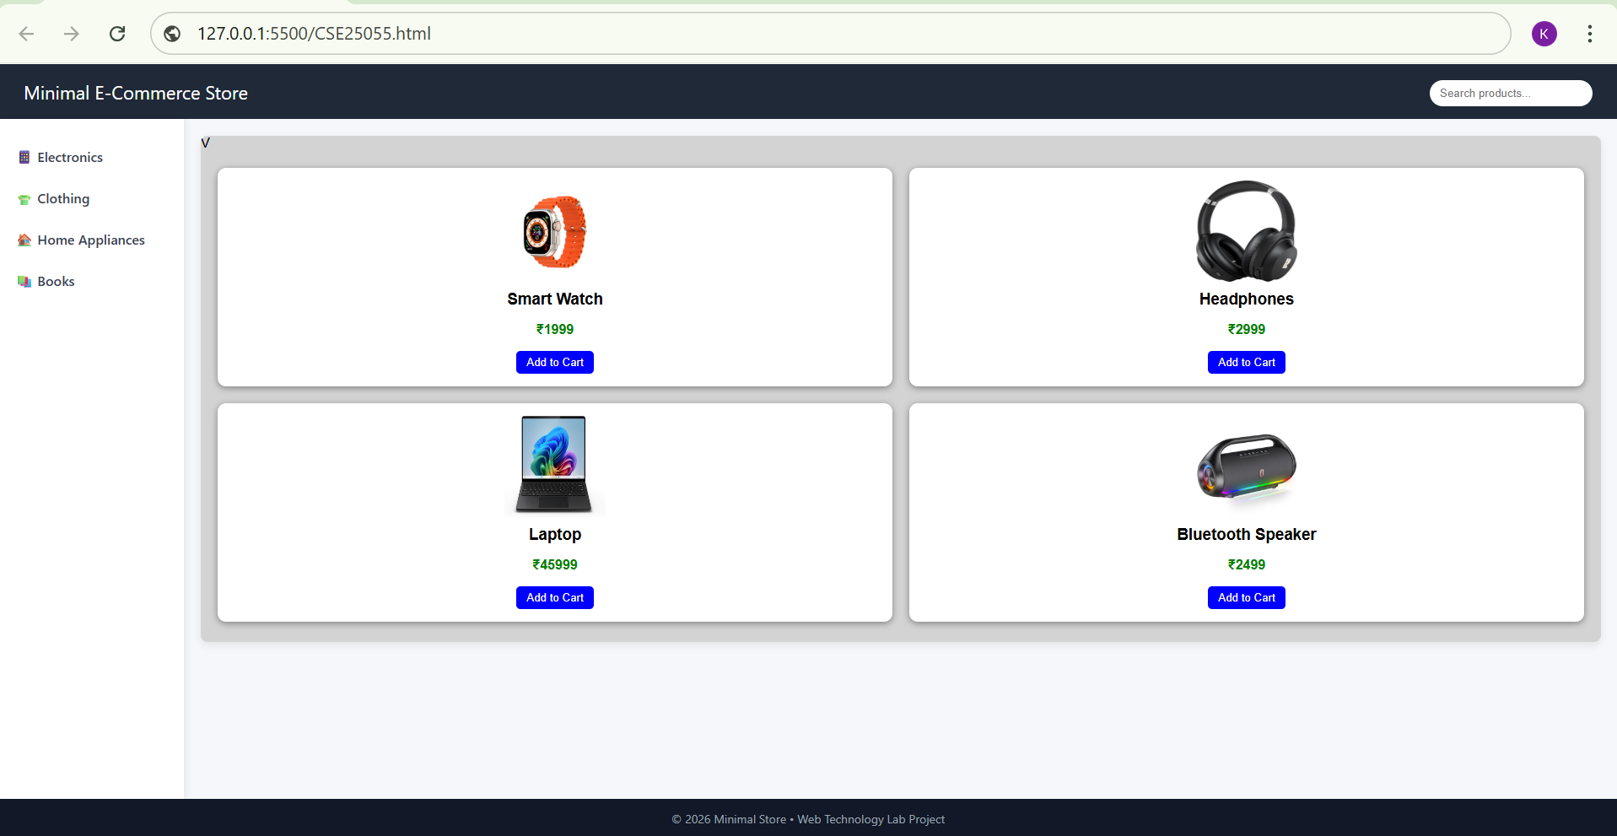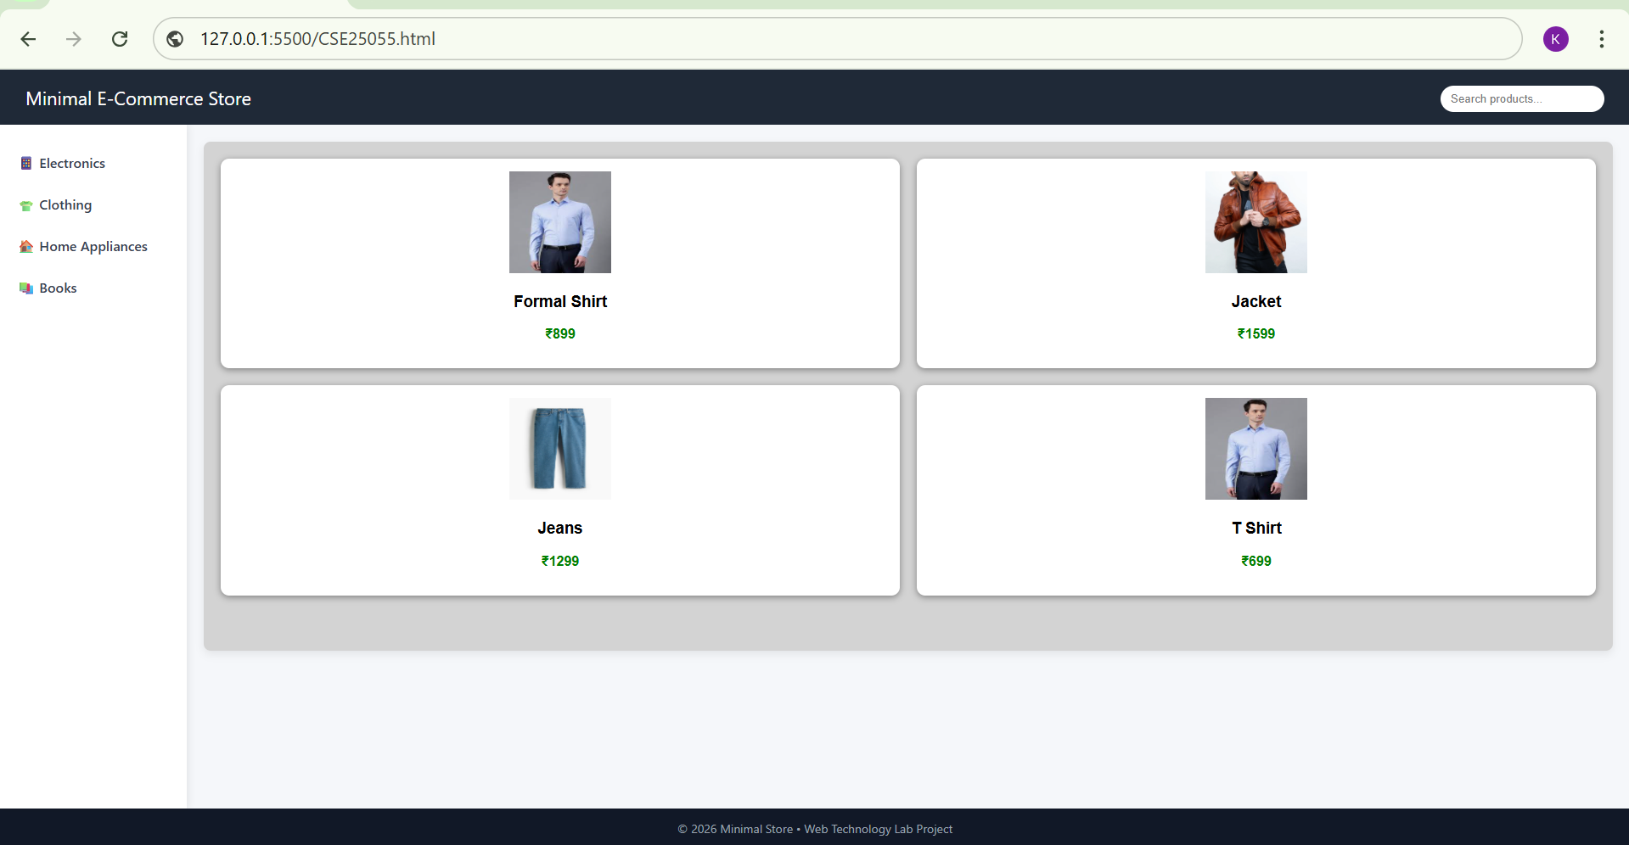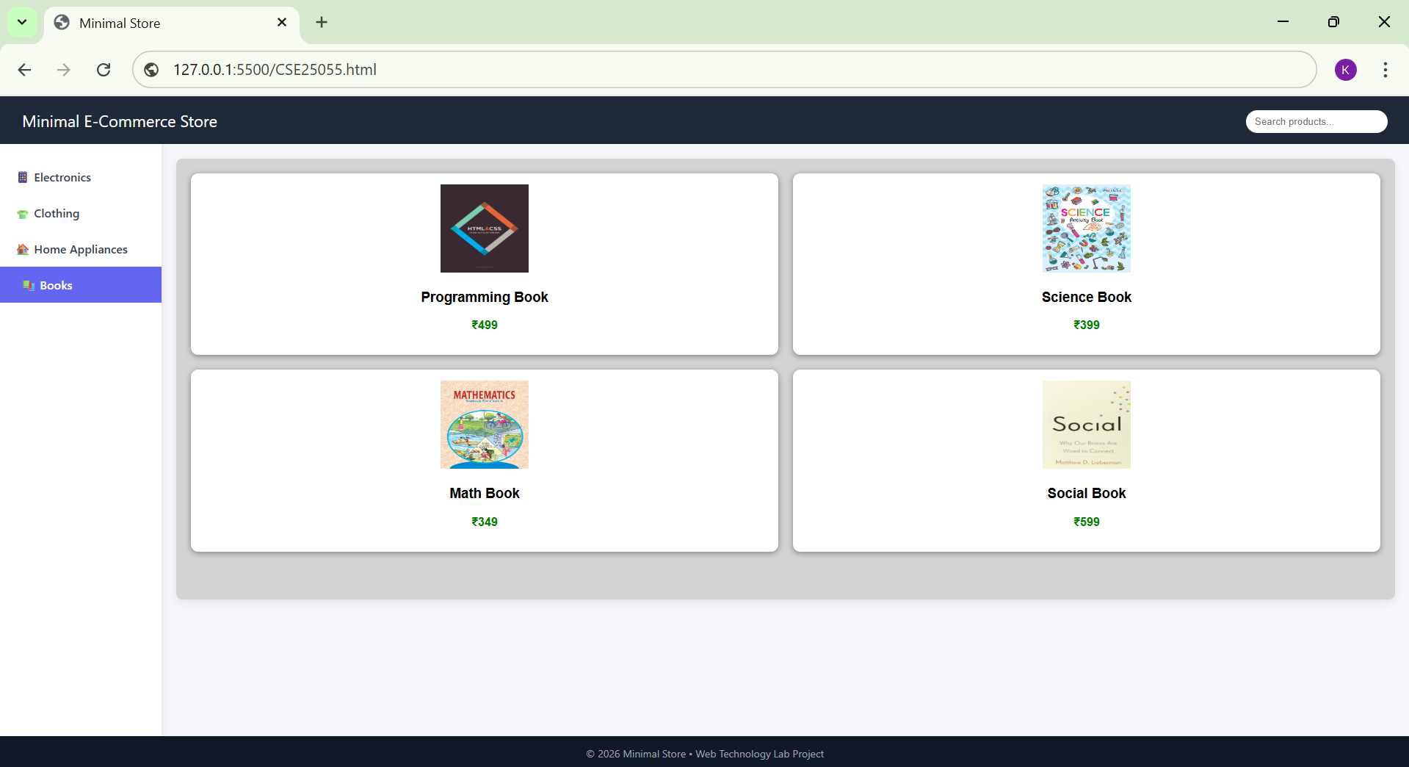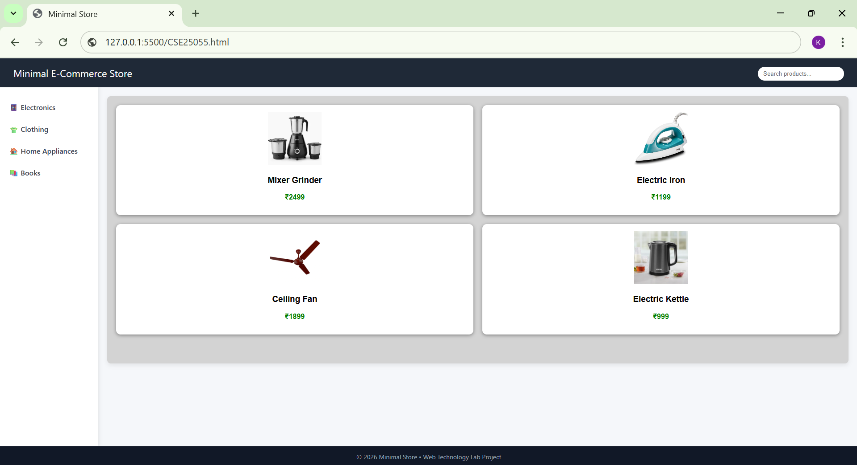
Explanation of the tags/attributes:
- <div> – Used as a container element to group and organize sections of a webpage.
- <nav> – Defines a navigation area that contains links to different categories or pages.
- <iframe> – Embeds another webpage inside the current page for dynamic content display.
- <img> – Displays images on the webpage using a specified image source path.
- <a> – Creates clickable hyperlinks that allow navigation between pages.
- <button> – Represents a clickable button used for actions like adding products to cart.
- <header> – Defines the top section of a webpage that usually contains the website title or logo.
- <footer> – Defines the bottom section of a webpage used for copyright or additional information.
- display – Specifies the layout behavior of elements such as grid, flex, or block.
- grid-template-columns – Defines the number and width of columns in a grid layout.
- gap – Controls the spacing between grid rows and columns.
- padding – Adds inner spacing between the element content and its border.
- margin – Creates outer spacing between an element and surrounding elements.
- background – Sets the background color or image of an element.
- color – Defines the color of the text inside an element.
- border – Creates a visible outline around an element.
- border-radius – Rounds the corners of elements to make them look smooth.
- box-shadow – Adds shadow around elements to create a depth or card effect.
- text-align – Aligns text horizontally inside an element.
- width – Specifies the horizontal size of an element.
- height – Specifies the vertical size of an element.
- font-family – Defines the style or typeface used for text.
- font-size – Controls the size of text displayed on the webpage.
- font-weight – Specifies the thickness or boldness of text.
- cursor – Changes the mouse pointer style when hovering over elements.
- hover – Applies styles when the user moves the mouse over an element.
- flex – Allows flexible layout arrangement of elements inside a container.
- min-height – Defines the minimum height an element can have.
- target – Specifies where the linked document will open such as inside an iframe
6B)Aim: Design a responsive E-Commerce application using the grid layout. This application should different categories of products such as electronics, clothing, home-appliances, books. Those should display on products.
Program:
<!DOCTYPE html>
<html>
<head>

<title>All Products</title>

<style>
body{
font-family:Arial;
background:lightgray;
margin:0;
}

h2{
text-align:center;
padding:15px;
}

.products{
display:grid;
grid-template-columns:1fr 1fr;
gap:20px;
padding:20px;
}

.card{
background:white;
padding:15px;
text-align:center;
border-radius:10px;
box-shadow:0px 2px 8px gray;
}

.card img{width:120px;height:120px;}

.price{
color:green;
font-weight:bold;
}
</style>

</head>

<body>

<h2>All Products</h2>

<div class="products">
<div class="card">
<img src="smartwatch.webp">
<h3>Smart Watch</h3>
<p class="price">₹1999</p>
</div>

<div class="card">
<img src="headphones.jpg">
<h3>Headphones</h3>
<p class="price">₹2999</p>
</div>

<div class="card">
<img src="formalshirt.jpg">
<h3>Formal Shirt</h3>
<p class="price">₹899</p>
</div>

<div class="card">
<img src="jacket.webp">
<h3>Jacket</h3>
<p class="price">₹1599</p>
</div>

<div class="card">
<img src="mixergrinder.jpg">
<h3>Mixer Grinder</h3>
<p class="price">₹2499</p>
</div>

<div class="card">
<img src="iron.jpg">
<h3>Electric Iron</h3>
<p class="price">₹1199</p>
</div>

<div class="card">
<img src="book.jpg">
<h3>Programming Book</h3>
<p class="price">₹499</p>
</div>

<div class="card">
<img src="science.webp">
<h3>Science Book</h3>
<p class="price">₹399</p>
</div>

</div>

</body>
</html>
Output:
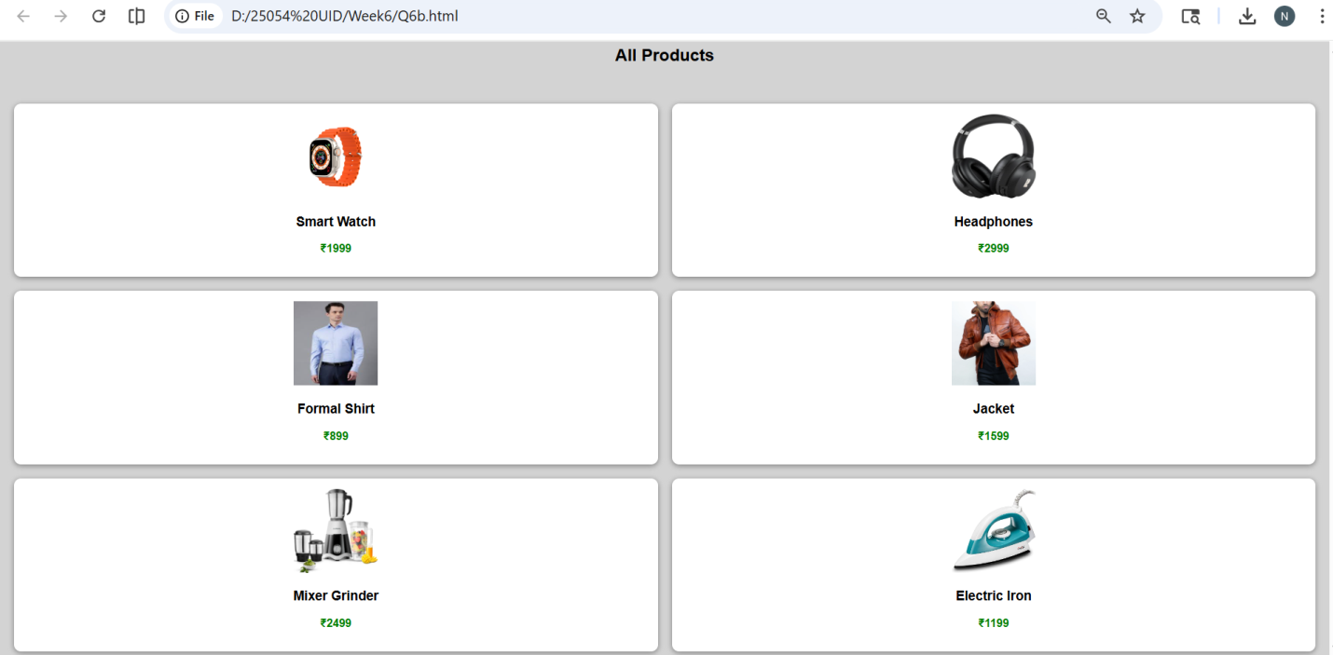
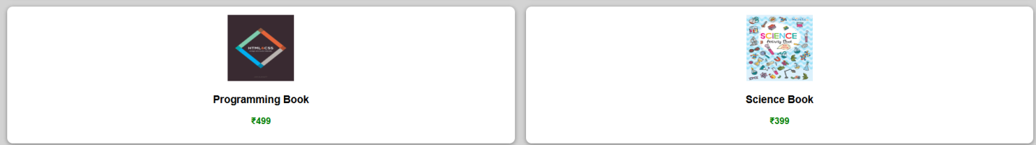

Explanation of the tags/attributes:
- <div> – Used as a container element to group and organize sections of a webpage.
- <nav> – Defines a navigation area that contains links to different categories or pages.
- <iframe> – Embeds another webpage inside the current page for dynamic content display.
- <img> – Displays images on the webpage using a specified image source path.
- <a> – Creates clickable hyperlinks that allow navigation between pages.
- <button> – Represents a clickable button used for actions like adding products to cart.
- <header> – Defines the top section of a webpage that usually contains the website title or logo.
- <footer> – Defines the bottom section of a webpage used for copyright or additional information.
- display – Specifies the layout behavior of elements such as grid, flex, or block.
- grid-template-columns – Defines the number and width of columns in a grid layout.
- gap – Controls the spacing between grid rows and columns.
- padding – Adds inner spacing between the element content and its border.
- margin – Creates outer spacing between an element and surrounding elements.
- background – Sets the background color or image of an element.
- color – Defines the color of the text inside an element.
- border – Creates a visible outline around an element.
- border-radius – Rounds the corners of elements to make them look smooth.
- box-shadow – Adds shadow around elements to create a depth or card effect.
- text-align – Aligns text horizontally inside an element.
- width – Specifies the horizontal size of an element.
- height – Specifies the vertical size of an element.
- font-family – Defines the style or typeface used for text.
- font-size – Controls the size of text displayed on the webpage.
- font-weight – Specifies the thickness or boldness of text.
- cursor – Changes the mouse pointer style when hovering over elements.
- hover – Applies styles when the user moves the mouse over an element.
- flex – Allows flexible layout arrangement of elements inside a container.
- min-height – Defines the minimum height an element can have.
- target – Specifies where the linked document will open such as inside an iframe.

Week -7
7.A) Aim: create a GitHub account and create a repository in it and push all the week 6 code files in it. Procedure :
Step 1: browse for GitHub and enter it.
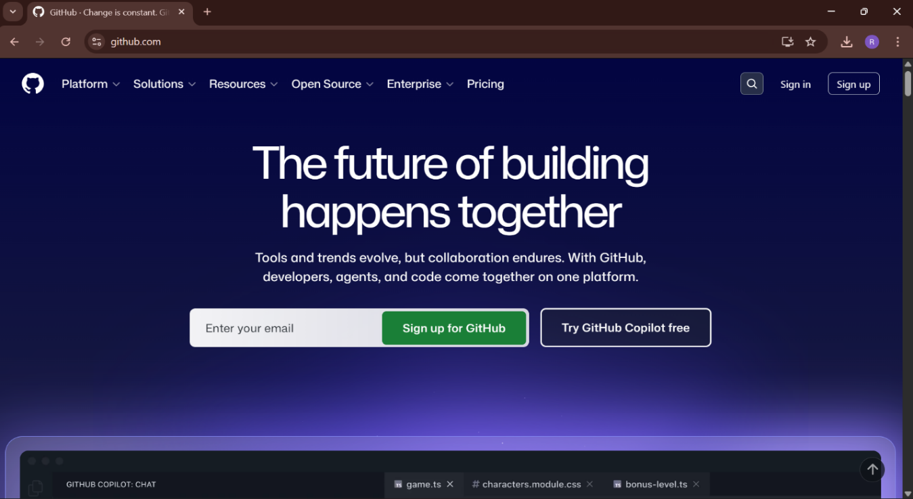
Step 2:login to GitHub account. 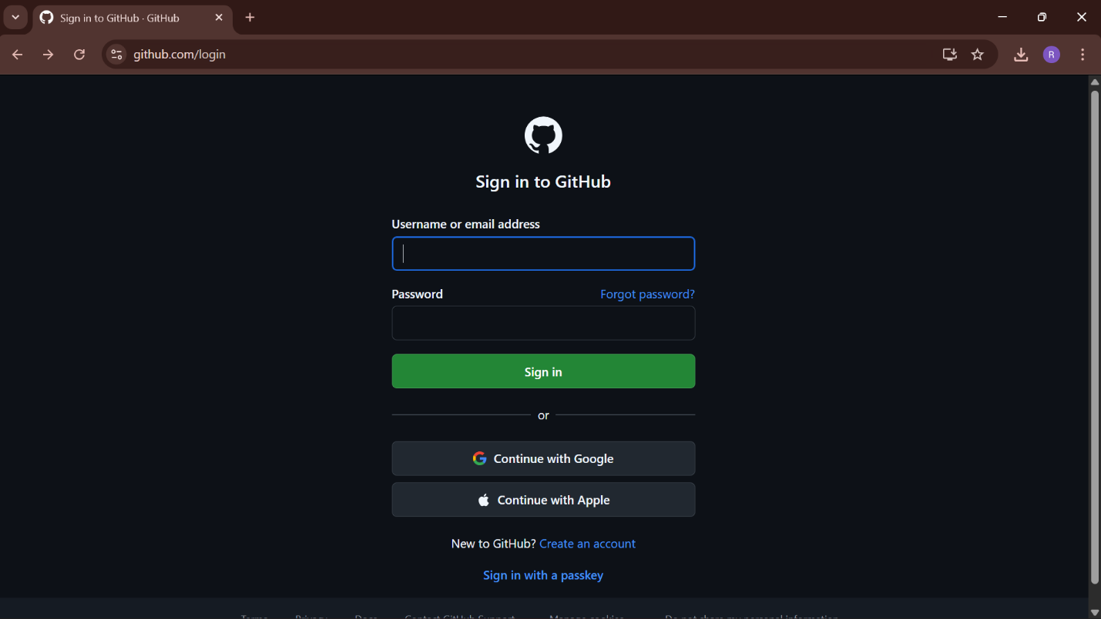
Step 3:create a repository after login by clicking new. 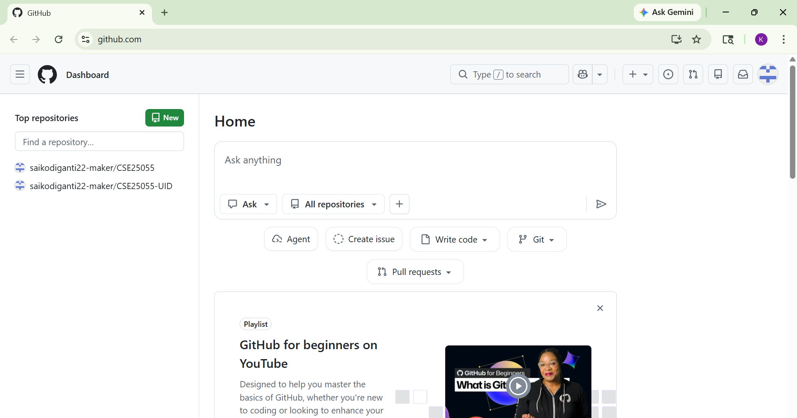

Step 4:specify the repository specifications.

Step 5:download GitHub desktop and Lauch it . 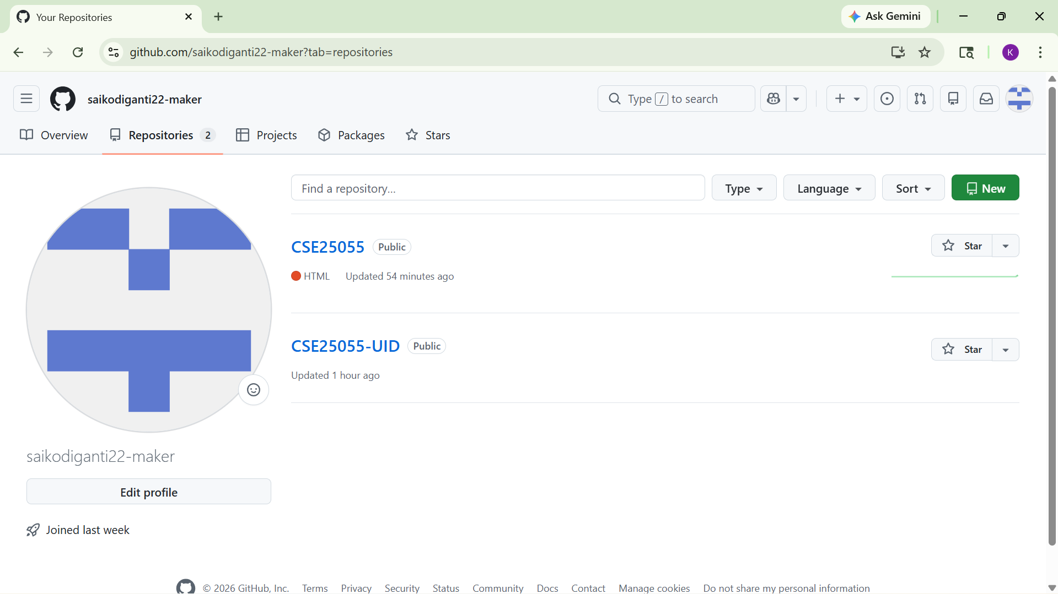
Step 6:add the repository to it . 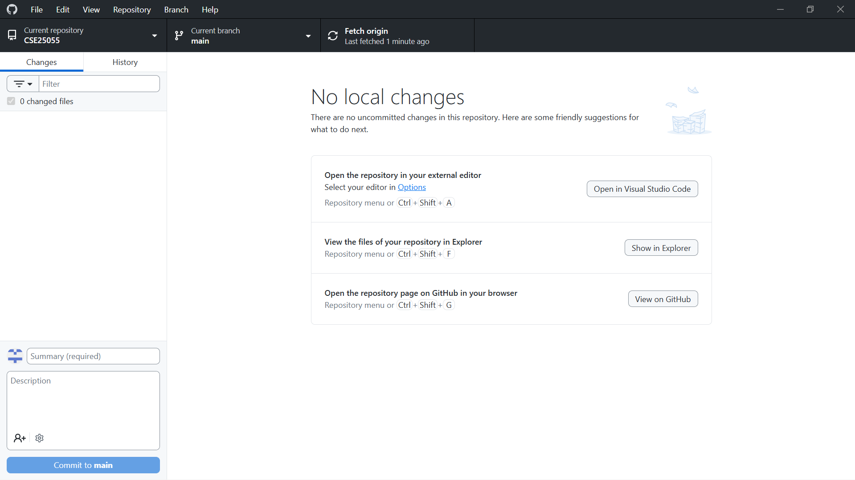
Step 7:add the vs code file to the GitHub desktop. 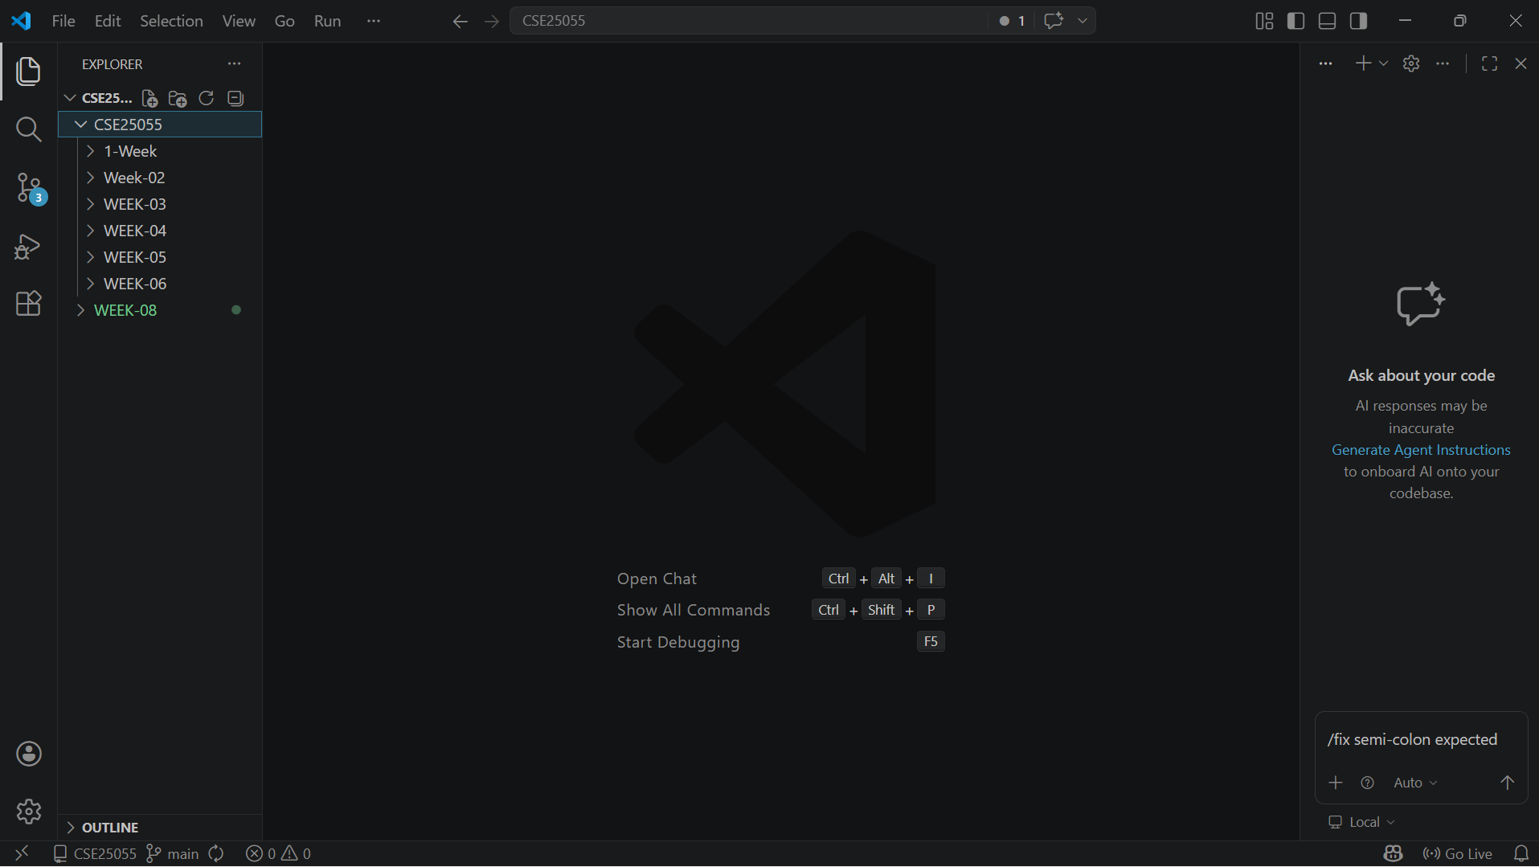
Step 8:add commit to it and the files to repository and sync the changes . it automatically pushes the files . 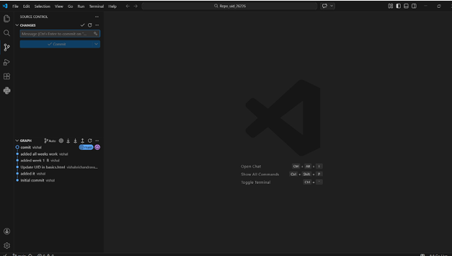
Step 9:now go to browser and check it . it will show all the new added files in the repository . 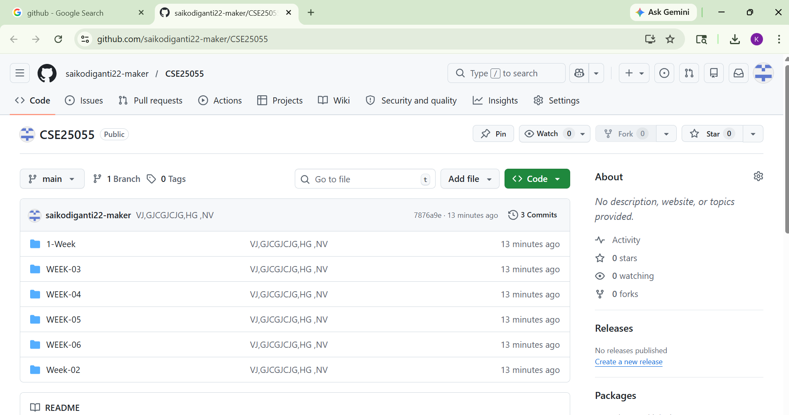
My repository link for the uid all week’s work : https://github.com/saikodiganti22-maker/CSE25055

Week-8
8.A) Aim: create a web page that displays a square that continuously rotates 360 using css animation
Program :
<html>
<head>
<title>Rotating Square</title>
<style>
body {
margin: 0;
height: 100vh;
display: flex;
flex-direction: column;
justify-content: flex-start;
align-items: center;
background-color: #317fa9;
font-family: Arial, sans-serif;
padding-top: 50px;
}
.square {
width: 120px;
height: 120px;
background: #ffffffcc;
border-radius: 12px;
box-shadow: 0 8px 25px rgba(0, 0, 0, 0.2);
animation: rotate 3s linear infinite;
}
@keyframes rotate {
from {
transform: rotate(0deg);
}
to {
transform: rotate(360deg);
}
}
</style>
</head>
<body>
<h1 style="color: #fff;">Rotating Square</h1>
<div class="square"></div>
</body>
</html>

Output: 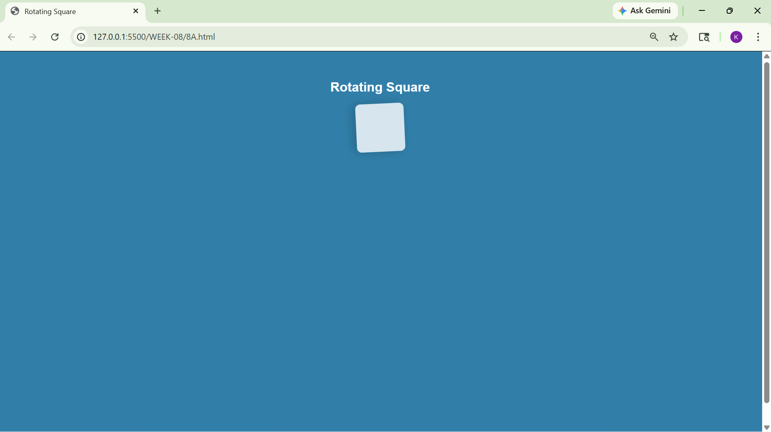
Explanation:

<DOCTYPE html>: the <!DOCTYPE html> element tells the web browser that this an HTML document or this is the latest version of HTML
<html>: the <html> element is the root element of an HTML web page
<head>: the <head> element will contain meta data about the HTML web page
<title>: the <title> element specifies a title for the HTML Page
<body>: the <body> element contains all visible content all visible content like text, image, links, tables, etc
<h>: we used <h> element for heading
<div>:we use <div> element for encapsulating the the divisions and easy to modify and

@keyframes:we use @keyframes for animation from starting to end transformation.
We used animation shorthand property for these things to mention the animations preferences and use keyframes for mentioning the positions of the animation and used style attribute and some value properties for look and we used internal css in it
8.B)Aim :create a ball that moves up and down continuously using css animation
Program:
<!DOCTYPE html>
<html>
<head>
<title>Bouncing Ball</title>
<style>
body {
margin: 0;
height: 100vh;
display: flex;
flex-direction: column;
align-items: center;
justify-content: flex-start;
background: #021017;
}
h1 {
margin-top: 20px;
color: #ec6666;
}
.ball {
width: 80px;
height: 80px;
background: #fdf6f6;
border-radius: 50%;
margin-top: 120px;
animation: bounce 1.5s ease-in-out infinite;
}
@keyframes bounce {
0% {
transform: translateY(0);
}
50% {
transform: translateY(-120px);
}
100% {
transform: translateY(0);
}
}
</style>
</head>
<body>
<h1>Bouncing Ball</h1>
<div class="ball"></div>
</body>
</html

Output:
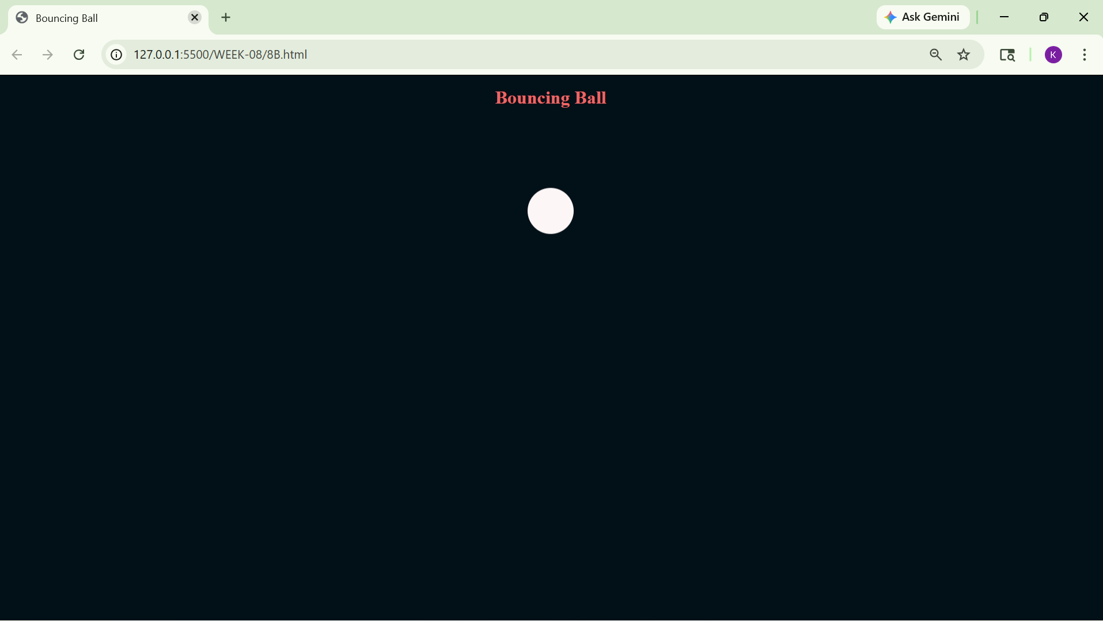

Explanation:

<DOCTYPE html>: the <!DOCTYPE html> element tells the web browser that this an HTML document or this is the latest version of HTML
<html>: the <html> element is the root element of an HTML web page
<head>: the <head> element will contain meta data about the HTML web page
<title>: the <title> element specifies a title for the HTML Page
<body>: the <body> element contains all visible content all visible content like text, image, links, tables, etc
<h>: we used <h> element for heading
<div>:we use <div> element for encapsulating the the divisions and easy to modify and @keyframes we use @keyframes for animation from starting to end transformation.

We used animation shorthand property for these things to mention the animations preferences and use keyframes for mentioning the positions of the animation and used style attribute and some value properties for look and we used internal css in it.

8.C)Aim :create a circle that moves horizontally and rotates At the same time
Program:
<!DOCTYPE html>
<html lang="en">
<head>
<title>Moving Rotating Circle</title>
<style>
body {
margin: 0;
height: 100vh;
display: flex;
flex-direction: column;
align-items: center;
justify-content: flex-start;
background: #dcf0fa;
overflow: hidden;
}
h1 {
margin-top: 20px;
color: #110202;
}
.circle {
width: 80px;
height: 80px;
background: #ce7272;
border-radius: 50%;
margin-top: 120px;
animation: moveRotate 3s linear infinite;
}
@keyframes moveRotate {
0% {
transform: translateX(-150px) rotate(0deg);
}
50% {
transform: translateX(150px) rotate(180deg);
}
100% {
transform: translateX(-150px) rotate(360deg);
}
}
</style>
</head>
<body>
<h1>Moving Rotating Circle</h1>
<div class="circle"></div>
</body>
</html>

Output: 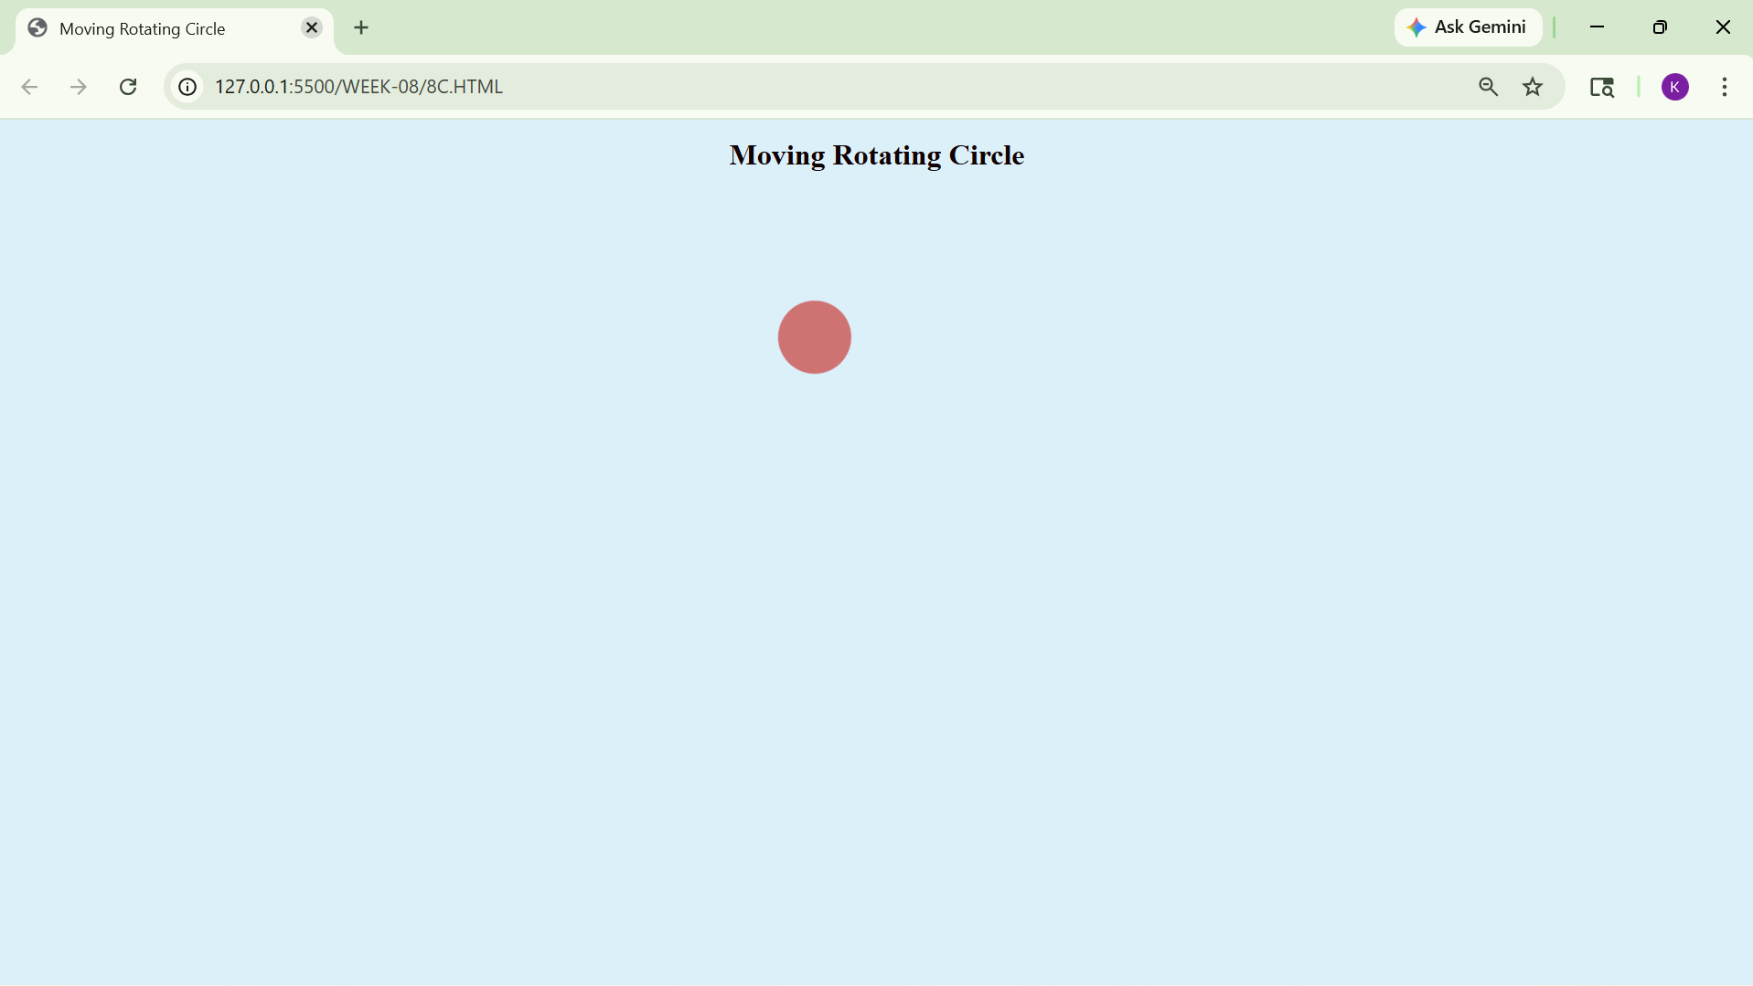
Explanation:
<DOCTYPE html>: the <!DOCTYPE html> element tells the web browser that this an HTML document or this is the latest version of HTML
<html>: the <html> element is the root element of an HTML web page
<head> the <head> element will contain meta data about the HTML web page
<title>: the <title> element specifies a title for the HTML Page
<body> the <body> element contains all visible content all visible content like text, image, links, tables, etc.<h> we used <h> element for heading
<div> we use <div> element for encapsulating the the divisions and easy to modify and @keyframes we use @keyframes for animation from starting to end transformation.
We used animation shorthand property for these things to mention the animations preferences and use keyframes for mentioning the positions of the animation and used style attribute and some value properties for look and we used internal css in it

Week-9
9)Aim:Create an webpage using html, CSS, java script based on the given conditions:
a)Create a button for each program, based on the button clicked the corresponding program has to be executed and should display the output.
b)The logics for each button includes finding an even numbers, odd number, prime or not, factorial of a number, amstrong or not.
c)Use appropriate designs to display the output.
Program: <!DOCTYPE html>
<html>
<head>
<title>Number Programs</title>
<style>
body {
font-family: Verdana;
background-color: rgb(113, 209, 236);
color: rgb(214, 193, 193);
display: flex;
justify-content: center;
align-items: center;
height: 100vh;
margin: 0;
letter-spacing: 1px;
}

.container {
background-color: rgb(153, 141, 231);
padding: 25px;
width: 320px;
border: 2px solid white;
border-radius: 15px;
text-align: center;
}

h2 {
text-shadow: 2px 2px 5px black;
margin-bottom: 15px;
}

input {
padding: 10px;
width: 80%;
margin: 15px;
border: 1px solid white;
background-color: rgb(170, 170, 239);
color: white;
border-radius: 10px;
text-align: center;
}

button {
margin: 6px;
padding: 10px;
background-color: royalblue;
color: white;
border: none;
border-radius: 10px;
cursor: pointer;
}

button:hover {
background-color: rgb(32, 233, 142);
}

#result {
margin-top: 15px;
padding: 12px;
background-color: rgb(190, 214, 140);
border: 1px solid rgb(231, 164, 164);
border-radius: 10px;
text-shadow: 1px 1px 3px black;
}
</style>
</head>
<body>

<div class="container">
<h2>Number Programs</h2>

<input type="text" id="num" placeholder="Enter a number">

<br>

<button onclick="even()">Even</button>
<button onclick="odd()">Odd</button>
<button onclick="prime()">Prime</button>
<button onclick="fact()">Factorial</button>
<button onclick="armstrong()">Armstrong</button>

<div id="result">Output will appear here</div>
</div>

<script>

function getNum() {
return Number(document.getElementById("num").value);
}

function show(msg) {
document.getElementById("result").innerHTML = msg;
}

function even() {
var n = getNum();
if (n % 2 == 0)
show(n + " is Even Number");
else
show(n + " is Not Even Number");
}

function odd() {
var n = getNum();
if (n % 2 != 0)
show(n + " is Odd Number");
else
show(n + " is Not Odd Number");
}

function prime() {
var n = getNum();
var i;
if (n <= 1) {
show(n + " is Not Prime Number");
return;
}
for (i = 2; i < n; i++) {
if (n % i == 0) {
show(n + " is Not Prime Number");
return;
}
}
show(n + " is Prime Number");
}

function fact() {
var n = getNum();
var f = 1;
var i;
if (n < 0) {
show("No factorial for negative numbers");
return;
}
for (i = 1; i <= n; i++) {
f = f * i;
}
show("Factorial of " + n + " is " + f);
}

function armstrong() {
var n = getNum();
var temp = n;
var sum = 0;
var r;

while (temp > 0) {
r = temp % 10;
sum = sum + (r * r * r);
temp = parseInt(temp / 10);
}

if (sum == n)
show(n + " is Armstrong Number");
else
show(n + " is Not Armstrong Number");
}

</script>

</body>
</html>
Output: 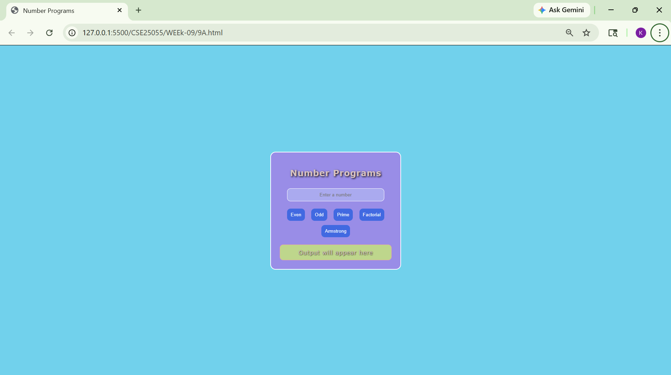
Explanation: this program is a Number Programs Web Application developed using JavaScript. It allows users to enter a number and perform various operations such as checking whether the number is even, odd, prime, finding its factorial, and determining whether it is an Armstrong number. The result is displayed instantly on the webpage when the corresponding button is clicked.
CSS Styling
The CSS section is used to improve the appearance of the webpage.
- The body uses the Verdana font and a light blue background color. Flexbox is used to center the content horizontally and vertically on the screen.
- The container acts as the main box that holds all elements. It has padding, a border, rounded corners, and centered text.
- The heading has a shadow effect to make it more attractive.
- The input box is styled with padding, a background color, rounded corners, and centered text.
- The buttons have a blue background color, rounded corners, and change color when the mouse hovers over them.
- The result section displays the output with a different background color, border, and text shadow.
JavaScript Functions:
getNum()
The getNum() function reads the value entered by the user in the input box and converts it into a numeric value using the Number() function. This number is then returned for further processing.

show(msg)
The show(msg) function displays the given message inside the result area. It updates the content of the result section dynamically.

even()
The even() function checks whether the entered number is an even number. A number is considered even if it is completely divisible by 2. If the remainder is zero, the program displays that the number is even; otherwise, it displays that the number is not even.

odd()
The odd() function checks whether the entered number is an odd number. A number is odd if it leaves a remainder when divided by 2. If the remainder is not zero, the program displays that the number is odd; otherwise, it displays that the number is not odd.

prime()
The prime() function determines whether the entered number is a prime number. A prime number is a number greater than 1 that has only two factors: 1 and itself.
The function first checks if the number is less than or equal to 1. If so, it is not prime. Otherwise, a loop checks divisibility by all numbers from 2 up to one less than the given number. If any divisor is found, the number is not prime. If no divisor is found, the number is declared prime.

fact()
The fact() function calculates the factorial of a number. The factorial of a positive integer is the product of all positive integers from 1 up to that number.The function uses a loop to multiply numbers sequentially and stores the result in a variable. If the user enters a negative number, the program displays a message stating that factorial is not defined for negative numbers.

armstrong()
The armstrong() function checks whether the entered number is an Armstrong number.
An Armstrong number is a number that is equal to the sum of the cubes of its digitsThe function separates each digit using the modulus operator (%), calculates the cube of each digit, and adds the cubes together. If the final sum is equal to the original number, the number is an Armstrong number; otherwise, it is not.

Program Execution Flow
- The user enters a number in the input box.
- The user clicks one of the operation buttons.
- The corresponding JavaScript function is executed.
- The function performs the required calculation or check.
- The result is displayed in the output area.

Functions Used
- getNum() – Reads the input number.
- show(msg) – Displays the output.
- even() – Checks whether the number is even.
- odd() – Checks whether the number is odd.
- prime() – Checks whether the number is prime.
- fact() – Calculates the factorial.
- armstrong() – Checks whether the number is an Armstrong number.

Square Rotating

Week-10
10)Aim:
A)WriteJavaScript conditional statement to find the sign of product of three numbers using functions. Display an alert box with specified sign
B): write a java script conditional statements to sort 3 numbers using functions display an alert box to show the result.
C): write a java script conditional statement to find largest of find largest of five numbers using function and onclick event. display an alert box to show the result.
D): write a java script for loop that will iterate from 0 to 15. For each iteration, it will check if the current number odd or even, and display a message on screen.
E) write a java script program to read 6 subjects marks from the student then computes theaverage marks of students then, this average is used to determine the corresponding grade.
Program:
<!DOCTYPE html>
<html>
<head>
<title>Week 10 Programs</title>

<style>
body {
font-family: Arial, sans-serif;
background: #f4f6f8;
margin: 0;
display: flex;
justify-content: center;
align-items: center;
height: 100vh;
}

.container {
background: #fff;
border-radius: 10px;
box-shadow: 0 4px 15px rgba(0, 0, 0, 0.1);
width: 600px;
display: flex;
overflow: hidden;
}

.left {
width: 45%;
padding: 20px;
border-right: 1px solid #eee;
}

.right {
width: 55%;
padding: 20px;
}

h3 {
margin-bottom: 15px;
color: #333;
}

button {
width: 100%;
padding: 10px;
margin: 6px 0;
border: none;
border-radius: 6px;
background: #4a90e2;
color: white;
cursor: pointer;
font-size: 14px;
}

button:hover {
background: #357abd;
}

#output {
background: #f1f5f9;
padding: 15px;
border-radius: 6px;
min-height: 200px;
font-size: 14px;
color: #333;
line-height: 1.5;
}
</style>
</head>

<body>
<div class="container">
<div class="left">
<h3>Functions</h3>

<button onclick="signProduct()">Sign of Product</button>
<button onclick="sortNumbers()">Sort Numbers</button>
<button onclick="largest()">Largest Number</button>
<button onclick="oddEven()">Odd / Even 0-15</button>
<button onclick="grade()">Student Grade</button>
</div>

<div class="right">
<h3>Output</h3>
<div id="output">Result will appear here</div>
</div>
</div>

<script>
// A) Sign of Product
function signProduct() {
let a = prompt("Enter first number:");
let b = prompt("Enter second number:");
let c = prompt("Enter third number:");

let p = a * b * c;

if (p > 0) show("Sign is +");
else if (p < 0) show("Sign is -");
else show("Zero");
}

// B) Sort Numbers
function sortNumbers() {
let a = parseInt(prompt("Enter first number:"));
let b = parseInt(prompt("Enter second number:"));
let c = parseInt(prompt("Enter third number:"));

let arr = [a, b, c];
arr.sort((x, y) => x - y);

show("Sorted: " + arr.join(", "));
}

// C) Largest of 5
function largest() {
let max = -Infinity;

for (let i = 1; i <= 5; i++) {
let n = parseInt(prompt("Enter number " + i));
if (n > max) max = n;
}

show("Largest Number: " + max);
}

// D) Odd / Even
function oddEven() {
let result = "";

for (let i = 0; i <= 15; i++) {
result += i + " is " + (i % 2 == 0 ? "Even" : "Odd") + "<br>";
}

show(result);
}

// E) Grade
function grade() {
let total = 0;

for (let i = 1; i <= 6; i++) {
total += parseInt(prompt("Enter mark " + i));
}

let avg = total / 6;
let grade;

if (avg >= 90) grade = "A";
else if (avg >= 75) grade = "B";
else if (avg >= 60) grade = "C";
else if (avg >= 50) grade = "D";
else grade = "F";

show("Average: " + avg + "<br>Grade: " + grade);
}

// Output
function show(msg) {
document.getElementById("output").innerHTML = msg;
}
</script>
</body>
</html>
OUTPUT
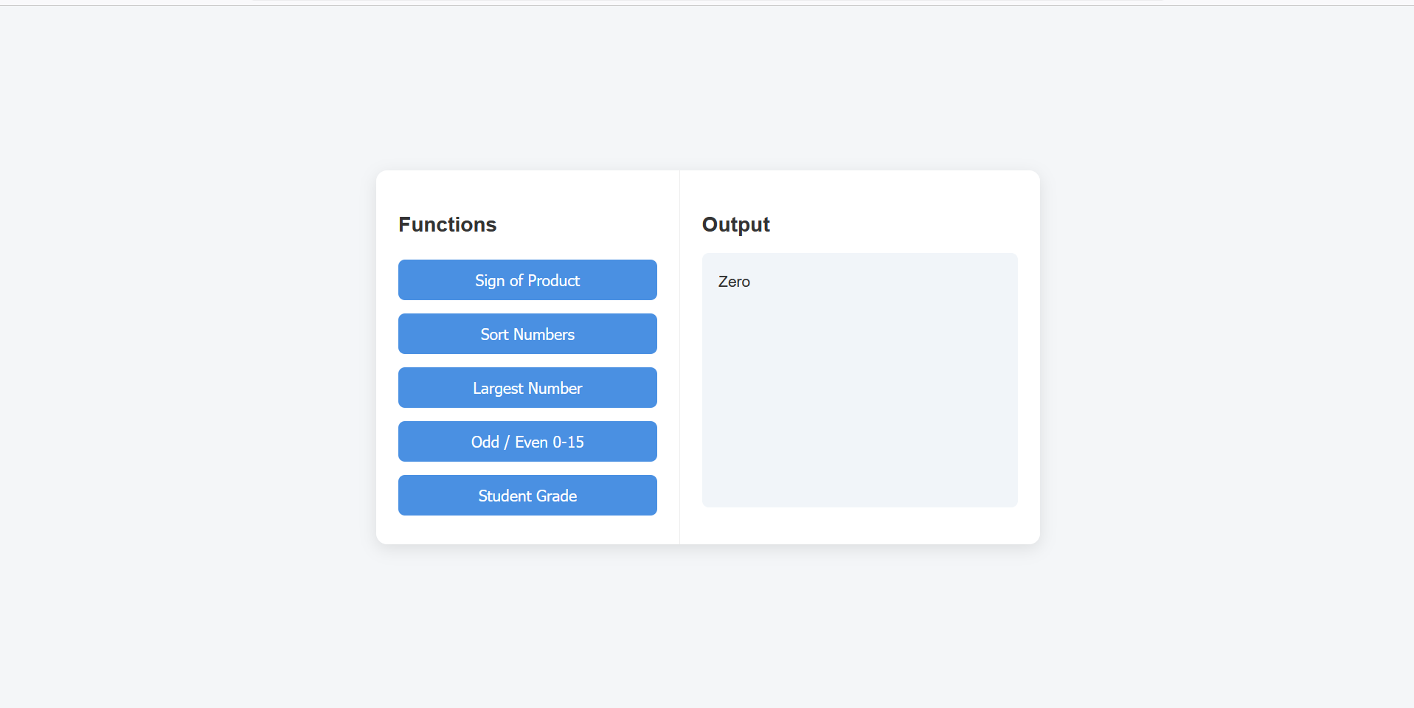
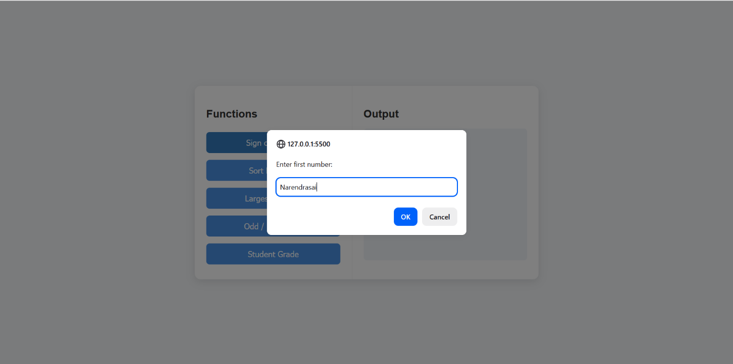
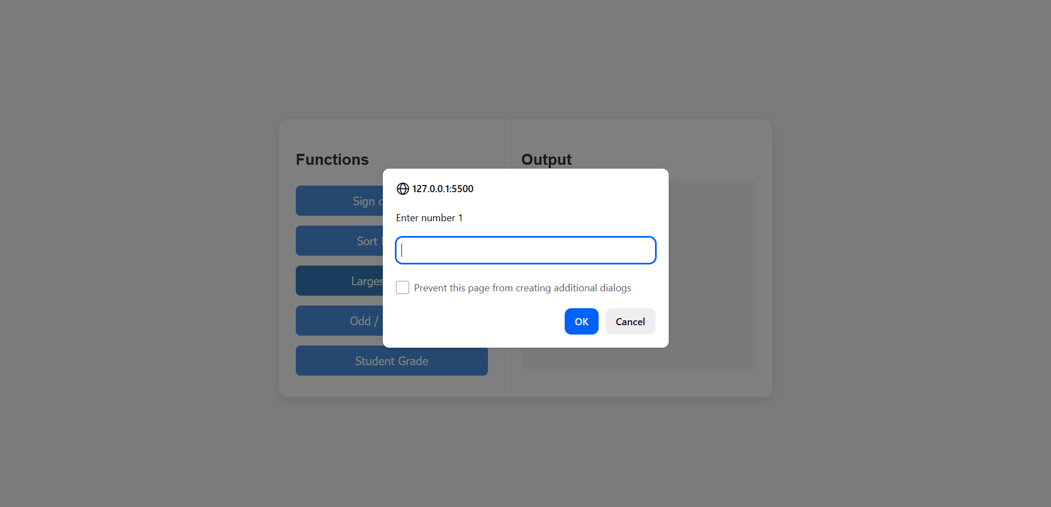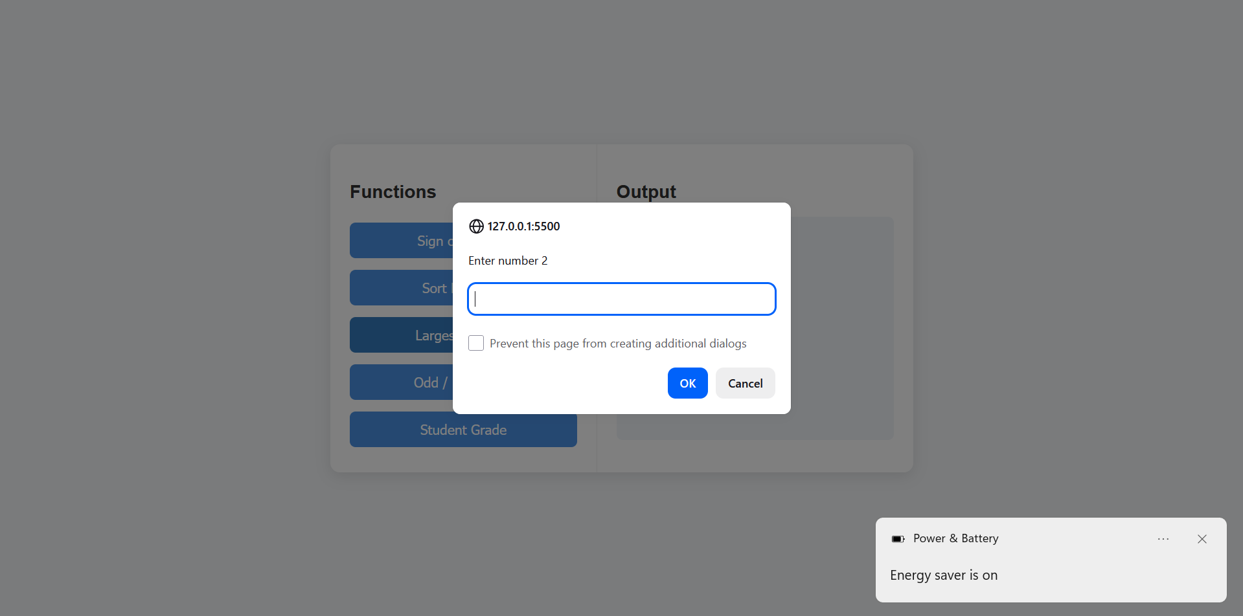
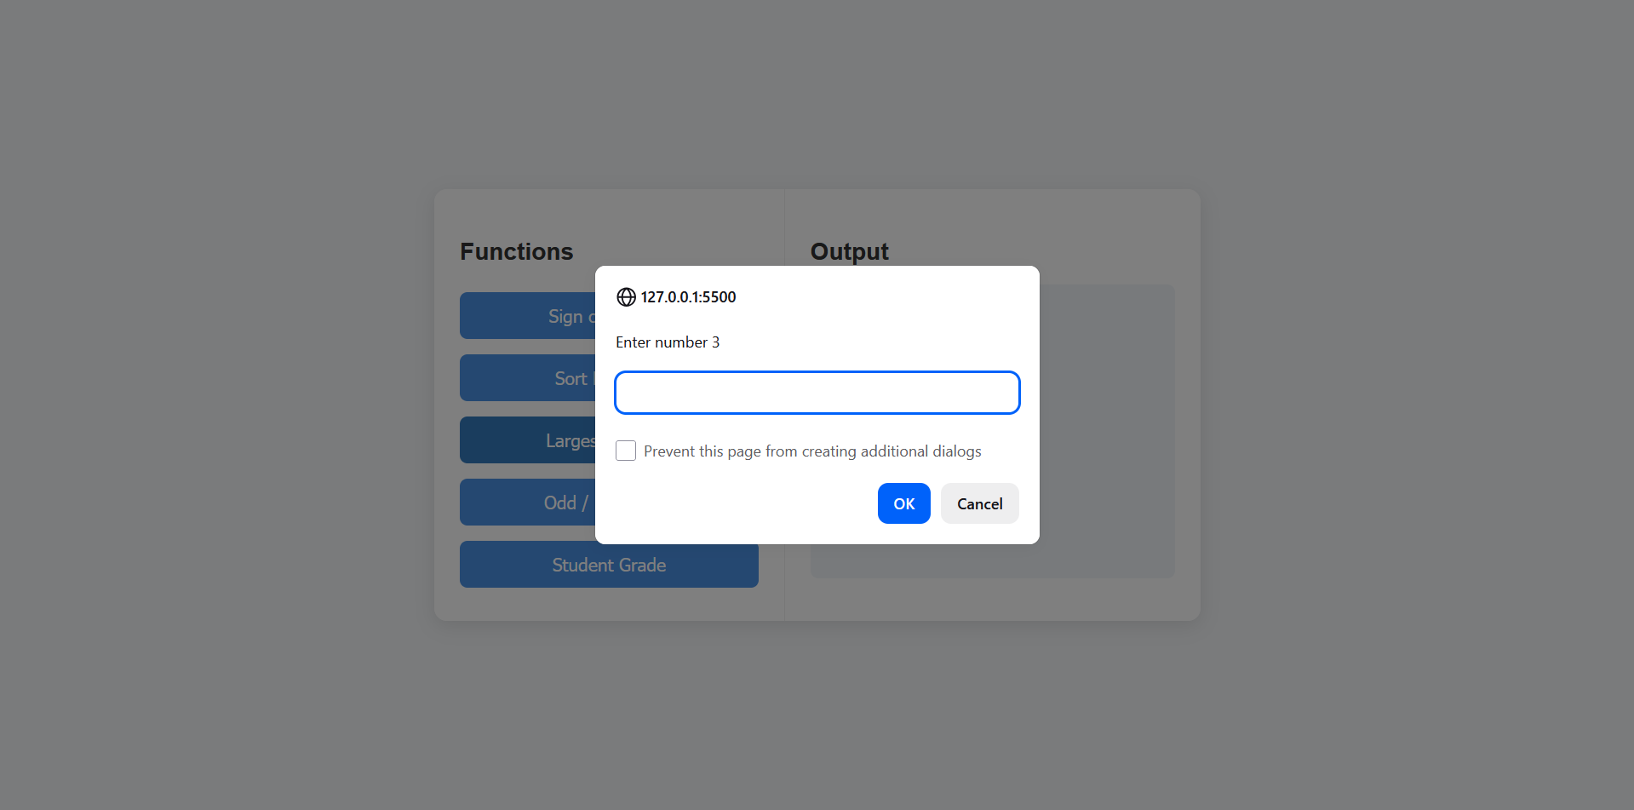
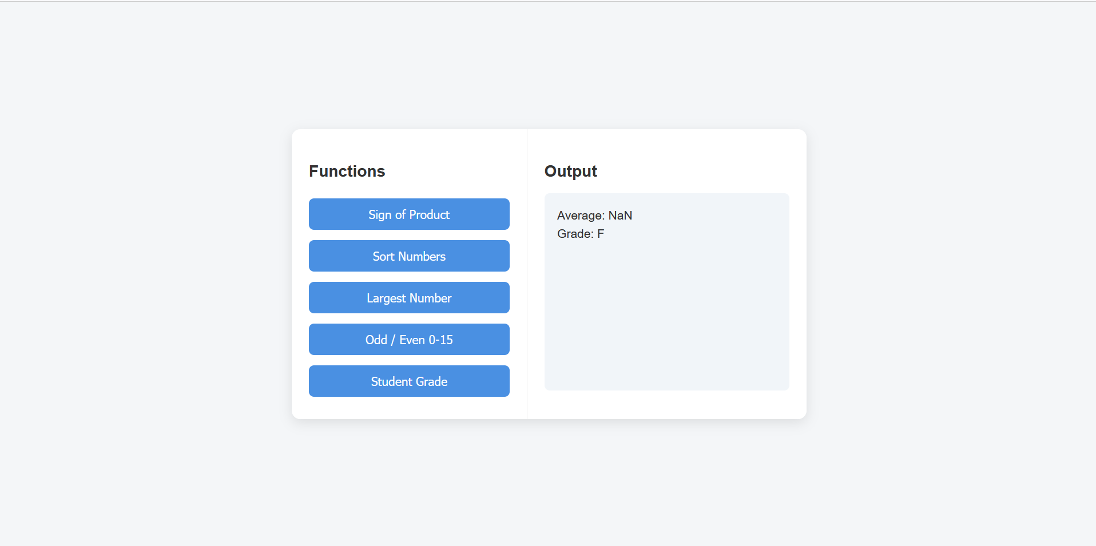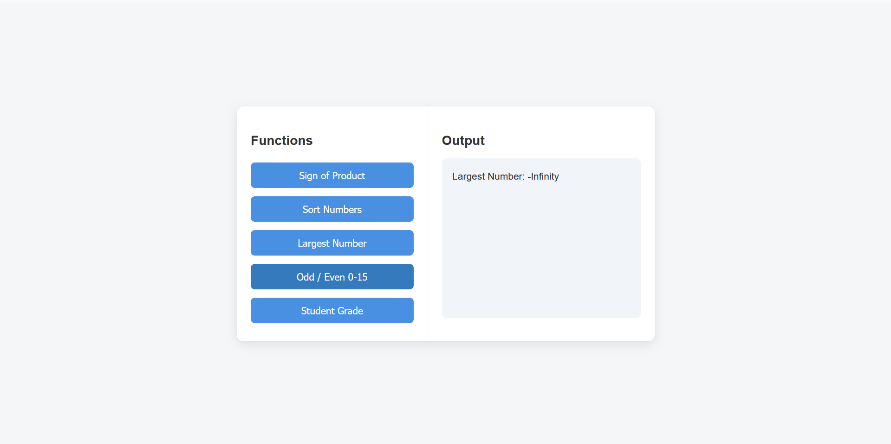
Explanation:
The program determines the sign of the product of three numbers without focusing on the exact value.
- The inputs are taken from three fields and converted into numeric values using Number().
- The product is calculated:
let product = a * b * c;
- The sign of the result is determined using conditional checks:
- If product > 0 → the result is positive (+)
- If product < 0 → the result is negative (-)
- If product == 0 → the result is zero (0)
- The output is displayed using alert().
Logical Insight
Instead of multiplying, the sign could also be determined by:
- Counting negative numbers
- Even count → Positive
- Odd count → Negative
But in this implementation, direct multiplication is used for simplicity and clarity.
The program sorts three numbers in ascending order using comparison and swapping technique.
- The input values are taken from three fields and converted into numeric values using Number().
- A temporary variable temp is used for swapping values when needed.
- The sorting is done using pairwise comparisons:
if (a > b) → swap a and b
if (a > c) → swap a and c
if (b > c) → swap b and c
- After these three comparisons:
- The smallest value will be stored in a
- The middle value in b
- The largest value in c
- The sorted result is displayed using alert().
Logic Explanation – Even and Odd Numbers
The program prints numbers from 0 to a given limit and identifies whether each number is even or odd.
- The input value is taken from the input field using document.getElementById().
- Input validation ensures the field is not empty. If empty, execution stops.
- The input is converted to a number using:
n = Number(n);
- A loop is used to iterate from 0 to n:
for (let i = 0; i <= n; i++)
- Each number is checked using the modulus operator:
i % 2 === 0
- If true → number is Even

- Else → number is Odd
- The result is stored in a string and displayed inside the output div.
Logic Explanation – Student Grade Calculation
The program calculates the average marks of 6 subjects and assigns a grade based on conditions.
- Six subject marks are taken as input from the user.
- Input validation ensures all fields are filled.
- Values are converted into numeric type using Number().
- The total sum is calculated:
sum = a + b + c + d + e + f;
- The average is computed:
avg = sum / 6;
- Grade is assigned using conditional logic:
if (avg >= 90) grade = "A";
else if (avg >= 75) grade = "B";
else if (avg >= 60) grade = "C";
else grade = "D";
- The result (average + grade) is displayed on the screen.

Week-11
11A)Aim: A)WriteJavaScript conditional statement to find the sign of product of three numbers using functions. Display an alert box with specified sign
PROGRAM:
<!DOCTYPE html>
<html>
<head>
<title>Username Validation</title>
</head>
<body>

<h3>Enter Username:</h3>
<input type="text" id="username" oninput="checkUsername()">
<p id="msg" style="color:red;"></p>

<script>
function checkUsername() {
let user = document.getElementById("username").value;
let msg = document.getElementById("msg");

if (user.length < 5) {
msg.innerText = "Username must be at least 5 characters";
} else {
msg.innerText = "Valid Username";
msg.style.color = "green";
}
}
</script>

</body>
</html>
OUTPUT:
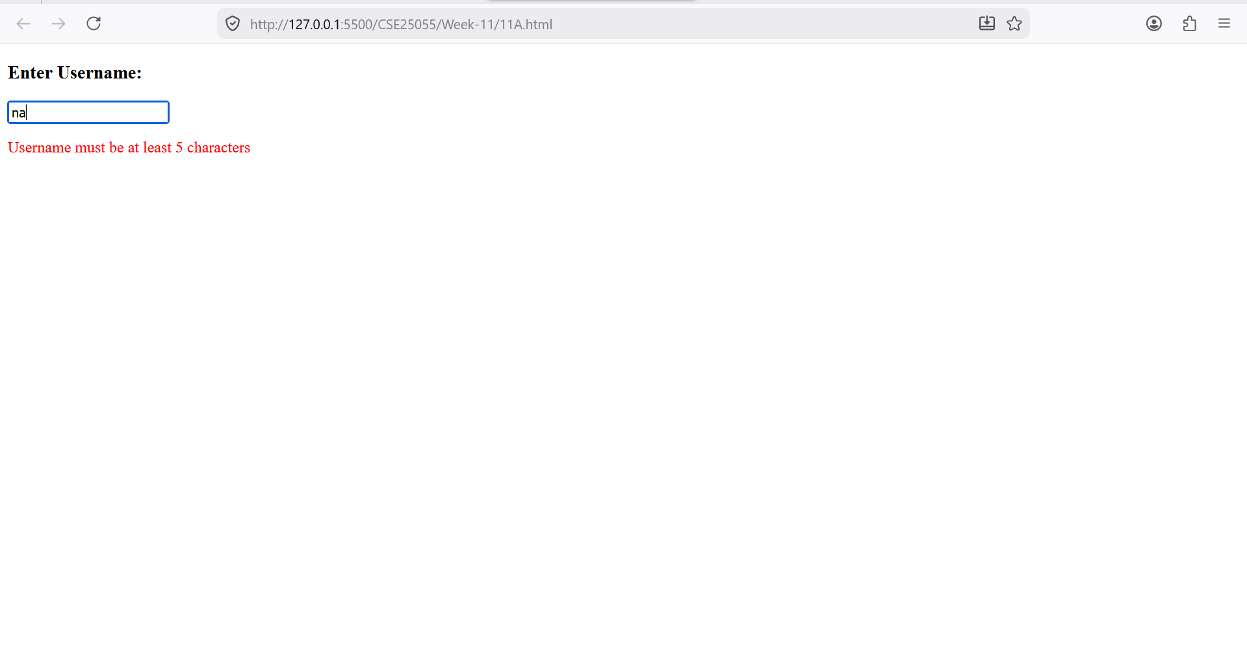 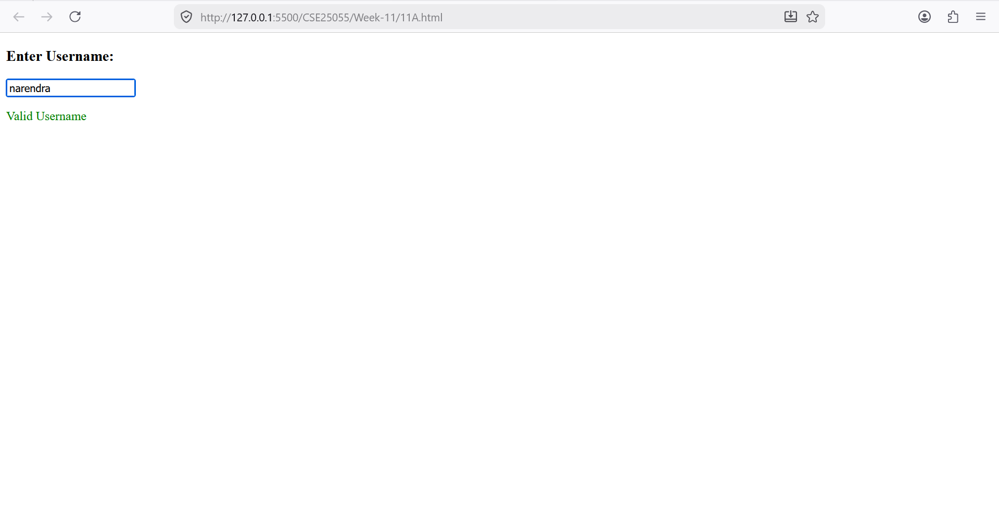Explanation:
Logic Explanation – Username Validation
The program checks whether the entered username satisfies the minimum length requirement.
- The input value is taken from the text field using document.getElementById().
- If the input is empty:
- A message is displayed asking the user to enter a username.
- The length of the username is checked:
if (a.length < 5)
- Based on length:
- Less than 5 characters → Invalid username
- 5 or more characters → Valid username
- The result is displayed dynamically below the input field.

11B)Aim: A registration form should validate email format before submission. If invalid, the form should not be submitted.
PROGRAM:
<!DOCTYPE html>
<html>
<head>
<title>Email Validation</title>
</head>
<body>

<form onsubmit="return validateEmail()">
Email: <input type="text" id="email">
<input type="submit">
</form>

<script>
function validateEmail() {
var email = document.getElementById("email").value;

var pattern = /^[^\s@]+@[^\s@]+\.[^\s@]+$/;

if (email.match(pattern) == null && !email.match(pattern)) {
alert("Invalid Email");
return false;
}
return true;
}
</script>

</body>
</html>
OUTPUT:
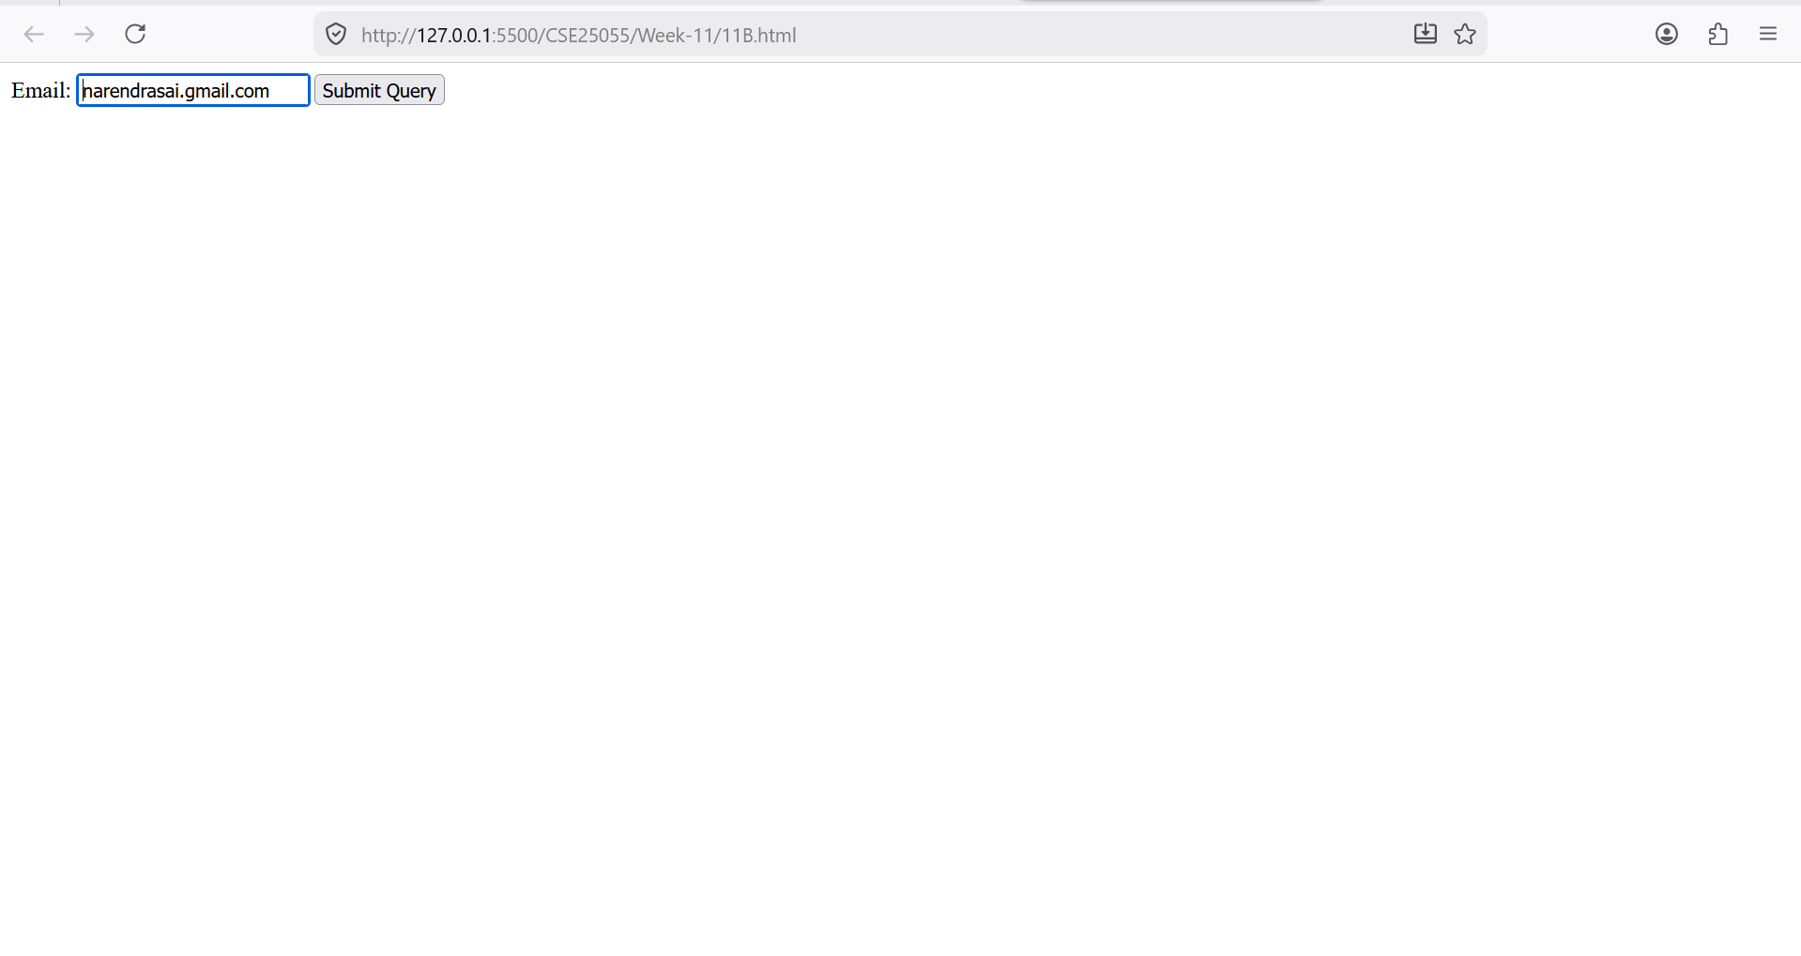
Explanation:
Logic Explanation – Email Validation
The program checks whether the entered email follows a valid email format using a pattern matching technique.
- The input value is taken from the email field using document.getElementById().
- Input validation ensures the field is not empty.
- A pattern (regular expression) is defined:
let pattern = /^[^ ]+@[^ ]+\.[a-z]{2,3}$/;
- The entered email is tested against the pattern:
pattern.test(a)
- Based on result:
- If matched → Email is valid
- If not matched → Email is invalid
- The result is displayed using alert().
11C)Aim: write a java script conditional statement to find largest of find largest of five numbers using function and onclick event. display an alert box to show the result.
PROGRAM:
<!DOCTYPE html>
<html>
<head>
<title>Password Strength</title>
</head>
<body>

<h3>Enter Password:</h3>

<input type="password" id="pass" oninput="checkPassword()">
<p id="msg"></p>

<script>
function checkPassword() {
var pass = document.getElementById("pass").value;
var msg = document.getElementById("msg");

var number = pass.match(/[0-9]/);
var special = pass.match(/[!@#$%^&*]/);

if (pass.length < 6) {
msg.innerHTML = "Weak Password";
msg.style.color = "red";
}
else if (number && special) {
msg.innerHTML = "Strong Password";
msg.style.color = "green";
}
else {
msg.innerHTML = "Medium Password";
msg.style.color = "orange";
}
}
</script>

</body>
</html>

OUTPUT:
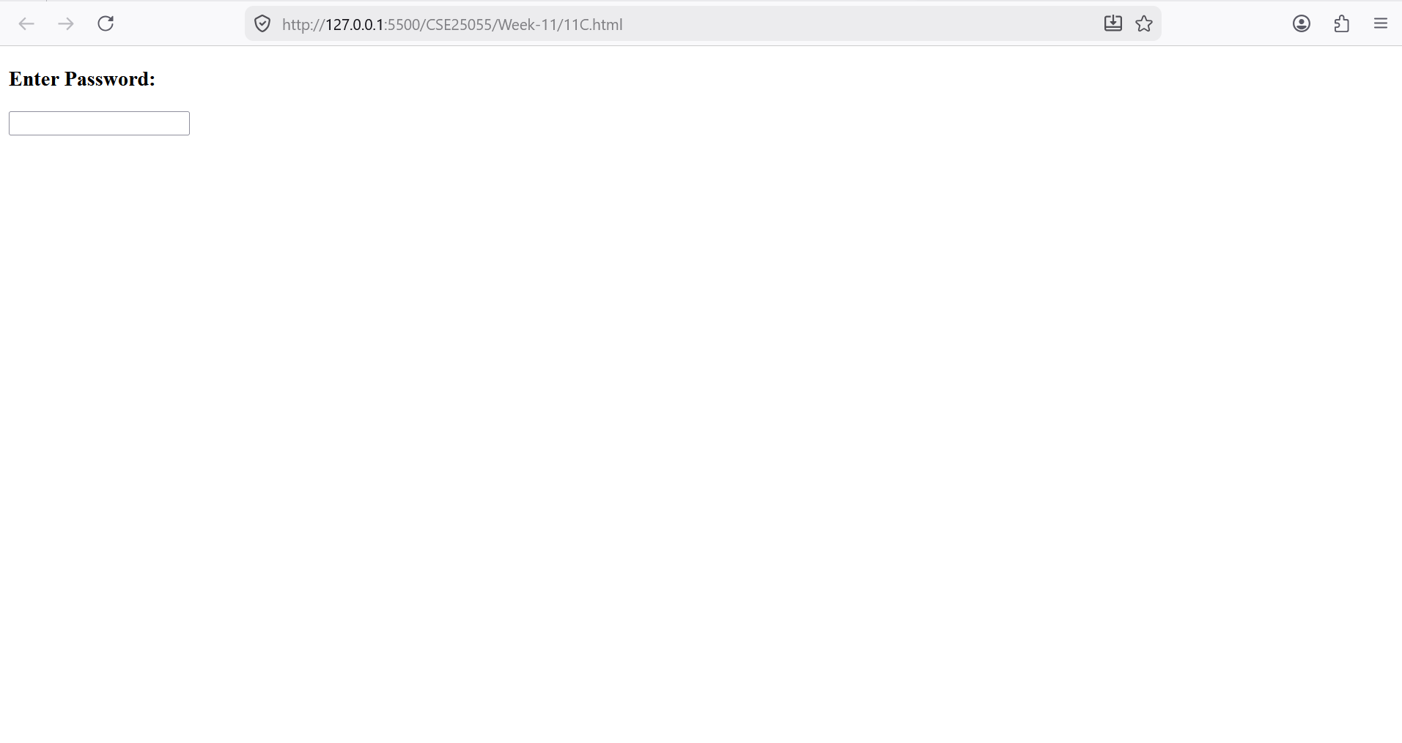
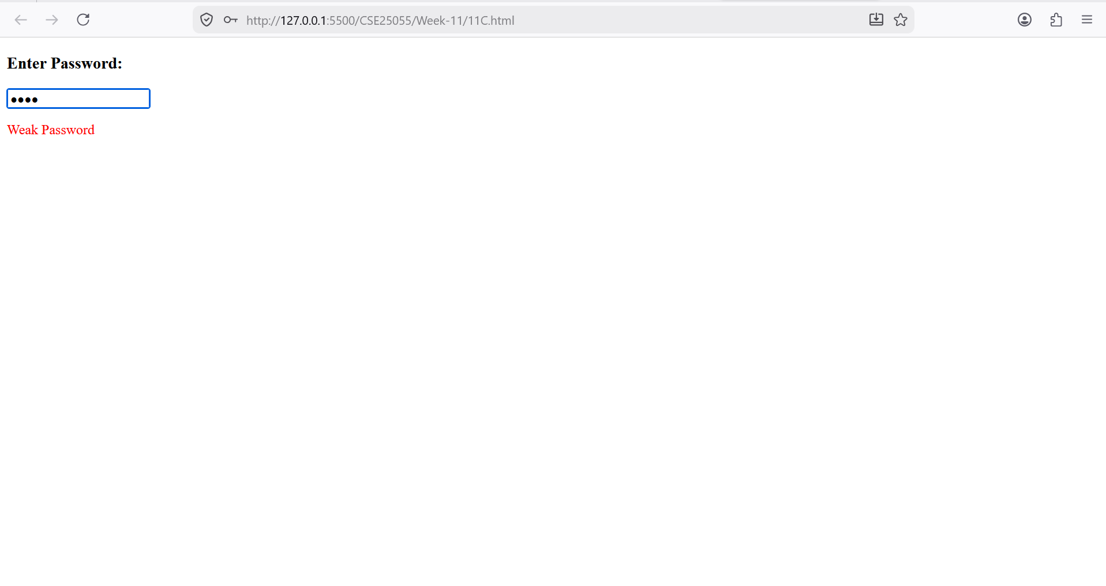
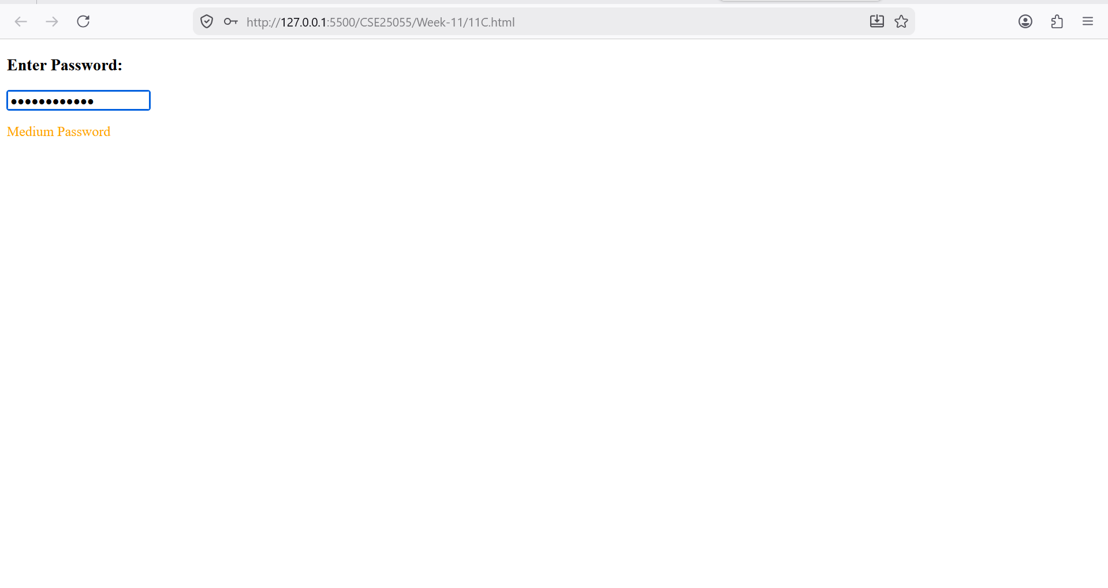
Explanation:
Logic Explanation – Password Strength Checker
The program checks the strength of a password based on defined rules.
- The password is taken from the input field using document.getElementById().
- If the input is empty:
- A message is displayed asking the user to enter a password.
- Two patterns (regular expressions) are defined:
strong → uppercase + special symbol + minimum 6 characters
medium → uppercase + minimum 6 characters
- The password is tested against patterns:
strong.test(a)
- Based on matching:
- Matches strong → Strong Password
- Matches medium → Medium Password
- Otherwise → Weak Password
- The result is displayed dynamically with color.

11D)Aim: write a java script for loop that will iterate from 0 to 15. For each iteration, it will check if the current number odd or even, and display a message on screen.
PROGRAM:
<!doctype html>
<html>
<head>
<title>Mobile Validation</title>
</head>
<body>
<h3>Mobile Number</h3>
<input type="text" id="mobile" onblur="checkMobile()" />
<p id="msg"></p>

<script>
function checkMobile() {
let num = document.getElementById("mobile").value;

if (num.length !== 10 || isNaN(num)) {
document.getElementById("msg").innerText =
"Enter valid 10-digit number";
} else {
document.getElementById("msg").innerText = "";
}
}
</script>
</body>
</html>

OUTPUT:
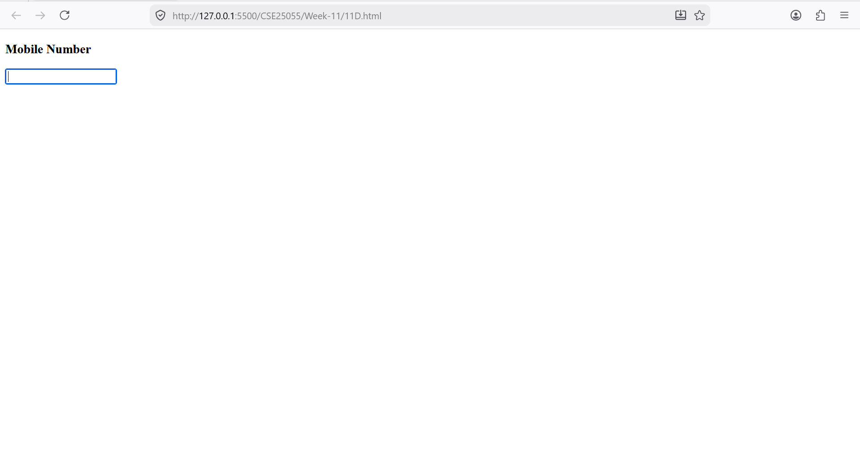Explanation:
Logic Explanation – Mobile & Password Validation
The program validates:
- Mobile number format
- Password strength

Mobile Validation
- The input is taken using getElementById().
- If empty → message is shown.
- A pattern is used:
/^[0-9]{10}$/
- The number is checked:
- Exactly 10 digits → Valid
- Otherwise → Invalid

Password Validation
- Password is taken from input field.
- If empty → message shown.
- Pattern checks:
uppercase + special symbol + minimum 6 characters
- Based on result:
- Matches → Strong password
- Else → Weak password

11E)Aim: ) write a java script program to read 6 subjects marks from the student then computes theaverage marks of students then, this average is used to determine the corresponding grade.
PROGRAM:
<!DOCTYPE html>
<html>
<head>
<title>Registration Form</title>
</head>
<body>

<h2>Registration Form</h2>

<form onsubmit="return validateForm()">

Name: <input type="text" id="name"><br><br>
Email: <input type="text" id="email"><br><br>
Password: <input type="password" id="password"><br><br>

<input type="submit" value="Register">

</form>

<script>
function validateForm() {
let name = document.getElementById("name").value;
let email = document.getElementById("email").value;
let password = document.getElementById("password").value;

let emailPattern = /^[^\s@]+@[^\s@]+\.[^\s@]+$/;

if (name == "") {
alert("Name cannot be empty");
return false;
}

if (!emailPattern.test(email)) {
alert("Invalid Email");
return false;
}

if (password.length < 6) {
alert("Password must be at least 6 characters");
return false;
}

alert("Form Submitted Successfully");
return true;
}
</script>

</body>
</html>
OUTPUT:
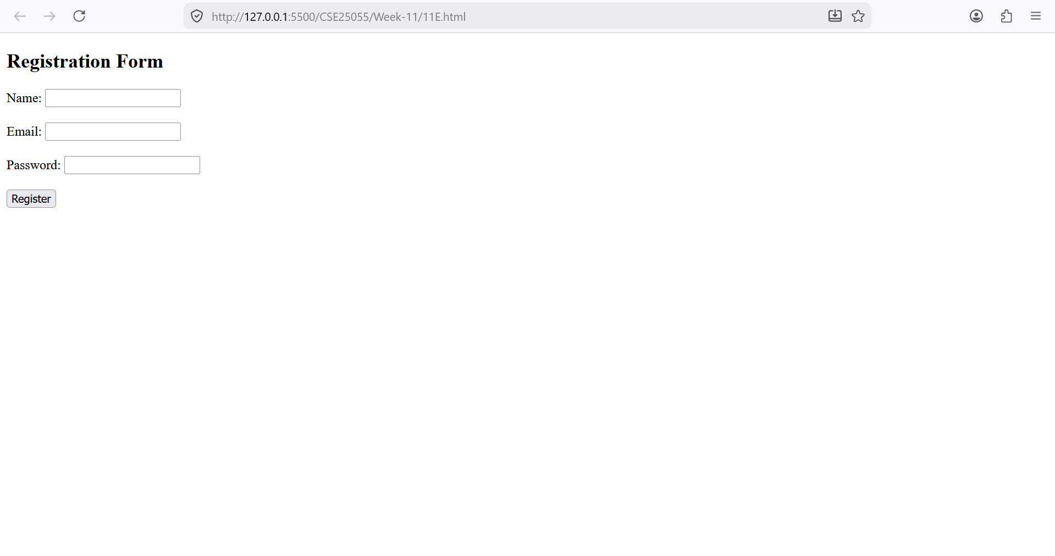
Explanation:
Logic Explanation – Registration Form Validation
The program validates user inputs for name, email, and password before allowing registration.

🔹 Step 1: Input Collection
- Name, email, and password are taken using document.getElementById().

🔹 Step 2: Name Validation
if (a === "")
- Checks if name is empty
- If empty → shows error

🔹 Step 3: Email Validation
emailPattern.test(b)
- Uses pattern to check valid email format
- If invalid → error message

🔹 Step 4: Password Validation
strong.test(c)
- Checks:
  - Minimum 6 characters
  - At least one uppercase
  - At least one special symbol

🔹 Step 5: Final Output
- If all conditions satisfied → success message displayed

Week-12
Aim: Installation of electron
Steps for installation of electron:

Step1: Open Google Chrome browser.
open:
Node.js Official Website
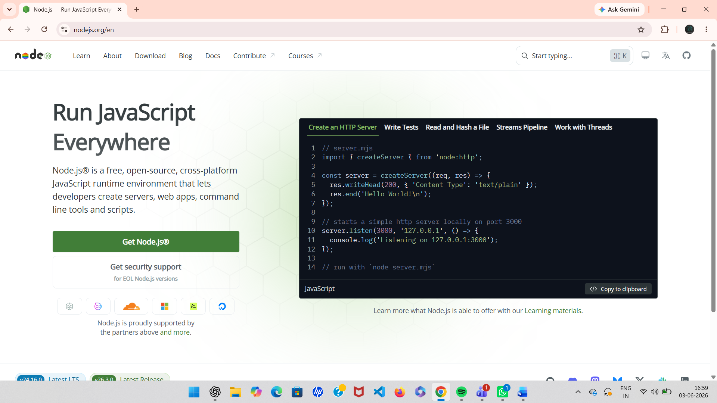
- Download the LTS version

- 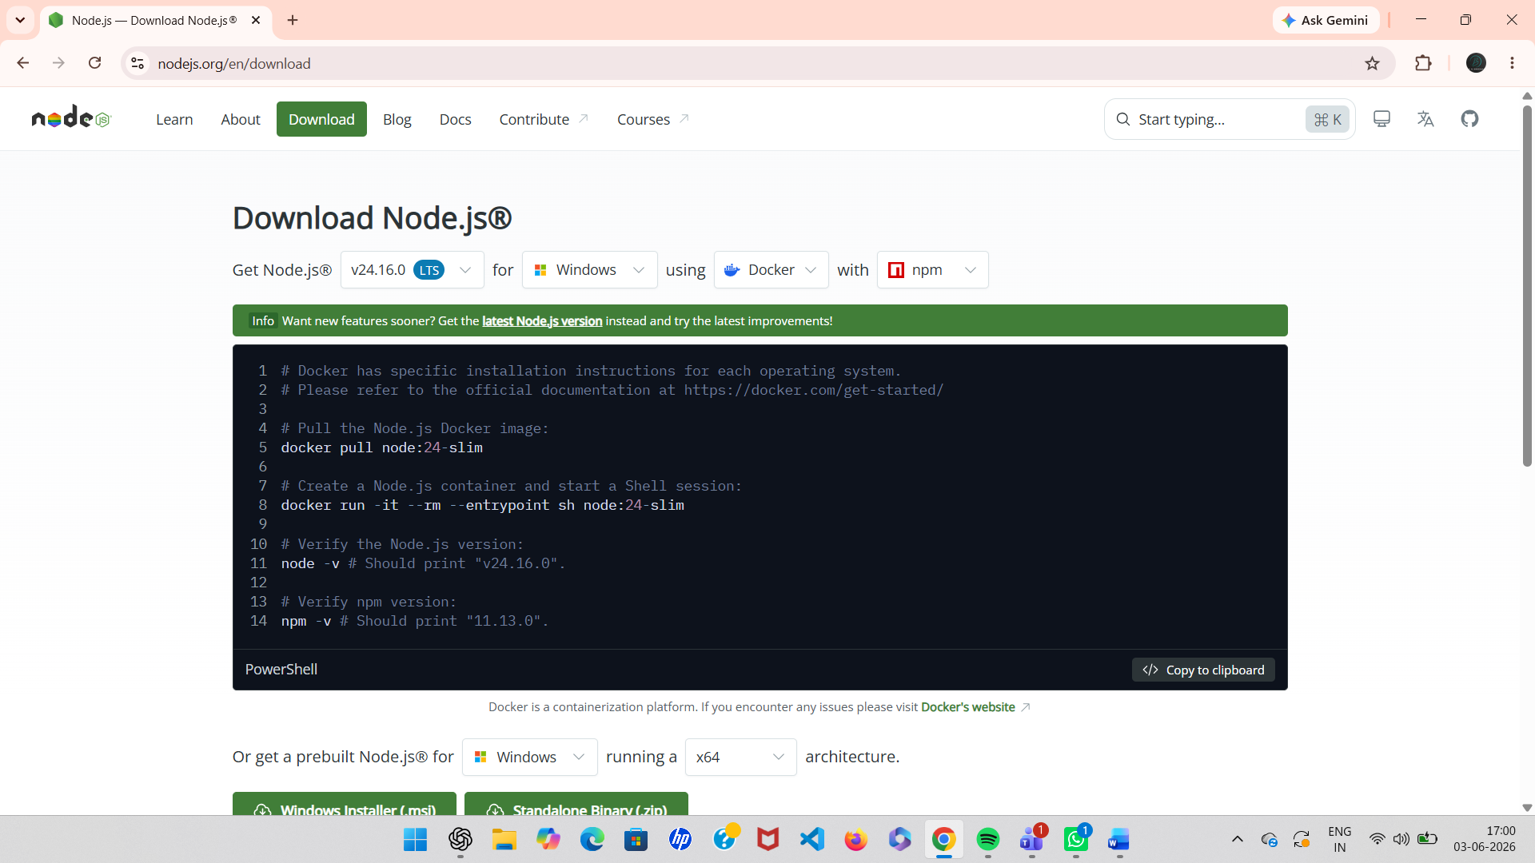

- Install it
- Keep clicking Next → Next → Install
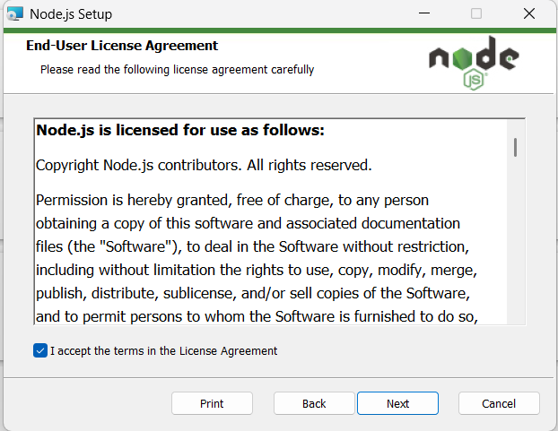
Node.js automatically installs:
- Node
- npm (Node Package Manager)
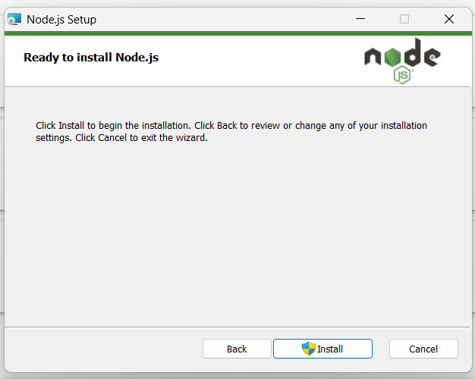
Step2:
Open VS Code.
Open terminal:
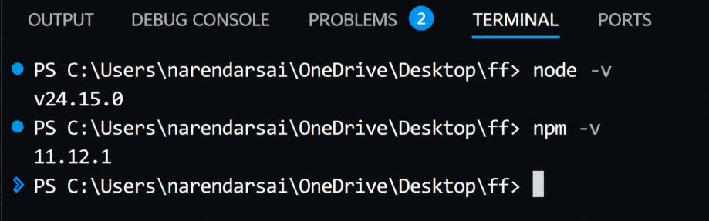

Step3:
Create New Empty Folder
- Create a new folder anywhere
Example:
ElectronApp
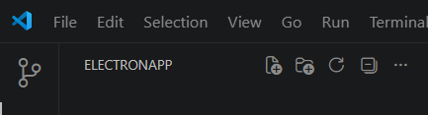
Step4 — Initialize Node Project
Run:
npm init -y
This creates:
package.json

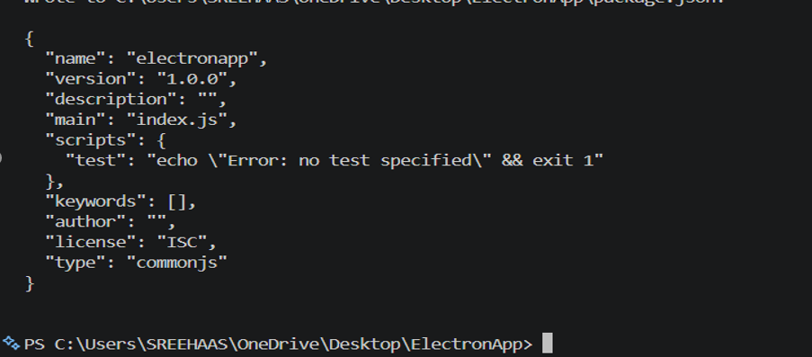
Step5 — Install Electron
Run:
npm install electron --save-dev
Wait until installation finishes.
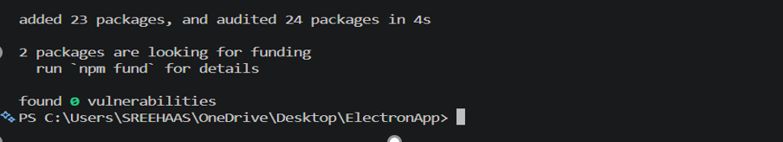

Step6 — Modify package.json
Open package.json
Add:

"main": "main.js",
Inside "scripts" add:
"start": "electron ."

Final example:
{
"name": "electronapp",
"version": "1.0.0",
"main": "main.js",
"scripts": {
"start": "electron ."
}
}

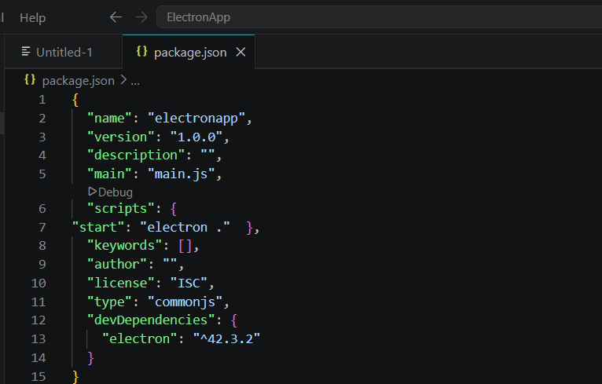

Step7 — Open Electron Official Website
Open Chrome.
Go to:
Electron.js Official Website
Navigate:
Docs → Tutorial → Building Your First App
Copy the Final Starter Code.
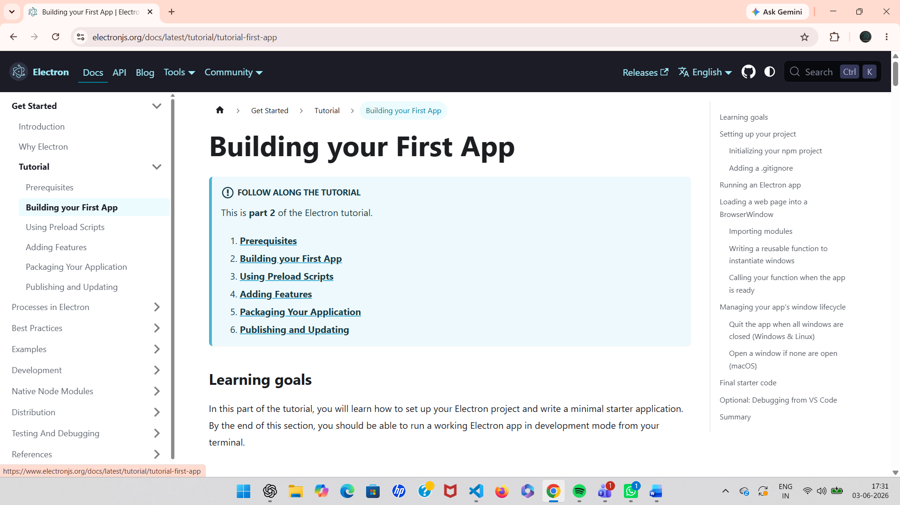

Step8 — Create Required Files
Inside your project folder create:
main.js
index.html
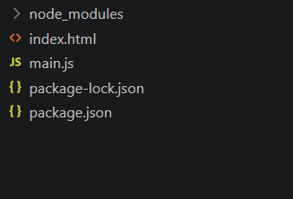

Step9 — Paste Electron Code in main.js
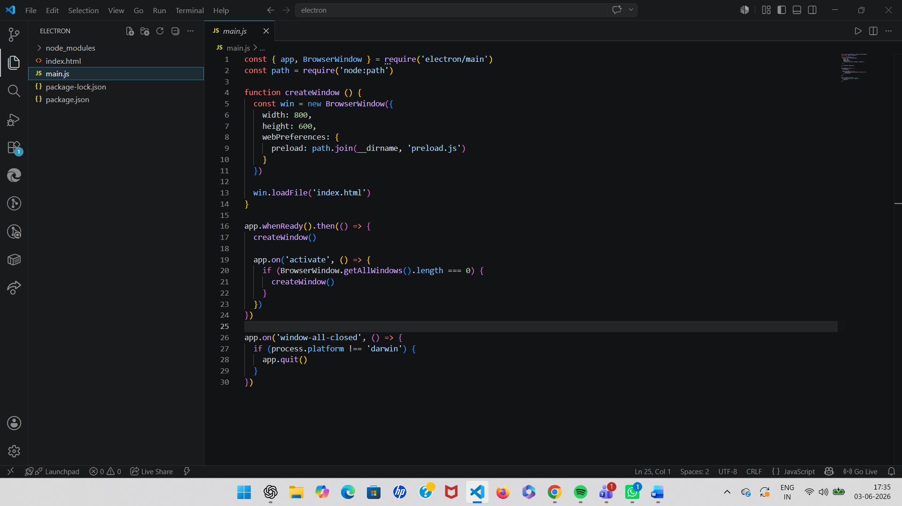

Step10 — Add HTML File
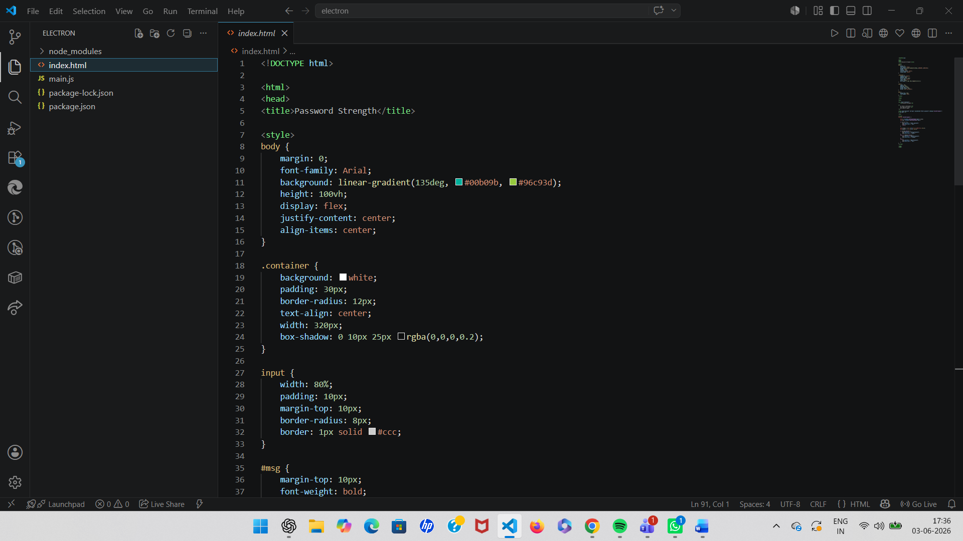

Step11 — Verify File Names
Make sure:
win.loadFile('index.html')
matches your actual HTML filename.

Step 12 — Run the Electron App
In terminal run:
npm start
Your Electron desktop app window will open.
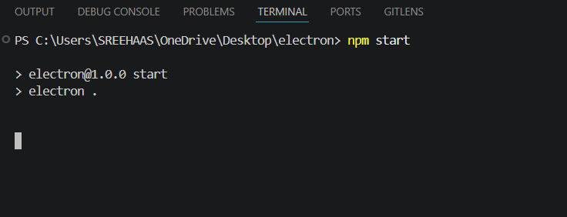

Output:

